Assumptions and Methodologies in the South African TIMES (SATIM) Energy Model

**Energy Research Centre**

**Systems Analysis & Planning Group**



Version 3.3.2

2019/03/12

# Executive Summary

The Energy Research Centre at the University of Cape Town maintains a TIMES energy model (SATIM) which is now in its 3rd generation. TIMES is a partial equilibrium linear optimisation model capable of representing the whole energy system, including its economic costs and its emissions, and is thus particularly useful in modelling potential mitigation policies. The approach is fundamentally sectoral as would be the case with other models, even simple spreadsheet models like MAED, and so the analysis of the structure of energy demand from sectors is a fundamental building block of the modelling process, regardless of the tools selected.

This report describes the modelling framework developed by the Energy Research Centre (ERC) for the South Africa energy sector. The modelling framework is based on a series of nation-wide energy modelling tasks/projects that have been carried by ERC since the Long Term Mitigation Scenarios (LTMS) modelling process and the model is in its third generation since then. The modelling system, the methodology and its various components are briefly described, followed by a more detailed description of the data and assumptions currently employed in the model on a sector by sector basis.

The South African TIMES model (SATIM) is structured into five demand sectors and two supply sectors – industry, agriculture, residential commercial and transport on the demand side, and electricity and liquid fuels on the supply side. The sectors vary somewhat in their share of final consumption and consequently greenhouse gas emissions, with Transport accounting for 27% of Total Final Consumption of Energy in 2006, the Industry Sector accounting for nearly 40% and the Agriculture Sector only accounting for 2.6%

Given these disparities, not all sectors in SATIM have enjoyed the same investment of research, and research funding has tended to concentrate on sectors having a high environmental impact and profile like the Transport Sector and Electricity Supply sector. The Transport Sector in particular is well documented and includes a high level of detail due to outside investment from recent projects.

This document should be a useful reference for readers involved in setting up national energy models for infrastructure planning or emissions mitigation purposes. While certain aspects are particular to South Africa, much of the approach and solving of problems will have universal application.

The detailed assumptions of the model in numbers are maintained in a Microsoft Excel spreadsheet which forms the appendices of this document. The spreadsheet is posted with this document on the website of the Energy Research Centre, University of Cape Town.

# **Table of** **Contents**

Executive Summary 2

Table of Contents 2

List of Tables 2

List of Figures 2

Glossary 2

Introduction 2

Structure of the SATIM Model 2

General Methodology for Sector Analysis in SATIM 2

The Use of sub-Sectors 2

Compiling a Reference Case 2

Key Data Sources – South Africa’s Integrated Resource Plan (IRP) 2

Exogenous Projection of Demand – General Approach and Data Sources 2

Emissions and Sectoral Energy Models 2

Industry Sector 2

Structural Assumptions & Modelling Decisions 2

Compiling the Base Year Consumption Data - Assumptions and Issues 2

Assumptions Characterising Technologies and Energy Services 2

Validation of the Sector Model 2

Future Demand for Energy from the Industry Sector 2

Agriculture Sector 2

Model Structure 2

Compiling the Base Year Consumption Data - Assumptions and Issues 2

Assumptions Characterising Technologies and Energy Services 2

Future Demand for Energy from the Agricultural Sector 2

Commercial Sector 2

Model Structure 2

Compiling the Base Year Consumption Data - Assumptions and Issues 2

Assumptions Characterising Technologies and Energy Services 2

Future Demand for Energy from the Commercial Sector 2

Transport Sector 2

Model Structure 2

Sub-Model for Profiling Base Year Technologies – The Vehicle Parc Model 2

Vehicle Parc Model Input Data and Assumptions 2

Characterising New Vehicle Technologies **Error! Bookmark not defined.**

Future improvements in vehicle fuel economy 2

Investment costs for New Transport Technologies and Constraints on Market Penetration 2

Sub-Model for Projecting Passenger Car Motorisation and the Demand for Passenger Travel – The Time Budget Model 2

Background - The daily travel time budget 2

Using the Time Budget Model to Project Demand for Passenger Travel on Land 2

Projecting Demand for Freight on Land 2

Calculation of Future Energy Demand from Road Vehicles 2

Residential Sector 2

Model Structure 2

Household classification process 2

Compiling the Base Year Consumption Data - Assumptions and Issues 2

Assumptions and constraints for reference scenario in the residential sector 2

Projecting the Evolution of Household Income 2

Assumptions on future technology share 2

Future Demand for Energy from the Residential Sector 2

Supply of Energy from the Electricity Supply Sector 2

Model Structure 2

Transmission 2

Distribution 2

Generation 2

Existing Power Plants 2

Parameterization of Existing Power Plants 2

Additional Parameterization for Combined Heat & Power (CHP) Plants 2

Additional Parameterization for Existing Pump Storage Systems 2

Basic Structure & Assumptions for New/Future Power Plants 2

Parameterization of New Technology Power Plants 2

Parameterisation of New Power Plant Technologies in the Process of Being Implemented 2

Supply of Energy from the Liquid Fuels & Gas Supply Sector 2

Model Structure 2

Base Year Data 2

Assumptions Characterising Refineries and Refining Processes 2

Parameterization of Refinery Technologies 2

Characterization of CTL Technology 2

Modelling the Supply of Ancillary Steam Input Services to Refineries 2

Supply of Primary Energy 2

References 2

Appendices 2

# List of Tables

Table 1: Global Warming Properties of Major Greenhouse Gases 2

Table 2: Example of IPCC Emission Factors - Stationary Combustion of sub-Bituminous Coal by Energy Industries (kg/TJ on a net calorific basis) 2

Table 3: Measured Emission Factors for Selected Southern African Power Plants Compared to IPCC Default Factors (Zhou, et al., 2009) 2

Table 4: Disaggregation of the SATIM Model by Industry sub-Sector Compared to the National Energy Balance and LTMS Model 2

Table 5: Disaggregation of the SATIM Model by Energy Source Compared to the National Energy Balance 2

Table 6: End Use Demands Modelled for the Industry Sector in SATIM and the Energy Source – Technology Chain to Supply Them 2

Table 7: Estimates of Attainable Overall Efficiency Improvements for Electricity End-Uses in the Industry Sector 2

Table 8: Comparison of Estimates of the Aggregate Consumption of Fuels (PJ) for the SATIM, DOE and IEA Energy Balances for South Africa - 2006 2

Table 9: Evolution of Sub-Sector Estimates of Coal Consumption for the Base Year (2006) 2

Table 10: Sector Adjustments to Coal Consumption in the SATIM Model Relative to the National Energy Balance 2

Table 11: Assumed Share of Electricity Consumption by Energy Services within Industry Sub-Sectors 2

Table 12: Assumed Efficiency of Technologies in Industry Sector 2

Table 13: Comparison of Energy Consumption by Source (PJ) for SATIM and the DOE Energy Balance for South Africa - 2006 2

Table 14: IEP Assumed Share by Energy Services of Useful Agricultural Electrical Energy Consumption 2

Table 15: LTMS Assumed Breakdown of Agricultural Total Final Consumption by Energy Service for 2001 2

Table 16: Evolution of Assumptions of Energy Supply Share of Irrigation Final Energy by Energy Services 2

Table 17: SATIM Assumed Energy Service Shares of Agriculture Sector TFC by Energy Supply 2

Table 18: Assumed Agricultural Energy Service Efficiencies in the SATIM Model 2

Table 19: Assumptions of Change in Agricultural Energy Intensity for the LTMS 2

Table 20: Commercial building categories used in 2006 study compared with previous LTMS assumptions 2

Table 21: Comparison of Estimates of the Aggregate Consumption of Fuels (PJ) by the Commercial Sector for the SATIM Model and the DOE Energy Balance for South Africa - 2006 2

Table 22: Estimated Energy Carrier Share of Energy Consumption by End Use and Fuel 2

Table 23: Existing Transport Sector Technologies in SATIM Base Year **Error! Bookmark not defined.**

Table 24: Key Data Inputs to the Vehicle Parc Model 2

Table 25: Vehicle classes adopted for the Vehicle Parc Model 2

Table 26: Vehicle Class Weibull Coefficients & Resulting Average Ages for the Calibrated Vehicle Parc Model Compared to other Studies & Sources 2

Table 27: Assumed average vehicle mileage (km/annum) 2

Table 28: Average annual mileage per vehicle for passenger modes in various African cities 2

Table 29: Improvements in passenger car fuel economy in world markets 2000–2010 2

Table 30: Calibrated model fuel economy (l/100km) by vehicle class compared to other studies and sources – Part 1 2

Table 31: Average occupancy per vehicle for passenger modes in various African cities 2

Table 32: Model occupancy and load factor by vehicle class compared to other studies and sources 2

Table 33: Additional Technologies Available to the Model for Meeting Future Demand for Transport **Error! Bookmark not defined.**

Table 34: Improvements in passenger car fuel economy in world markets 2000–2010 **Error! Bookmark not defined.**

Table 35: Hypothetical fuel economy improvement scenarios for gasoline passenger cars compared to the current efficient non-hybrid gasoline passenger cars 2

Table 36: Assumptions and checks used to estimate access to private vehicles by income groups – base year (2006) 2

Table 37: Total distance, time and speed for the new European drive cycle 2

Table 38: Time budget model assumptions for calculating passenger travel demand for public and private modes 2

Table 39: Organisation of road and rail freight demand such that the road/rail split can be kept constant for the base case 2

Table 40: Households grouping in current South African TIMEs Model (SATIM) 2

Table 41: Energy Intensive Appliances 2

Table 42: Comparison of Estimates of the Aggregate Consumption of Fuels (PJ) by the Commercial Sector for the SATIM Model and the DOE Energy Balance for South Africa - 2006 2

Table 43: Mapping of Stats SA Income and Expenditure Survey Categories and CGE Modelling Results to Three Income Categories 2

Table 44: Generic Example of Assumed technology limit shares 2

Table 45: Illustrative Example of Assumptions of the Elasticity of Useful Energy Use by Household with respect to Household Income for increasing household income 2

Table 46: Assumed Future South African Electrification Rates by Income Group 2

Table 47: Distribution Technologies in SATIM 2

Table 48: SATIM Aggregation of Existing Power Plants (before 2010) into Technologies 2

Table 49: SATIM Parameterization of Power Plant Technologies 2

Table 50: Additional Parameterization in SATIM for CHP Power Plants 2

Table 51: Additional Parameterization in SATIM for Pumped Storage Power Plants 2

Table 52: SATIM Parameterization of New Power Plant Technologies 2

Table 53: SATIM Refinery Outputs 2

Table 54: SATIM Parameterisation of Refinery Technologies 2

Table 55: Assumed Upper Bounds on Output Commodity Shares for Refinery Technologies 2

Table 56: Summary of Existing and New Refinery Technology Characteristics 2

Table 57: Current Refinery Steam Boiler Technologies Implemented in SATIM 2

# List of Figures

Figure 1: Share of Total Final Energy Consumption by Sector – DOE Energy Balance 2006 2

Figure 2: Share of Total National Energy Sector Greenhouse Gas Emissions 2000 (Mwakasonda, 2009) 2

Figure 3: Typical Framework followed for energy analysis 2

Figure 4: LTMS GDP growth rate projection **Error! Bookmark not defined.**

Figure 5: SATIM GDP growth rate projection **Error! Bookmark not defined.**

Figure 6: Sectoral Source Apportionment of Global Greenhouse Gas Emissions – CO2 eq terms (IPCC c, 2007) 2

Figure 7: Source Apportionment of Global Greenhouse Gas Emissions – CO2 eq terms (IPCC c, 2007) 2

Figure 8: LTMS Methodology for including Efficiency Programs in an Optimisation Model of a Simplified Industry Sector with Aggregate Technologies having Unknown Costs 2

Figure 9: Indexed Intensity of Electricity Consumption for Industry sub-Sectors 1998 – 2009 2

Figure 10: Indexed Physical Output for Industry sub-Sectors 1998 – 2009 2

Figure 11: RES Diagram Showing the Structure of the Agriculture Sector as Represented in the SATIM Model 2

Figure 12: Energy Source Shares of Agricultural Energy Consumption (DOE Energy Balance, 2006) 2

Figure 13: IEP Assumed Useful Agricultural Energy Consumption Disaggregated by Energy Service Demands (Howells, Kenny, & Solomon, 2002) 2

Figure 14: Comparison of energy consumption by end use for 2001 with updated base year of 2006 2

Figure 15: Generalised System of pre-Processing Transport Sector Inputs for SATIM using sub-Models 2

Figure 16: System diagram and data table features of analytical platform 2

Figure 17: Schematic representation of the vehicle parc model and its data inputs and validations 2

Figure 18: Base year scrapping curves for the vehicle technology types in the vehicle parc model 2

Figure 19: EPA Mobile 6 annual mileage decay assumptions compared to results of vehicle activity study for Nairobi Kenya 2

Figure 20: Assumed historical evolution of vehicle fuel economy in the model 2

Figure 21: Gompertz Curve model of the correlation of motorisation with income per capita *Dargay et al. (2007)* 2

Figure 22: Average per-capita travel budget for various localities and regions across the GDP spectrum *Schafer & Victor (2000)* 2

Figure 23: CGE model output for annual household consumption 2005-2030 by deciles of households *Author’s calculations using data from Alton et al. (2012)* 2

Figure 24: Appliance saturation levels 2

Figure 25: Indexed households appliance ownership 2

Figure 26: Projected Household Income Category Share **Error! Bookmark not defined.**

Figure 27: Simplified Schematic of SATIM Model of the South African Power Sector 2

Figure 28: Assumed Refurbishment/retirement Profiles for Existing ESKOM Plant 2

Figure 29: Schematic of Pumped Storage sub-Model in SATIM 2

Figure 30: New Electricity Production Technologies Available in SATIM 2

Figure 31: Illustrative Comparison of SATIM Capacity Availability Factors by Model Timeslice for New Solar Central Receiver Technologies Having 3 - 14 Hours of Storage – Winter Season 2

# Glossary

**BRT:** Bus Rapid Transport

**CSIR:** Council for Scientific and Industrial Research

**CTL:** Coal to Liquid (Synthetic Fuel Refinery with Coal Feedstock)

**GTL:** Gas to Liquid (Synthetic Fuel Refinery with Natural Gas Feedstock)

**HCV:** Heavy Commercial Vehicles (> 8500 kg GVM)

**IRP**: Integrated Resoource Plan – The Department of Energy’s long term electricity supply plan

**LCV:** Light Commercial Vehicle (> 3500 kg GVM)

**MBT:** Minibus-Taxi

**MCV:** Medium Commercial Vehicle (3500 – 8500 kg GVM)

**NAAMSA:** National Association of Automobile Manufacturers of South Africa

**Natis/eNatis:** South African National Traffic Information System

**pkm:** passenger.kilometres

**SAPIA:** South African Petroleum Industry Association

**SATIM:** The South African Times Model, a TIMES-MARKAL linear optimisation model of the South African energy system

**SOL:** State of Logistics Reports (Annually published by the CSIR)

**Statistics South Africa (Stats SA):** The government agency responsible for measuring and collating national statistics for South Africa

**SUV:** Sport Utility Vehicle. Usually a large 4 wheel drive passenger vehicle

**t.km:** ton.kilometres

# Introduction

The Energy Research Centre’s TIMES energy model is now in its 3rd generation since the completion of the LTMS project. The current model is known as SATIM – the South African Times Model. This document aims to provide some insight into energy models through augmenting a brief overview of general approaches with a fairly detailed description of the SATIM model and its methodology, drawing not only on its current form but also, where relevant, from the LTMS models where that approach differed.

This document aims to describe the sector analysis methodology of the SATIM model with particular attention to the development of assumptions that account for shortcomings in data and the practical necessity of simplifying complex economic and industrial structures. The document is structured such that dedicated sections are presented for each primary economic sector prefaced by a general overview of sector analysis. Fundamentally, the modelling methodology of SATIM characterises the demand for energy by the energy services required by a sector. These services are supplied by technologies that require energy and the quantity of that energy supply will depend on the efficiency of the technology. The cost of supplying the service will depend on the cost of the energy carrier (fuels, electricity etc.) and the cost of the technology over time which together can be calculated as a levelised cost of supplying the service. The model will select technologies to minimise this cost subject to constraints. In order to articulate the assumptions required by this methodology for each of the 5 demand sectors, Industry, Agriculture, Commercial, Transport and Residential, this document attempts to broadly cover the following:

* The structure of the sector and its energy services as it impacts on the demand for energy
* The establishment of base year demand for energy in the sector
* Technical and cost parameters of the technologies available to satisfy the demand for energy services currently and in the future. Technology costs and the projection of these are clearly critical to an optimisation model as are constraints on the penetration rates of new technologies to reflect realistic replacement rates of existing technologies and non-cost based choices.
* The projection of future demand for energy services

The level of detail for a sector depends on the relative contribution of the sector to total consumption and also on how much funding has been historically received for developing that sector in the model. Thus Transport is quite detailed but Agriculture is not and is quite simplistically represented in SATIM because in South Africa the Agriculture sector accounts for relatively small energy consumption and low emissions.

The two supply sectors involved in transformation, Electricity and Liquid Fuels Production are described in some detail as regards their structure and the technical and cost parameters of the technologies available to supply the energy required by the demand sectors in the form of electricity, heat and liquid fuels. These supply sectors require primary energy and this is part of the energy chain that must be costed to determine a levelised cost of supply. Assumptions regarding primary energy supply are therefore briefly discussed in the relevant section.

In SATIM, useful energy is an exogenous input disaggregated by energy carrier, for each demand sector. Final energy demand is determined endogenously using the assumed efficiencies of the least cost demand-side technologies selected by the model. The two supply sectors and primary energy sources must meet the sum of these demands. The supply sectors do not therefore have their own demand projections and projection of demand is not discussed in the supply-side sections. The model optimiser will select supply-side technologies to meet the demand for final energy at least cost.

Some general discussion on sectoral modelling, the projection of future demand for energy from sectors for exogenous input to the model and the inclusion of emissions in the model precedes the sector by sector documentation.

# Structure of the SATIM Model

The economy of a nation or region consumes energy in the form of a number of primary and secondary sources which deliver services by means of a myriad of technologies large and small. A model of the demand for energy needs to capture this complex structure and thus these sources and technologies need to be organised in some logical way. Options include by source or by technology but more commonly demand models organise the demand for energy by economic sector. This is for a number of reasons, particularly because data tends to be collected by economic sector but also because economic sectors will have many consistencies with regard to technologies and energy sources that facilitate similar treatment.

TIMES, the platform for SATIM, is a partial equilibrium linear optimisation model capable of representing the whole energy system, including its economic costs and its emissions, and is thus particularly useful in modelling potential mitigation policies. The approach is however fundamentally sectoral as would be the case with other models, even simple spreadsheet models like MAED, and so the analysis of the structure of energy demand from sectors is a fundamental building block of the modelling process, regardless of the tools selected.

The SATIM energy model has been constructed on a modelling platform called TIMES, developed by ETSAP, one of the International Energy Agency’s implementing agencies, and is a successor to MARKAL. TIMES is a partial equilibrium linear optimisation model capable of representing the whole energy system of a country, including its economic costs and its emissions, and is thus particularly useful in modelling potential mitigation policies. The model is capable of solving for a variety of constraints including emissions constraints, by sector, for the whole economy, or cumulatively over a period, and can be used to identify the more complex consequences of mitigation actions. The South African TIMES model structure is contained in a database, and constructed via a user interface called ANSWER, which provides a framework for both structuring the model and scenarios, and also for interpreting results. ANSWER compiles the model data into a set of linear equations, which are then solved by a linear solver such as CPLEX.

The South African TIMES model (SATIM) is structured into five demand sectors and two supply sectors – industry, agriculture, residential commercial and transport on the demand side, and electricity and liquid fuels on the supply side. The sectors vary somewhat in their share of final consumption and greenhouse gas emissions as shown below.

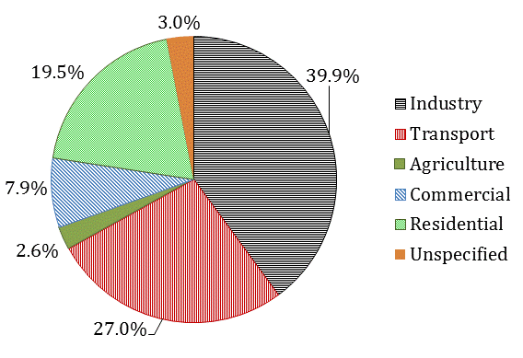

Figure 1: Share of Total Final Energy Consumption by Sector – DOE Energy Balance 2006



Figure 2: Share of Total National Energy Sector Greenhouse Gas Emissions 2000 (Mwakasonda, 2009)

Given these disparities, not all sectors in SATIM have enjoyed the same investment of research, and research funding has tended to concentrate on sectors having a high environmental impact and profile like the Transport sector and Electricity Supply sector. The Transport sector in particular is well documented and includes a high level of detail due to outside investment from recent projects. The assumptions for modelling this sector and their development are therefore described with more rigour than some of the other sectors. Agriculture on the other hand, accounting for less consumption in the energy balance than the unspecified sectors and less than 5% of total greenhouse gas emissions in 2000 (Mwakasonda, 2009) is dealt with relatively simplistically in SATIM. In other countries, the Agriculture sector can be a major, even dominant emitter, and a quite different approach to that of SATIM would be warranted. The industry sector warrants a greater level of detail and this is part of the ongoing program of improvement in SATIM. The structure of each sector and assumptions around its technologies and energy services are covered in the respective sections below.

# General Methodology for Sector Analysis in SATIM

The energy modelling process involves three fundamental steps, being database development, energy analysis and review evaluation, as depicted in Figure 3 below. These steps can be done iteratively, without following any order. The database development deals with assembly of all necessary data required to conduct an energy analysis. This step also involves calibrating the data for input into energy model.

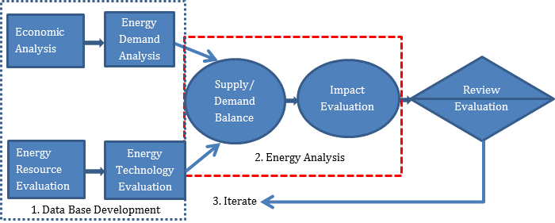

Figure 3: Typical Framework followed for energy analysis

Source: IAEA, 1984

The South African TIMES model has relatively detailed characterisation of the technologies used in both the demand and supply sectors and this therefore makes up a substantial portion of the data and assumptions required to build the model.

## The Use of sub-Sectors

A sub-sector is an economic classification more disaggregated than sector level. Examples are Mining and Iron & Steel Manufacture within the Industry sector, and Passenger and Freight within the Transport ector. Organising demand and technologies by sub-sectors is useful as technologies may be used differently and have different characteristics within sub-sectors of a sector.

## Compiling a Reference Case

Since the key drivers of energy demand are future economic and population growth, projection of these are key assumptions for an energy demand modelling exercise. On top of these two drivers, there are other variables such as shares of technologies used, changes in technological efficiency and sectoral disaggregation which also need to be projected into the future. In an optimisation model it is frequently necessary to constrain these parameters in the model to actively prevent the rapid dominance of the cheapest technology option to reflect the realities of consumer preference, policy and shortage of capital for replacement.

Scenario based energy modelling requires development of differing scenarios which are underpinned by assumptions in the form of “What If?” analysis. In such a modelling exercise, there is always a reference case (also termed business-as-usual scenario) which will be changed or modified to construct other scenarios. This is essentially the default version of the future. A scenario is made up of alternative assumptions on factors such as future fuel use, fuel prices, and technology costs in different sectors, technology efficiencies and changes in technology market shares.

This paper will attempt to briefly describe the critical assumptions and constraints that were used to construct the reference scenario and the basis for selected assumptions for each of the economic sectors modelled in SATIM.

## Key Data Sources – South Africa’s Integrated Resource Plan (IRP)

The South African Department of Energy has undertaken an extensive study that included modelling to produce an Integrated Resource Plan (IRP) for Electricity (DOE, 2011). The first report was published in October 2010 with revisions released in 2011. The outputs include:

* Projections of economic growth for the period extending from 2010 to 2035
* A detailed review of Power Generation technology undertaken by the Electric Power Research Institute (EPRI). This included the publication of detailed technology data and cost data including projections of learning rates on technology costs
* Various fundamental assumptions required for modelling such as discount rates.

This work provides a rich source of data for SATIM particularly as regards costs in the Electricity Supply sector and is referred to frequently in this document.

# Exogenous Projection of Demand – General Approach and Data Sources

The general approach used in projecting energy demand from an economic sector is to define an indicator/s that reflects the demand for energy services. For example, in the case of transport this would be passenger.km and ton.km and for the commercial sector this might be floor area. If a bottom up model with sufficient historical data is available the indicator can be correlated with drivers like GDP or population using that data. Alternatively a rate of change in energy intensity (MJ/pass.km for passenger transport say) needs to be estimated and historical values for the indicator generated.

The relationship derived with drivers like GDP, population and prices can then be projected over the study period. The energy services of a bottom-up model will need to meet this demand for the indicator, given assumptions of activity. To project future demand for useful energy, assumptions of energy intensities need to be derived, usually from historical trends, and multiplied by the projected indicator.

In SATIM the demand for useful energy is exogenously input for each of the 5 demand sectors. This may take the form of natural units (say Petajoules) or an indicator that reflects the demand for energy services as yet unconverted into energy units. Currently in SATIM the demand projections for all sectors are in natural units except for the Transport sector where the demand indicator billion vehicle kilometres is input to the model. In this case the technology efficiency is not in units of % as it would be if useful demand was in natural units but in units of km/MJ and final energy and the useful energy service from the demand projection relate as follows:

U = F X η Equation 1

U = Useful Energy Service (billion vehicle km)

F = Final Energy (PJ)

η = Technology Efficiency (km/MJ)

In undertaking demand projections for SATIM, gross domestic product and population projections important sets of scenario parameters. For population we rely on work done by IIASA…

GDP projections (and corresponding sector and household income growths) can either be done completely exogenously or with the help of the E-SAGE (Energy extension to the South African General Equilibrium), which provides a more consistent framework for the growth of the economy as a whole, as well as for the various sectors in the model. (Arndt, Davies, & Thurlow, 2011).

# Emissions and Sectoral Energy Models

In global terms all the economic sectors are significant contributors to anthropogenic greenhouse gas emissions and offer potential for mitigation strategies as indicated below.

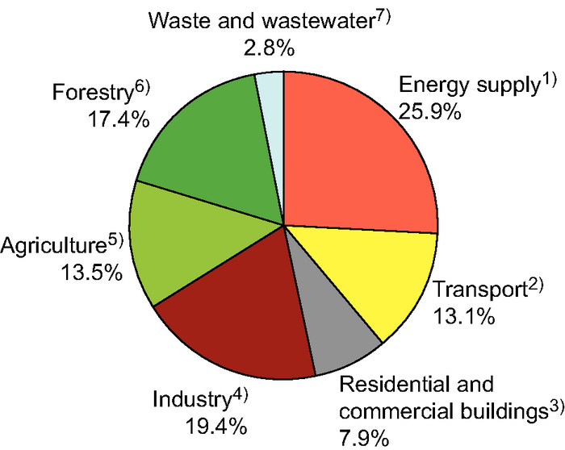

Figure 4: Sectoral Source Apportionment of Global Greenhouse Gas Emissions – CO2 eq terms (IPCC c, 2007)

Energy models and particularly optimisation models were originally designed around infrastructure planning but with increasing concerns around climate change and air quality they now find use in evaluating emissions mitigation interventions or planning infrastructure constrained by limits on emissions. If a carbon tax is part of one of the modelling scenarios, emissions will need to be calculated to determine the levelised cost of new infrastructure. Energy models clearly lend themselves to tracking emissions from the combustion of fuels used in transformation or to provide energy services because they account for the quantity of final energy supplied and consumed.

Emissions however also arise from the extraction of energy commodities, fugitive emissions from coal mining for instance, as well as other non-energy emissions arising from the storage of fuels or from chemical processes in industry. Agriculture can be a significant contributor through land-use change, enteric fermentation or direct emissions from cultivation, particularly rice. Waste from all sectors is the fourth major aggregate source of anthropogenic greenhouse gases.

One of the decisions that needs to be made early on in using sectoral energy models in mitigation studies is whether to try track all these emissions in the energy model by linking them to the activity of technologies or whether to account for energy emissions only in the model and account for the other emissions elsewhere, an inventory for example. Care must be taken in the latter case to adjust constraints like national greenhouse gas emission targets to represent just the energy emission portion thereof in the model.

All atmospheric gases contribute to global warming to a greater or lesser degree and the Intergovernmental Panel on Climate Change publish data on 63 gases common to industrial emissions for the purpose of compiling inventories (IPCC b, 2007). Typically however, the critical emissions to consider are the three major greenhouse gases CO2, CH4and N2O for which some basic data is presented below.

Table 1: Global Warming Properties of Major Greenhouse Gases

|  |  |  |  |  |
| --- | --- | --- | --- | --- |
|  | **Carbon Dioxide (CO2)** | **Methane (CH4)** | **Nitrous Oxide (N2O)** | **Chlorofluoro-carbons (CFC’s)** |
| **Atmospheric Lifetime (years)** | 50 – 200* | 12 | 114 | 1.3 – 1,700 |
| **Global Warming Potential** | 1 | 25 | 310 | 90 – 8,100 |

*Source except where indicated:* (IPCC b, 2007)

*\*:* (Gutknecht & Akos) *– the IPCC source uses a relatively complex response function to define atmospheric lifetime so this alternative source was used to rather show an indicative range*

Data for CFC’s are included for comparison to show the wide range of global warming potentials and atmospheric lifetimes of greenhouse gases. CO2, the emission of greatest concern has a low global warming potential and a fairly average lifetime in the atmosphere but its dominant contribution stems from the massive rate of production by anthropogenic sources. The disproportionate contribution of greenhouse gases per unit quantity is dealt with by a convention of expressing quantities as CO2 equivalent or CO2 eq for short. When annual emissions of all greenhouse gases are converted to equivalent terms, CO2 accounts for over 75% of the global anthropogenic greenhouse gas load as shown below.

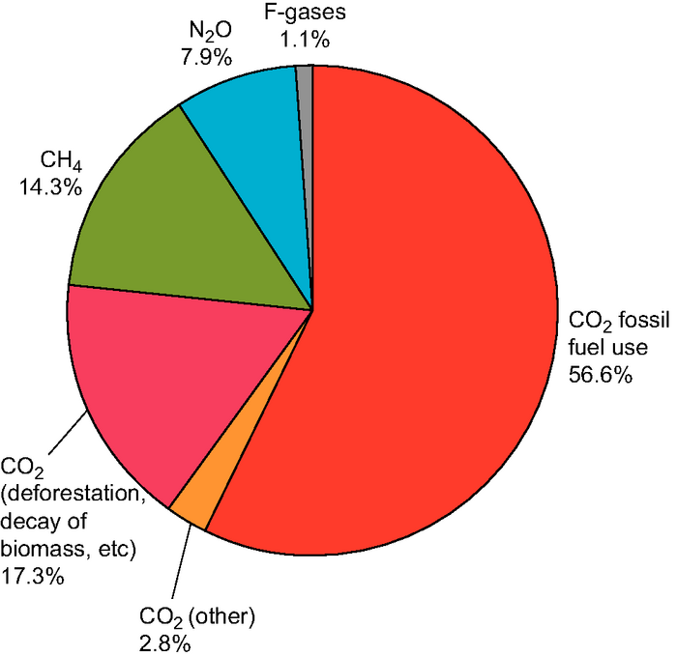

Figure 5: Source Apportionment of Global Greenhouse Gas Emissions – CO2 eq terms (IPCC c, 2007)

Modellers therefore need to be careful in tracking whether emission factors reflect tons of pollutant or tons CO2 equivalent of that pollutant. In the former case the different gases need to be converted to CO2 eq before being compared to a constraint or target. National targets themselves may only apply to CO2 emissions in which case the other gases need to be excluded from model constraints.

Consistency across sectors is also a potential pitfall. If the Electricity Supply sector is represented in the model and emissions from electricity production are accounted for in that module, they should not be double counted in the consuming sectors, Industry for example.

This discussion centres on greenhouse gases but if air quality is also a focus of a modelling study, the toxic emissions regulated in most countries are also often modelled. A detailed discussion is beyond the scope of this document but typically these will include the following:

* Oxides of Sulphur (SOX)
* Oxides of Nitrogen (NOX)
* Carbon Monoxide (CO)
* Non-Methane Volatile Organic Compounds (NMVOC)
* Particulate Matter (PM10 and PM2.5)

Depending on the level of detail of the assessment NMVOC’s may be further disaggregated by species, benzene for example, or by organic family for example polycyclic aromatic hydrocarbons (PAH’s) which are known carcinogens. Air quality is often a concern in studies that include road transport and detailed resources for emission factors of the above pollutants exist in the public domain for mobile sources, for instance the European Union’s COPERT model or the US EPA’s Mobile 6 model. Both of these sources are also referenced in the IPCC emission factor database.

In order to calculate total emissions in our model emission factor data needs to be collected along with the efficiency and activity data for each technology. Emissions factors can be expressed in a number of ways:

* Typically for stationary combustion on per unit energy basis (tons pollutant/TJ of fuel energy),
* Typically for production emissions on a per mass basis (tons pollutant/ ton of fuel),
* Typically for mobile combustion sources like cars or trucks it can be activity based (kg pollutant /km travelled).

Clearly for an energy model the most useful form is on a per unit energy basis because this is the common quantity for all sectors, technologies and services in the model and this keeps calculations simple. Activity based emissions for motor vehicles, for example, can be converted to a per energy basis in a pre-processing exercise using an assumed fuel economy.

A typical source of greenhouse gas emissions factors is the IPPC National GHG Guideline (IPCC a, 2006) which includes an exhaustive public database of emission factors for sectors and activities. In some cases these are disaggregated by country but predominantly these are default factors such as the following:

Table 2: Example of IPCC Emission Factors - Stationary Combustion of sub-Bituminous Coal by Energy Industries (kg/TJ on a net calorific basis)

|  |  |  |  |  |
| --- | --- | --- | --- | --- |
| **IPCC 2006 Source/Sink Category** | **Gas** | **Fuel 2006** | **Value** | **Unit** |
| 1.A.1 - Energy Industries | CARBON DIOXIDE | Sub-Bituminous Coal | 96100 | kg/TJ |
| 1.A.1 - Energy Industries | METHANE | Sub-Bituminous Coal | 1 | kg/TJ |
| 1.A.1 - Energy Industries | NITROUS OXIDE | Sub-Bituminous Coal | 1.5 | kg/TJ |

*Source: 2006 IPCC Guidelines for National Greenhouse Gas Inventories, Volume 2: Energy, Tables 1.4 and 2.2*

These have been extensively used in SATIM but the guiding principle of emissions inventories should be applied wherever possible.

*Local emission factors should be used wherever they are available from creditable sources*

This is particularly true for a fuel like coal for which the chemical composition and calorific value varies markedly by region. Measurements by Zhou, et al., 2009 for power stations in Southern Africa showed significant deviations from IPCC default emission factors, in the case of one plant, even falling outside the IPCC range of uncertainty. The CO2 results, while in some cases extreme, are not inconsistent with the high ash content and low carbon content of many coals used for power production in the region.

Table 3: Measured Emission Factors for Selected Southern African Power Plants Compared to IPCC Default Factors (Zhou, et al., 2009)

|  |  |  |  |  |  |  |  |
| --- | --- | --- | --- | --- | --- | --- | --- |
|  |  | **Measured** | | **IPCC Default Factors** | | **IPCC Uncertainty Range** | |
| **Country** | **Plant Name** | **CO2 (kg/GJ)** | **NOx (kg/TJ)** | **CO2 (kg/GJ)** | **NOx (kg/TJ)** | **CO2 (kg/GJ)** | **NOx (kg/TJ)** |
| South Africa | Kendal | 96.3 | 0.446 | 94.6 | 1.5 | 89.5-99.7 | (0.5-5) |
|  | Kendal (Repeat) | 97.4 | 0.21 | 94.6 | 1.5 | 89.5-99.8 | (0.5-5) |
|  | Lethabo | 99.6 | 0.583 | 94.6 | 1.5 | 89.5-99.7 | (0.5-5) |
|  | Arnot | 95.3 | 0.28 | 96.1 | 1.5 | 92.8-100 | (0.5-5) |
| Zimbabwe | Bulawayo | 97.5 | 0.07 | 94.6 | 1.5 | 89.5-99.7 | (0.5-5) |
| Botswana | Morupule | 103.0 | 0.32 | 96.1 | 1.5 | 92.8-100 | (0.5-5) |

While local emission factors should take precedence over a generalised source, this should not preclude a thorough assessment of their veracity. Before adopting the very high CO2 value for the Botswana plant or the very low NOx value for the Zimbabwean plant, for example, the data should be subjected, wherever possible, to a scrutiny of its repeatability and a review of the instrument quality, calibration procedures and certification. CO2 emissions should balance the carbon content and calorific value and these should have been repeatably determined for multiple samples.

# Industry Sector

The Industry Sector in South Africa accounted for 40% of final energy consumption in 2006 and is, in general, energy intensive, being dominated by heavy industries in the mining and metals refining sub-sectors. Mitigation actions designed around energy efficiency programs were identified in the LTMS to be amongst the potentially most cost effective ways to reduce emissions although the net reductions attainable were estimated to be significant but not large (Hughes, Haw, Winkler, Marquard, & Merven , 2007). This sector is therefore an important component of the SATIM model.

## Structural Assumptions & Modelling Decisions

Modelling the structure of the energy chain from fuel input through to energy services in the industry sector of any country will present a challenge because of the great diversity of activities and processes. Data collection is further complicated, relative to say the similarly complex but centrally regulated transport sector, by the large number of regulatory and industry bodies. The challenges and expense involved with detailed disaggregation of the Industry Sector has resulted in a fairly simple structural approach in the SATIM model which is discussed in more detail below.

SATIM is more disaggregated by sub-Sectors within the Industry Sector than the LTMS generation of the model as shown below and now disaggregates all the major energy consuming Industry sub-Sectors. The smaller sub-Sectors included in the national energy balance published by the Department of Energy (DOE) that are reported to contribute only a fraction of a percent to total consumption are however aggregated into the sub-Sector “Other” in SATIM as shown below.

Table 4: Disaggregation of the SATIM Model by Industry sub-Sector Compared to the National Energy Balance and LTMS Model

|  |  |  |  |
| --- | --- | --- | --- |
| **DOE3 Energy Balance** | **DOE Share of Total Consumption (2006)** | **SATIM1** | **LTMS** |
| Mining and Quarrying | 16.9% | Mining SIC2 | Gold Mining |
| Other Mining |
| Iron and Steel | 28.0% | Iron & Steel - 351 | Manufacturing |
| Chemical and Petrochemical | 13.3% | Chemicals -33 |
| Non-Ferrous Metals | 4.5% | Precious & Non-Ferrous metals - 352 |
| Non-Metallic Minerals | 4.8% | N.M.M Products -34 |
| Food and Tobacco2 | 0.3% | Food, Beverage & Tobacco - 30 |
| Paper Pulp and Print2 | 0.6% | Pulp & Paper Products -323 |
| Construction | 1.1% | Other |
| Machinery | 0.2% |
| Textile and Leather | 0.1% |
| Wood and Wood Products | 0.1% |
| Transport Equipment | 0.02% |
| Non-specified (Industry) | 30.2% |

*1: Numbers are Standard Industrial Classification (SIC) codes*

*2: These account for 5% and 7% of consumption in SATIM after revision of coal consumption data*

*3: DOE – Department of Energy, Republic of South Africa*

Similarly the disaggregation by energy source in SATIM accounts for 90% of energy consumption by the Industry Sector according to the Department of Energy (DOE) energy balance consumption as shown below. LPG and HFO (residual oil), although accounting for only a fraction of consumption in 2006, are included because they are boiler fuels and this allows the optimisation model some scope to select between fuels, given emissions constraints. Wood and Bagasse biomass are included in SATIM because, as discussed in Section 0 below, they represent a far greater share of consumption than indicated by the DOE energy balance.

Table 5: Disaggregation of the SATIM Model by Energy Source Compared to the National Energy Balance

|  |  |  |
| --- | --- | --- |
| **DOE Energy Balance** | **DOE Share of Total Consumption (2006)** | **SATIM** |
| Electricity | 39.15% | Electricity |
| Bituminous Coal | 38.54% | Coal |
| Gasworks Gas | 9.77% | Gas |
| Coke oven coke | 4.69% | Coke oven coke |
| Gas Diesel | 3.36% | Oil Diesel |
| Coking Coal | 1.93% |  |
| Blast Furnace Gas | 1.47% |  |
| Bitumen# | 0.68% |  |
| Lubricants# | 0.29% |  |
| Other Kerosene | 0.06% |  |
| Motor Gasoline | 0.05% |  |
| Residual Fuel | 0.02% | Oil HFO* |
| White Spirit | 0.0026% |  |
| LPG | 0.0004% | Oil LPG* |
| Paraffin Wax | 0.0002% |  |
| Renewables & Waste | - | Biomass Wood |
| Biomass Bagasse |

*\*: Included as boiler fuels for optimisation with emissions constraints*

*#: non-Energy*

In the SATIM model these energy sources supply the energy chain that meets the demand for useful energy services in each Industry sub-Sector. The services currently included are as follows:

Table 6: End Use Demands Modelled for the Industry Sector in SATIM and the Energy Source – Technology Chain to Supply Them

|  |  |  |
| --- | --- | --- |
| **Energy Source** | **Technology** | **Energy Service Demands** |
| Electricity | Elec Heating - Electricity | Elec Heating |
| Electricity | Compressed air - Electricity | Compressed air |
| Electricity | Lighting - Electricity | Lighting |
| Electricity | Cooling - Electricity | Cooling |
| Electricity | HVAC - Electricity | HVAC |
| Electricity | Pumping - Electricity | Pumping |
| Electricity | Fans - Electricity | Fans |
| Electricity | Other motive - Electricity | Other motive |
| Electricity | Electrochemical - Electricity | Electrochemical |
| Electricity | boiler/process heating - Electricity | boiler/process heating |
| Coal | boiler/process heating - Coal | boiler/process heating |
| Gas | boiler/process heating - Gas | boiler/process heating |
| HFO | boiler/process heating - HFO | boiler/process heating |
| LPG | boiler/process heating - LPG | boiler/process heating |
| Biomass Bagasse | boiler/process heating - Biomass Bagasse1 | boiler/process heating |
| Biomass Wood | boiler/process heating - Biomass Wood2 | boiler/process heating |
| Diesel | Transport – Diesel3 | Transport |

*Note: The energy service demands listed apply to all sub-Sectors except those where indicated otherwise*

*1: Food, Beverage & Tobacco sub-Sector only*

*2: Pulp & Paper Products sub-Sector only*

*3: Mining and Other sub-Sectors only*

The following assumptions apply to the model structure briefly described above:

* In the SATIM model of the Industry Sector there is no disaggregation of technologies using a particular fuel for a particular end use. All technology shares within a fuel and end-use are therefore 100% and the technology characteristics represent the average. This reflects the practical limits of local data and may be changed should better information be available.
* Currently, no capital, fixed or variable costs are loaded for these generic fuel specific technologies. Only the fuel cost will therefore contribute to costing the energy chain.
* All thermal fuels except diesel are used for high temperature process heat. SATIM also assumes that these thermal fuels are not used for transformation.
* Diesel is assumed to be consumed by the Mining and ‘Other’ (Construction) sub-sectors for transport / traction.
* Improvement in efficiency in industry is assumed to be slow and is only reflected in improved energy intensity in the exogenous demand calculation and not endogenously by more efficient end use technologies.
* Currently all sectors are modelled to experience electricity supply at national average distribution losses (10%). In general however large industries have their own substation supplied at the very highest distribution voltage so losses would be lower than is currently modelled in SATIM.

The first two of these structural assumptions would seem to render an optimisation model sterile and without scope for modelling mitigation actions because there is no competition between technologies to meet end-use demand, only fuel competition based on fuel price. There is however scope to add efficiency improvement programs to the model by loading them as dummy technologies, allocating a variable cost (or capital cost with a lifetime) that is calculated to give an appropriate payback period relative to the marginal cost of the fuel being saved. It is important to bear in mind that the model cost of electricity, being the marginal cost of supply calculated by the model, will likely be different to a real life tariff. Such dummy technologies were used for the LTMS which defined a number of industry efficiency ‘wedges’ in the mitigation scenarios. The modelling methodology is illustrated below.

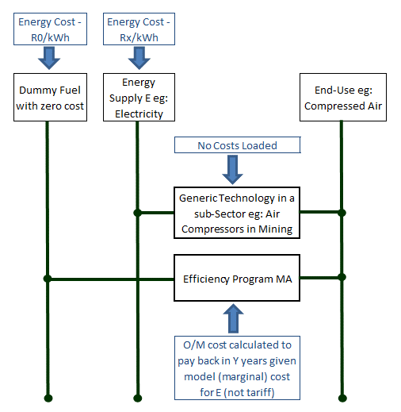

Figure 6: LTMS Methodology for including Efficiency Programs in an Optimisation Model of a Simplified Industry Sector with Aggregate Technologies having Unknown Costs

Clearly, the future penetration rate of the dummy Efficiency Program technology needs to be bounded to the maximum percentage energy saving that is estimated to be possible given the nature of the intervention.

An alternative to loading dummy technologies to reflect efficiency programs is to develop scenarios whereby future technology efficiencies improve relative to the base year. The profile of these improvements will usually be derived from a look-up table of projected net energy savings per end-use. The model does of course not select the efficiency measures endogenously in this case. Such a table would look much like the attainable efficiency gains table that came out of the LTMS stakeholder process shown below.

Table 7: Estimates of Attainable Overall Efficiency Improvements for Electricity End-Uses in the Industry Sector

|  |  |  |  |  |
| --- | --- | --- | --- | --- |
| **End-Use** | **2008** | **2015** | **2030** | **2050** |
| Boilers and steam systems | 0% | 10, 10% | 16, 16% | 20, 20% |
| Compressed air | 0% | 7.5, 7.5% | 16,16% | 20, 20% |
| Process heat | 0% | 3,-% | 4, -% | 5, -% |
| HVAC | 0% | 12, -% | 18, -% | 25, -% |
| HVAC with waste heat | 0% | 0% | 10% | 30% |
| Lighting | 0% | 30,10% | 70,10% | 75,10% |
| Other motive | 0% | 9% | 11% | 15% |
| Pumping, fans (process flow) | 0% | 10% | 25% | 40% |
| Process cooling | 0% | 5% | 7% | 10% |

***Note:*** *The table distinguishes between technological efficiency and systems savings. Technology efficiency improvements are listed first and comma separated from system efficiency improvements*

***Source:***(Winkler, H (ed.), 2007)

Future technology efficiencies can be estimated using the following equation for a scenario of energy efficiency improvement like those above that were developed for scenario assessment in the LTMS.

If:

ηi: Future Technology Efficiency in Year i

η0: Base Year Technology Efficiency

Si: Overall % Energy Savings Achieved by Year i

FEi: Final Energy required for an energy service in year i

Si = (FEi – FE0)/ FE0 **Equation 2**

ηi = η0/(1 - Si) Equation 3

## Compiling the Base Year Consumption Data - Assumptions and Issues

The data situation for the industry sector in South Africa can be summed up as good electricity consumption data to per sub-sector level for customers of the national electricity supply utility, ESKOM, but questionable aggregate data for other energy sources and non-existent or very out of date end-use data within sub-sectors. Municipal data is generally unavailable even at sector (eg: industry, commerce etc.) level. There is a lack of good studies on the Industry Sector in South Africa exacerbated by a general culture of secrecy enforced by confidentiality clauses that with some exceptions, keeps the information collected by industries for their own planning out of the public domain. The main sources for industrial data related to energy consumption and output are:

* ESKOM-Electricity sales by SIC CODE (2nd and 3rd level where needed),
* DOE Energy Balance - Industrial consumption by fuel type
* NERSA - Municipal electricity distributed to industry
* STATSSA -Physical output from industry [STATTSA 2002], Value added by industrial sectors [STATSSA,
* Industry Associations
* Annual reports
* Personal communication and internet searches

This means a bottom-up model can be fairly well calibrated for electricity but attributing consumption to end uses relies heavily on assumptions. For other energy sources the aggregate consumption data from the national energy balance is sometimes also problematic as can be seen from Table 8 below which contrasts the aggregate SATIM sub-sector consumptions with the official national energy balance and the IEA energy balance for the base year 2006. The compilers of the energy balance face the same challenges as modellers in collating data across the disparate activities in industry and gaps are possible where energy like biomass is not traded through a traceable retail structure by a small number of entities in the way that electricity is.

Table 8: Comparison of Estimates of the Aggregate Consumption of Fuels (PJ) for the SATIM, DOE and IEA Energy Balances for South Africa - 2006

|  |  |  |  |  |  |  |  |  |
| --- | --- | --- | --- | --- | --- | --- | --- | --- |
| **Fuel** | Coal | Electricity | Gas | Oil Diesel | Oil HFO | Oil LPG | Biomass Wood | Biomass Bagasse |
| **SATIM** | 536 | 429 | 105 | 36.0 | 0.17 | 0.004 | 41.2 | 10.0 |
| **DOE EB1** | 413 | 420 | 105 | 36.0 | 0.17 | 0.004 | 0.00 | 0.00 |
| **IEA2** | 328 | 408 | 94 | 35.6 | | | 72.39* | |

*\*Biofuels & Waste*

*1:* (DOE, 2009) *– South African Department of Energy*

*2:* (IEA, 2009)*– International Energy Agency*

Differences are notable for Wood, Bagasse and Coal consumption. The first of these is based on industry information that indicates that wood waste supplies a large portion of the energy needs of the Pulp and Paper Industry. South Africa has a large sugar industry and while bagasse is certainly an energy source in that industry, the SATIM bagasse consumption value is currently a rough order of magnitude estimate. The total biomass estimate is however in fair agreement with that of the IEA.

Coal used for process heating is however the dominant non-electricity source and therefore most of the effort in mitigating errors in base year consumption data has focussed on improving the data for coal use by industry. Unfortunately coal consumption data in South Africa is poor and alternative figures have generally been derived by means of inference and assumption. The assumptions of sub-sector coal use for the SATIM model rely heavily on the following:

* National statistics for expenditure flows between sub-sectors, called ‘Supply and Use’ tables published by Statistics South Africa (Stats SA). Because the prices which individual industries pay for coal is unknown, energy consumption estimites derived from the tables are done using the same coal price for all sectors and grades of coal.
* This data is supplemented with Annual reports to shareholders published by dominant firms in industries and a newly emerged corporate governance document, the so-called ‘Sustainability Report’.
* The resulting base year data is compared to historical estimates from publications and personal communications (confidential) from industry insiders to try and prevent any gross errors.

Thus, although the national energy balance attributes no coal consumption to the Pulp and Paper industry, the supply and use tables indicate that this industry spends a large amount of money on coal. The quantity can be estimated from that expenditure or from data in industry reports from the two large paper manufacturers, being Sappi and Mondi. Table 9 below shows how a sub-sector disaggregation of coal use has developed in contrast to the DOE’s national energy balance.

Table 9: Evolution of Sub-Sector Estimates of Coal Consumption for the Base Year (2006)

|  |  |  |
| --- | --- | --- |
| **Sub-Sector** | **DOE** | **SATIM** |
| Iron and steel | *117.4* | **125.4** |
| Chemical and Petrochemical | *50.8* | *50.8* |
| Non-Ferrous Metals | *0.0* | **0.8** |
| Non-Metallic Minerals | *20.3* | **54.0** |
| Food and Tobacco | 0.0 | **32.4** |
| Paper Pulp and Print | 0.0 | **64.8** |
| Other | *171.5* | **154.5** |
| Mining | *53.3* | 53.3 |
| Total | 413.3 | **536.0** |

*Note: Where LTMS and SATIM values agree with DOE (italics) the model was/ is calibrated to the DOE Energy Balance value for the base year without amendment. Alternative estimates derived from supply and use tables or other research are in bold*

To some extent these efforts to attribute coal to industry sub-sectors reflects the need to reallocate excess coal from other sectors where the energy balance consumption seems implausible, for instance in the Residential Sector. The total national consumption of coal is however fairly well known and the national energy balance can be considered reliable in this case. Thus the sum of coal consumption from all sectors in SATIM should balance this number. The SATIM bottom-up calculation of household coal use in the Residential Sector yielded a much lower number than the national energy balance and this difference has been balanced by the extra coal allocated to the Industry Sector in the SATIM model as shown below in **Table 10**.

Table 10: Sector Adjustments to Coal Consumption in the SATIM Model Relative to the National Energy Balance

|  |  |  |
| --- | --- | --- |
| **Balance** | **Industry Sector (PJ)** | **Residential Sector (PJ)** |
| National Energy Balance | 413.3 | 152.6 |
| SATIM Model | 536.0 | 26.8 |
| **Difference** | **122.7** | **-125.8** |

## Assumptions Characterising Technologies and Energy Services

There have been relatively few studies in South Africa which have looked at energy services within industry. The earliest notable study and to date the most complete is that of Bennett (Bennett, 1975). Whilst several sectors still rely on the same processes, due to continued process efficiency improvements, this study is out of date and therefore indicative at best. Other than these, there are isolated examples related to energy services, for example process heating in the food and beverage industry. These studies were used along with international data related to energy services. The best source of international end use data was found on the US EIA website (EIA,1998).

The approach taken was to supplement the South African data available from local studies with international benchmarks and personal opinions where no other data was available. Table 11 below shows the assumed percentage of electricity attributed to each energy service.

Table 11: Assumed Share of Electricity Consumption by Energy Services within Industry Sub-Sectors

|  |  |  |  |  |  |  |  |  |
| --- | --- | --- | --- | --- | --- | --- | --- | --- |
| **Energy Service Fractional Shares by Sub-sector** | **Mining** | **Iron & Steel** | **Chemi-cals** | **Precious & Non-Ferrous metals** | **N.M.M Products** | **Food, Beverage & Tobacco** | **Pulp & Paper Products** | **Other** |
| Elec Heating | 2.0% | 40.0% | 2.0% | 1.0% | 23.0% | 7.0% | 2.0% | 9.7% |
| Compressed air | 18.6% | 5.0% | 15.0% | 0.0% | 13.0% | 4.0% | 35.0% | 10.9% |
| Lighting | 4.5% | 3.5% | 4.0% | 1.0% | 5.0% | 5.0% | 10.0% | 8.1% |
| Cooling | 8.1% | 1.0% | 5.0% | 0.0% | 0.0% | 23.0% | 0.0% | 5.1% |
| HVAC | 8.0% | 2.0% | 2.0% | 1.0% | 2.0% | 6.0% | 4.0% | 8.5% |
| Pumping | 17.9% | 2.5% | 35.0% | 0.0% | 8.5% | 28.0% | 35.0% | 13.0% |
| Fans | 6.9% | 4.5% | 8.0% | 0.0% | 9.0% | 4.0% | 0.0% | 5.5% |
| Other motive | 33.8% | 41.5% | 20.0% | 7.0% | 39.5% | 21.0% | 14.0% | 36.9% |
| Electrochemical | 0.2% | 0.0% | 8.0% | 90.0% | 0.0% | 0.0% | 0.0% | 1.3% |
| Boiler/process heating | 0.0% | 0.0% | 1.0% | 0.0% | 0.0% | 2.0% | 0.0% | 1.0% |
| **Total** | **100%** | **100%** | **100%** | **100%** | **100%** | **100%** | **100%** | **100%** |

The efficiencies of energy services were estimated to be as follows:

Table 12: Assumed Efficiency of Technologies in Industry Sector

|  |  |
| --- | --- |
| **Technology** | **Efficiency** |
| Elec Heating - Electricity | 100% |
| Compressed air - Electricity | 5% |
| Lighting - Electricity | 30% |
| Cooling - Electricity | 200% |
| HVAC - Electricity | 90% |
| Pumping - Electricity | 80% |
| Fans - Electricity | 80% |
| Other motive - Electricity | 80% |
| Electrochemical - Electricity | 76% |
| boiler/process heating - Electricity | 76% |
| boiler/process heating - Coal | 64% |
| boiler/process heating - Gas | 72% |
| boiler/process heating - HFO | 68% |
| boiler/process heating - LPG | 72% |
| boiler/process heating - Biomass Bagasse | 60% |
| boiler/process heating - Biomass Wood | 60% |

Currently SATIM does not introduce new technologies in the future for the Industry Sector and for the reference case efficiencies are assumed to stay constant. The model can only select between technologies for boiler/process heating and so upper and lower bounds to prevent improbable rates of penetration have been defined for these technologies only.

## Validation of the Sector Model

The end use data and assumptions in SATIM for all sectors, including the Industry Sector are calibrated to the aggregate consumption data from the energy balance or an adjustment of that figure. This is the primary validation of any bottom-up model.

For the industry sector an additional check is performed at sub-sector level for electricity consumption whereby electrical energy intensity is calculated for an extended period. Electricity intensity is calculated by dividing the physical output of goods produced by a sub-sector as reported by Stats SA by an estimate of electrical energy consumed based on ESKOM and municipality sales data. The objective is to check that energy intensity for each sub-Sector is sensible and continuous. As can be seen from Figure 7 below energy intensity for most sub-Sectors apparently decreased gradually or was stable until 2006 and then rose, rapidly in the case of Iron & Steel, till 2009.



Figure 7: Indexed Intensity of Electricity Consumption for Industry sub-Sectors 1998 – 2009

The rapid rise in energy intensity between 2006 and 2009 relates to the rapid drop in production in response to the effects of the credit crunch which affected Iron & Steel most severely as shown by Figure 8 below. Energy intensity tends to correlate with output because a drop in production equates to plant running at low capacity factor which tends to be inefficient.



Figure 8: Indexed Physical Output for Industry sub-Sectors 1998 – 2009

## Future Demand for Energy from the Industry Sector

The projection of demand for the industry sector in SATIM relies on three inputs:

* Analysis of the projections for year on year GDP growth for industry sub-sectors output from a Computable General Equilibrium (CGE) model. These results were made available by a collaborating research group, the University of WIDER in Finland. This CGE model for South Africa was developed to study the economic implications of introducing carbon taxes in South Africa for the purpose of greenhouse gas emissions mitigation (Alton, et al., 2012).
* The relationship between GDP projections for the sector and sectoral output where physical quantitiy is used as the unit for energy intensity.
* Estimates of historical energy intensity of industry sub-sectors in terms of either value added or physical quantity of product depending on the sub-sector.

The future demand for energy services in the industry sector is then computed in the following steps:

1. The growth in activity (Rands of output per year) in each subsector is projected using the economic CGE model, with sectors aggregated to match those in the energy model. Activity growth is recorded either as value add in the sector or physical output.
2. The intensity ( energy/rand of output or energy/physical unit of production) of each sector is projected by extrapolating historical observations.
3. Final energy is calculated by multiplying the intensity in each sector by the output of the sector over time, final energy is attributed to end uses using the estimates in Table 11
4. Useful energy demand is calculated for each end use in the sub-sectors by multiplying the final energy calculated by the assumed efficiency of electrical and thermal consumption.

Add Tamaryn’s sectors here

# Agriculture Sector

Although relatively small in monetary and energy terms, the agricultural sector plays an important role in the South African economy. Primary agriculture was estimated by the Department of Energy (DOE) to account for 2.6% of Total Final Consumption (TFC) of Energy in 2006 (DOE, 2009) which closely mirrors the 2.4% contribution of the sector to gross domestic product (GDP) in that year (Stats SA, 2012). Energy emissions from the sector were estimated to contribute less than 1% to total greenhouse gas emissions in 2000 (Mwakasonda, 2009) but when other agricultural sources of GHG emissions like enteric fermentation, biomass burning and N2O emissions from managed soils are considered, this share of total emissions approaches a more significant 6%.

South Africa has a total land area of 122 million hectares, of which 82 % (100 million hectares) is farmland. Farmland is primarily used for livestock rearing and crop production. South Africa’s land resource with sufficient rainfall to be considered arable is estimated to be 14 percent of farmland (14 million ha). Dry land farming is practised on 11.2 million ha with only 1.2 million ha under irrigation. The latter area nonetheless produces 25 to 30% of the country’s agricultural output (Gbetibouo & Ringler, 2008). The implication is that a growing population may drive significant growth in energy consumption by irrigation.

## Model Structure

Five energy services have been identified in agriculture for analysis purposes (Winkler, H et al, 2006):

* Traction
* Irrigation
* Heating
* Processing and
* ‘Other’ purposes such as lighting and cooling

Given the relatively small contribution to TFC of the Agriculture Sector, this module of the SATIM model is kept quite simple, and the whole energy chain of the model can be represented by the Reference Energy System (RES) diagram shown below.

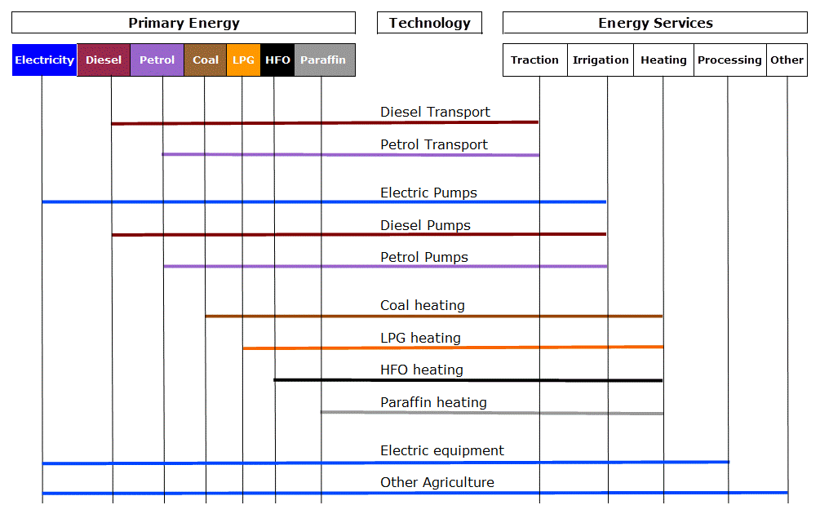

Figure 9: RES Diagram Showing the Structure of the Agriculture Sector as Represented in the SATIM Model

## Compiling the Base Year Consumption Data - Assumptions and Issues

Diesel is the most important energy source in the agricultural sector and accounts for more than half of the energy consumed, or just over 38 PJ in 2006. Diesel is primarily used to fuel vehicles such tractors and combine harvesters. Electricity is also a significant source of energy in the agricultural sector, accounting for 30% of the energy consumed by the agricultural sector in 2006. Motor gasoline, other kerosene, heavy fuel oils and coal account for the remaining energy consumed.

Figure 10: Energy Source Shares of Agricultural Energy Consumption (DOE Energy Balance, 2006)

Comparison of historical statistics has shown good agreement between the DOE electricity consumption estimate and ESKOM’s sales data. Likewise thermal fuels estimates show good historical agreement with the sectoral estimates of the South African Petroleum Industry Association (SAPIA). At this time therefore the DOE energy balance is assumed correct and the data applied directly in SATIM. As can be seen from Table 13 below, the energy consumption disaggregated by energy source in SATIM agrees closely with the national energy balance for the base year 2006, omitting only non-energy sources and accounting for 98.5% of agricultural total final consumption.

Table 13: Comparison of Energy Consumption by Source (PJ) for SATIM and the DOE Energy Balance for South Africa - 2006

|  |  |  |
| --- | --- | --- |
| **Energy Source** | **DOE EB (PJ)** | **SATIM (PJ)** |
| **Oil Diesel** | 38.23 | 38.23 |
| **Electricity** | 21.03 | 21.03 |
| **Oil Gasoline** | 4.96 | 4.96 |
| **Oil Paraffin** | 2.51 | 2.51 |
| **Oil HFO** | 1.76 | 1.76 |
| **Coal** | 0.76 | 0.76 |
| **Oil LPG** | 0.001 | 0.001 |
| **Lubricants** | 0.85 | - |
| **White Spirit** | 0.19 | - |
| **Total** | **70.28** | **69.25** |

## Assumptions Characterising Technologies and Energy Services

The study supporting the 2003 South African Integrated Energy Plan (IEP) (Howells, Kenny, & Solomon, 2002) modelled energy services by sector for input to a MARKAL model, a predecessor of the current SATIM model. This study derived the following breakdown of electricity use by the agriculture sector using relatively disaggregate energy services similar in detail to the industrial sector.



Figure 11: IEP Assumed Useful Agricultural Energy Consumption Disaggregated by Energy Service Demands (Howells, Kenny, & Solomon, 2002)

The table below shows the percentage share of each energy service of useful electrical energy consumption for the base year 2001.

Table 14: IEP Assumed Share by Energy Services of Useful Agricultural Electrical Energy Consumption

|  |  |
| --- | --- |
| Pumping | 29.0% |
| Process | 10.0% |
| Other Motive | 3.2% |
| Materials Handling | 16.0% |
| Lighting | 4.1% |
| Homes & Hostels | 20.4% |
| HVAC | 6.4% |
| Fans | 1.5% |
| Cooling | 9.5% |

The later LTMS model simplified the number of energy services, presumably because of the lack of data and studies, aggregating the above as follows:

* Electrical, Diesel and Gasoline Powered ‘Pumping’ became ‘Irrigation’ retaining the assumption from the IEP that Irrigation Final Energy Share is 76% Electricity, 12% Diesel and 12% Gasoline which translates to a useful energy share of 91% Electricity, 5% Diesel and 4% Gasoline based on efficiencies of 95% for electrical pumping, 35% for diesel pumping and 25% for gasoline pumping.
* ‘Process’ and ‘Materials Handling’ were aggregated into ‘Processing’
* All remaining IEP electrical energy services were aggregated into ‘Other’

This yielded the following share of energy services for the agricultural analysis base year of 2001 with diesel and gasoline not used in ‘Irrigation’ attributed to ‘Tractors, harvesters & transport’ and all other use of petroleum products in the energy balance assumed to be used in heating.

Table 15: LTMS Assumed Breakdown of Agricultural Total Final Consumption by Energy Service for 2001

|  |  |  |
| --- | --- | --- |
| **Energy Service** | **Share of Final Energy** | **Share of Useful Energy** |
| Irrigation | 11.5%1 | 16.2% |
| Tractors, harvesters and transport | 59.5% | 36.6% |
| Processing | 7.8%2 | 13.9% |
| Heat | 7.7% | 9.4% |
| Other | 13.5%3 | 24.0% |
| Total | 100.0% | 100% |

*1: Calculated as (29% X Agricultural Electricity TFC) + 12% Diesel Share + 12% Gasoline Share*

*2: Calculated as [16%+10%] X Agricultural Electricity TFC*

*3: Calculated as (1-[29%+16%+10%]) X Agricultural Electricity TFC*

The 2003 IEP assumptions of the share of energy services of total electrical energy consumption have therefore essentially been retained. The only major change to the LTMS approach to the agriculture sector is in the split of final energy allocated to ‘Irrigation’ by energy supply as shown below. This reflects the electrification of rural areas and the increasing dominance of large industrialised commercial farms such that diesel or petroleum powered pumping for irrigation is almost negligible.

Table 16: Evolution of Assumptions of Energy Supply Share of Irrigation Final Energy by Energy Services

|  |  |  |  |
| --- | --- | --- | --- |
| **Fuel** | **IEP (2002)** | **LTMS (2007)** | **SATIM (2011)** |
| **Irrigation\Elec** | 76% | 76% | 95% |
| **Irrigation\Diesel** | 12% | 12% | 4% |
| **Irrigation\Petrol** | 12% | 12% | 1% |

The energy service shares of final energy for SATIM are determined by the following steps for the base year 2006, assuming the 2006 DOE energy balance data to be correct.

* All thermal fuels other than diesel and petrol are allocated to ‘Heat’. This yields a share of TFC of 7.3% rather than the 7.7% in Table 15 so the other shares are adjusted slightly up.
* This adjustment yields an irrigation share of TFC of 11.5% which is then split by energy supply using the assumptions in Table 16.
* All remaining diesel and gasoline in the energy balance is assumed to be used in Traction and Transport.
* All ‘Processing’ is assumed to be supplied by electricity and is calculated using the adjusted share in Table 15. As we have seen this rests on the assumption that ‘Process’ is 26% of Electricity TFC as per the IEP, the sum of 10% 'Process' and 16% 'Materials Handling'.
* All 'Other' energy services are assumed to be supplied by electricity. This would be lighting, fans, cooling etc. As we have seen this rests on the assumption that ‘Other’ is 45% of Electricity TFC as per an aggregation of energy services assumed in the IEP.

This yields the following breakdown of agricultural TFC by energy supply and energy service:

Table 17: SATIM Assumed Energy Service Shares of Agriculture Sector TFC by Energy Supply

|  |  |  |  |  |  |  |  |
| --- | --- | --- | --- | --- | --- | --- | --- |
| **Energy Service** | **Coal** | **Oil Diesel** | **Elec-tricity** | **Oil Gasoline** | **Oil HFO** | **Oil Paraffin** | **Oil LPG** |
| **Heating** | 100.0% |  |  |  | 100.0% | 100.0% | 100.0% |
| **Processing** |  |  | 26.1% |  |  |  |  |
| **Traction** |  | 99.2% |  | 98.4% |  |  |  |
| **Irrigation** |  | 0.8% | 36.1% | 1.6% |  |  |  |
| **Other** |  |  | 37.8% |  |  |  |  |
| **SUM** | 100.0% | 100.0% | 100.0% | 100.0% | 100.0% | 100.0% | 100.0% |

The following efficiencies are assumed in converting final to useful energy for agricultural energy services in the SATIM model.

Table 18: Assumed Agricultural Energy Service Efficiencies in the SATIM Model

|  |  |  |
| --- | --- | --- |
| **Energy Service** | **Energy Supply** | **Efficiency** |
| Heating | Coal | 65% |
| Oil HFO | 70% |
| Oil Paraffin | 70% |
| Electricity | 75% |
| Processing | Electricity | 100%1 |
| Traction | Oil Diesel | 35% |
| Electricity | 95% |
| Oil Gasoline | 25% |
| Irrigation | Oil Diesel | 35% |
| Electricity | 95% |
| Oil Gasoline | 25% |
| Other | Electricity | 100%1 |

1: These aggregate energy services are treated as abstract with an efficiency of 100%

## Future Demand for Energy from the Agricultural Sector

Although the balance has steadily swung in favour of imports over the last 50 years, South Africa is still reported to be a net food exporter (SAIRR, 2012) (FAO, 2011), exporting 30 – 47% more food than it imported in 2006/2007 (FAO, 2011). Given therefore that not all production is consumed locally, Value Added (GDP) is used as the driver for energy demand in the agricultural sector.

In the LTMS, assumptions were made as to the future change in energy intensity of services in the Agricultural Sector as follows:

Table 19: Assumptions of Change in Agricultural Energy Intensity for the LTMS

|  |  |  |  |  |
| --- | --- | --- | --- | --- |
|  |  | **Intensity [GJ/2003 Rands]** | | |
| **Energy Service** | **Reduction factor** | **2001** | **2020** | **2030** |
| Irrigation | 0.5% | 0.201 | 0.220 | 0.232 |
| Traction | -0.5% | 0.453 | 0.412 | 0.392 |
| Processing | -0.5% | 0.172 | 0.156 | 0.149 |
| Heat | -1.0% | 0.117 | 0.096 | 0.087 |
| Other | 0.5% | 0.298 | 0.328 | 0.344 |

In SATIM however, until such time as better data can be acquired on which to base these assumptions, energy intensity has been assumed constant over the projection period and the elasticity of energy demand with respect to value added has been set to 1. In SATIM currently therefore, agricultural energy demand is assumed to grow directly proportional to GDP. In South Africa’s case where the Agriculture Sector accounts for less than 3% of total final energy consumption, this is unlikely to be a major source of error. In other economies, especially those where agriculture is a dominant contributor to the economy, energy intensity and elasticity would have to be more precisely determined.

The growth in Value Added for the Agricultural Sector is derived from the output of the E-SAGE Computable General Equilibrium (CGE) model which includes projections for GDP by sector from 2010 to 2030 (Arndt, Davies, & Thurlow, 2011). This projects Agricultural GDP growth of around 3.5% annualised and is generally lower than most other sectors and sub-sectors over the projection period.

# Commercial Sector

The following description of the modelling of the Commercial Sector in SATIM draws heavily on the equivalent section of the Low Emissions Pathways Technical Report (Energy Research Centre, 2011)

## Model Structure

In SATIM the commercial sector includes all non-residential buildings, excluding buildings used for industrial and agricultural activities. The sector is further divided into three building activities based on Statistics South Africa building data categories (StatsSA, 2010a). Each building activity was linked to the Statistics South Africa economic data categories (Stats SA, 2010b). The percentage share of floor area for each building activity in 2006 was based on buildings completed between 1993 and 2006 (Table 20).

Table 20: Commercial building categories used in 2006 study compared with previous LTMS assumptions

|  |  |  |  |
| --- | --- | --- | --- |
| **Building activity** | **Economic sector** | **Percentage share of floor area 2001** | **Percentage share of floor area 2006** |
| Shopping space | Wholesale, retail, motor trade and accommodation | 37% | 36% |
| Office and banking space | Finance, real estate and business services | 30% | 39% |
| Other non-residential space | Personal services | 33% | 24% |

Note: The building categories of 'industrial & warehouse' and 'additions and alterations' were excluded as they could not be disaggregated by sector.

## Compiling the Base Year Consumption Data - Assumptions and Issues

Aside from minor differences for electricity, paraffin and LPG, the aggregate consumptions by fuel assumed for the Commercial Sector in SATIM have been sourced from the DOE Energy Balance for 2006 as shown below.

Table 21: Comparison of Estimates of the Aggregate Consumption of Fuels (PJ) by the Commercial Sector for the SATIM Model and the DOE Energy Balance for South Africa - 2006

|  |  |  |  |  |  |  |  |  |
| --- | --- | --- | --- | --- | --- | --- | --- | --- |
| **Fuel** | **Coal** | **Oil Diesel** | **Elec-tricity** | **Gas** | **Oil Gasoline** | **Oil HFO** | **Oil Paraffin** | **Oil LPG** |
| SATIM | 76.30 | 1.74 | 114.66 | 0.86 | 0.24 | 17.77 | 1.33 | 2.22 |
| DOE EB | 76.30 | 1.74 | 103.80 | 0.86 | 0.24 | 17.77 | 1.01 | 0.00 |

The electricity discrepancy arises from the redistribution of the ‘General/Unspecified’ share (35.2 PJ or 5%) of sales in 2006 as reported by the National Regulator (NERSA, 2006) between the Industry, Commercial and Residential sectors. The Paraffin and LPG differences are a reallocation of some of the Residential Sector share of these fuels in the national energy balance of 99.96% and 84% respectively. The energy balance allocates no LPG to the Commercial Sector but it’s used as a cooking fuel in hospitality, catering and restaurant businesses.

## Assumptions Characterising Technologies and Energy Services

The most recent published data found on Commercial Sector energy consumption by energy service in South Africa was a greenhouse gas mitigation study for the sector also referenced by the LTMS (de Villiers, 2000). Calculating weighted values of end-use energy consumption for each building activity and fuel gave an estimate of energy consumed by each end use for each fuel. Since then the percentage share of floor area of each building activity has been updated (Stats SA, 2010a). This required reducing the number of building activities considered in the previous LTMS from eight to three major groups (Table 20).

The USA commercial buildings energy consumption survey table E6A (CBECS, 2003) provided electricity energy use intensities that related to the Stats SA economic sectors of 'office and banking space' and 'shopping space'. For 'other non-residential space' the average electricity energy intensity for all types of buildings located in the climate zone most similar to South Africa from CBECS table E6A was used. The weighted electricity energy-intensity by end use from these three categories was then calculated.

The share of non-electricity energy carriers consumed by commercial end uses was based on information from the annual survey of registered industrial and commercial fuel burning appliances undertaken by the City of Cape Town air quality department in 2007 and so may not be representative of the national building stock (CCT, 2007). The end use shares shown below were estimated by reviewing the comments in the database relating to energy consumption and considering the activities being undertaken within the buildings. The contribution of different energy carriers to delivering space heating and hot water were obtained from the LTMS as it was not possible to determine the split from the available data.

Table 22: Estimated Energy Carrier Share of Energy Consumption by End Use and Fuel

|  |  |  |  |  |  |  |  |
| --- | --- | --- | --- | --- | --- | --- | --- |
|  | **Lighting** | **Space heating** | **Water heating** | **Cooling & ventilation** | **Refrigeration** | **Cooking** | **Other** |
| Electricity | 40% | 5.82% | 2.18% | 30% | 7% |  | 14% |
| LPG |  |  | 100% |  |  |  |  |
| Paraffin |  |  |  |  |  | 100% |  |
| Coal |  | 54% | 46% |  |  |  |  |
| Residual oil |  | 0% |  |  |  |  | 100% |
| Town gas |  | 0% |  |  |  |  | 100% |

The figure below compares the energy consumption by end use for the base year of 2001 from the previous LTMS study with the estimated energy consumption by end use for the base year of 2006.

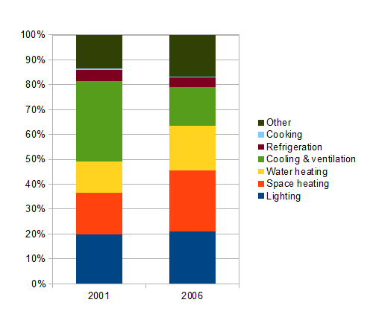

Figure 12: Comparison of energy consumption by end use for 2001 with updated base year of 2006

## Future Demand for Energy from the Commercial Sector

The energy demand in the commercial sector is based on the floor space for a given commercial activity. The increase in energy demand is modelled on increasing floor space area relative to the base year. Floor space projections are generated using an elasticity derived from a regression of floor area against GDP between 1993 and 2006. The projection of Commercial Sector GDP in SATIM is based on the same CGE model output as is used for the Industry Sector as described above.

The future demand for energy services in the commercial sector is computed in the following steps:

1. The growth of the tertiary sector (Communications, Financial Services, Business Services sub-sectors etc. aggregated) is projected by means of an economic CGE model.
2. The total floor space is projected by using an elasticity of 0.64, derived from observed historical data, to relate floor area to the tertiary sector growths using the following equation:

FAi =FAi-1*(1+elasticity*(GDPIi/GDPIi-1-1)) **Equation 4**

Where:

FAi = Floor Area in year i

GDPIi = Indexed GDP of tertiary Commercial Sector in year i

elasticity = %change in floor area / % change in indexed GDP as indicated by historical data

1. The floor space is split into two classes, and an estimate of the share of each class is estimated over the study horizon:

* Old building code (2006: 95% dropping to 2030: 50%)
* New building code (2006: 5% rising to 2030: 50%)

1. For the floor space using “old building codes”, the useful energy intensity for each end-use is set at the calibrated useful energy intensities (correcting for the 5% new buildings).
2. For the floor space using “new building codes”, the useful energy intensity is set 20% lower than the “old building code” from 2010 onwards. Energy intensity for new building codes is at this time assumed to remain at this level for the model horizon (typically to 2050).
3. The useful energy is then projected by multiplying the intensity by the floor area for the two building code classes and then summing them up for each year in the projection.

The elasticity of 0.64 is currently under review due to the small number of data points used to determine it. The 20% efficiency gain of new buildings is also under review and remains a fairly speculative assumption at this time. Error is both these assumptions can result in future energy demand being significantly under or over projected.

# Transport Sector

The energy consumption of the transport sector in South Africa is large, totaling around ~30% of total final consumption (TFC) in the national energy balances. The bulk of this energy demand (97%) is in the form of liquid fuels, and this transport sector share of liquid fuels is 84% of the national liquid fuel demand (DoE, 2014; IEA, 2011). The evolution of transport demand, both in terms of its magnitude and form (carrier) is very uncertain and has large implications for infrastructure requirements.

This has led to the transport sector, along with the electricity supply sector, being modelled in relative detail compared to other sectors. Funding for research on this sector has also driven development of this part of the SATIM model and its detailed documentation so the structure and assumptions for the transport sector described below undertake a higher level of detail and rigour than the other sectors.

## Model Structure

The Transport Sector input data of the SATIM model disaggregates road vehicles by basic vehicle type and fuel type but does not at this stage disaggregate by technical specifications like engine size or emissions regulation compliance level. While disaggregation by engine size for instance can be useful, this level of detail would create problems in a cost optimised model because typically the choice of larger more expensive cars by the consumer is not cost based, or at best only partially so, and bounds on penetration would have to be carefully constructed to produce realistic results. Rail is disaggregated by its broad energy services but inter-city passenger rail has not yet been included as there is no data in the public domain. At this stage pipeline freight, passenger and freight aviation and navigation fuelled by heavy fuel oil (HFO) are combined in one sub-Sector called ‘Other’ and are represented by generic fuel based technologies without efficiency and cost detail.

In order to meet future demand for future transport sector demand for passenger and freight transport energy services, the SATIM model has new technologies available in addition to the existing stock (Table 23).

**Table 23: Transport Sector Technologies in SATIM (Refer to** Table 24 **for base year vehicle typology)**

|  |  |  |  |  |  |  |  |  |  |  |  |  |  |  |  |  |  |  |  |
| --- | --- | --- | --- | --- | --- | --- | --- | --- | --- | --- | --- | --- | --- | --- | --- | --- | --- | --- | --- |
| Fuel/ Technology | Freight Road | | | | | Freight Rail | | | Passenger Private Road | | | Passenger Public Road | | | Passenger Rail | | Other | | |
| LCV | HCV1 | HCV2–3 | HCV4–5 | HCV6–9 | Corridor | Export (Bulk Mining) | Other | Car | SUV | Motor-cycle | Minibus | Bus | BRT(1) | Metro(2) | High‐ Speed Metro | Aviation | Pipeline | Other |
| Gasoline/ ICE* | • | • |  |  |  |  |  |  | • | • | • | • |  |  |  |  |  |  |  |
| Diesel/ICE | • | • | • | • | • | • | • | • | • | • |  | • | • | • | • | • |  |  |  |
| Gasoline/ Hybrid-ICE | • |  |  |  |  |  |  |  | • | • |  |  |  |  |  |  |  |  |  |
| Diesel/ Hybrid-ICE | • |  |  |  |  |  |  |  | • | • |  | • |  |  |  |  |  |  |  |
| Natural Gas/ICE | • | • | • | • | • |  |  |  | • | • |  | • | • | • |  |  |  |  |  |
| Blended Bioethanol- Gasoline (E85)/ICE |  |  |  |  |  |  |  |  | • | • |  | • | • | • |  |  |  |  |  |
| Electricity# | • | • | • |  |  | • | • | • | • | • | • | • | • | • | • | • |  | • |  |
| Hydrogen/ Fuel-Cell |  |  | • | • | • |  |  |  | • | • |  | • | • | • |  |  |  |  |  |
| HFO(3) |  |  |  |  |  |  |  |  |  |  |  |  |  |  |  |  |  |  | • |
| Jet Fuel |  |  |  |  |  |  |  |  |  |  |  |  |  |  |  |  | • |  |  |
| Aviation Gasoline |  |  |  |  |  |  |  |  |  |  |  |  |  |  |  |  | • |  |  |

*(1): BRT: Bus Rapid Transport; (2): Metro: Metropolitan i.e. intra‐city; (3): Used for Coastal & Inland Navigation*

*\* Internal Combustion Engine; #: Battery Electric for Road Vehicles; HCV1: Medium commercial vehicle of 3 000–7 500kg GVM; HCV 2: Heavy commercial vehicle of 7 501–12 000 kg GVM; HCV 6: Heavy commercial vehicle of 24 001–32 000 kg GVM. SUV: Sport Utility Vehicle (usually 4X4 and >1ton in mass)*

Externally funded projects since the LTMS have led to a great deal of refinement in road transport modelling in SATIM. Much have of this effort has gone into the development of sub-models that estimate the base data and exogenous demand for input into SATIM. The functions of these sub-models and their platforms are summarised below in Figure 13. The Vehicle Parc Model, Time-budget model, freight demand model and road transport portion of the passenger demand model are further described in their respective sections below.



Figure 13: Generalised System of pre-Processing Transport Sector Inputs for SATIM using sub-Models

## Sub-Model for Profiling Base Year Technologies – The Vehicle Parc Model

A vehicle parc model, calibrated over seven model years from 2003 to 2009, was developed to provide a comprehensive picture of the baseline vehicle parc, the disaggregation of vehicle classes and technologies and the activity level of those classes and technologies.

The Analytica software platform was selected for developing the model as it lends itself to a systems approach, catering for feedback relationships between system elements and both deterministic and stochastic outputs from elements. A graphical interface allows the system elements to be set out in a comprehensible network and thus adding new system elements to an existing model is easier than in, say a spreadsheet, because in Analytica it only requires a simple addition to the model framework. Some of the advantages of a spreadsheet are retained in that data tables, for instance of base year vehicle category fuel economy, can be quickly entered or accessed from the system diagram as shown in Figure 3.



Figure 14: System diagram and data table features of analytical platform

Fuel demand was calculated by multiplying the kilometers travelled, the vehicle technology fuel efficiency and the number of vehicles in the vehicle technology segment as shown in the equation below. The technology segment fuel demands were summed to yield the vehicle parc demand and compared to historical fuel sales for calibration purposes.

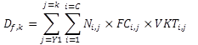 **Equation 5**

Df,k  = Demand for fuel f in year k

Ni,j  = The number of vehicles in technology segment i with model year j (Y1 being the first model year), where technologies numbered 1 to C all use fuel f.

FCi,j  = Estimated fuel consumption for technology segment i with model year j

VKTi,j  = Vehicle kilometres travelled per vehicle in technology segment i with model year j

The fuel demand calculation and model calibration process therefore required a number of assumptions to populate the three variables in Equation 1, N the number of vehicles, VKT, their mileage and FC their fuel economy:

1. A vintage profile derived from realistic scrapping curves that enabled vehicle stock to be estimated from historical vehicles sales disaggregated by vehicle type. The curves were calibrated so that the stock estimate closely matched a vehicle registration database.
2. An assessment of annual vehicle mileage for each vehicle class and the rate at which this decays as the vehicle ages.
3. Estimates of the fuel economy of each vehicle class and how this will change over time.

**Calibration**

The fuel demand was calibrated to match the known fuel sales data by first iterating till approximate agreement by means of scaling the kilometres travelled per vehicle and then fine tuning with adjustments to the fuel economy assumptions. The calibration procedure was broadly as follows:

1. Historic vehicle sales data (Lightstone Auto, 2015) were adjusted by scrapping curves to

develop an estimate of the stock of vehicles of different vehicle types for each model year which

was calibrated to the eNaTiS registration database by adjusting the rate of scrapping.

2. Vehicle mileage estimates were developed for both passenger and freight vehicles, assuming

that the annual mileage travelled by vehicles decays from an initial value as they age.

International literature informed this rate of decay.

3. Fuel demand was calculated by multiplying the kilometres travelled, the vehicle technology fuel economy and the number of vehicles in the vehicle technology segment. The technology

segment fuel demands were summed to yield the vehicle parc fuel demand for petrol and

diesel and compared to aggregate fuel sales data.

4. An additional step for freight vehicles involved adjusting the average maximum load, load factor and mileage so that the model not only calibrated against fuel sales but also against the

published tkm road freight demand (Havenga J. , Simpson, de Bod, & Braun, 2016a).

A schematic representation of the previous and current vehicle parc model and its data inputs

and validations is shown in Figure 15.

A schematic representation of the vehicle parc model and its data inputs and validations is shown in Figure 15 with a key to the data inputs in Table 23.



Figure 15: Schematic representation of the vehicle parc model and its data inputs and validations

Table 23: Key Data Inputs to the Vehicle Parc Model

|  |  |  |
| --- | --- | --- |
| NAAMSA | National Association of Automobile Manufacturers of South Africa | Industry association that collates detailed vehicle sales data |
| eNatis | National Traffic Information System | National vehicle registration database |
| Natmap | National Transport Master Plan | Wide-ranging Department of Transport study between 2008 and 2010 intended for policy design |
| SOL | State of Logistics | Collaboration between Council for Scientific & Industrial Research (CSIR) and the University of Stellenbosch that produces an annual analysis of freight transport in South Africa |
| SAPIA | South African Petroleum Industry Association | Industry association that collates petroleum products retail data |
| EB | Energy Balance | National Energy Balance published by the Department of Energy |

### Vehicle Parc Model Input Data and Assumptions

Developing transport sector models and projecting demand into the future is challenging in the South African context because there is a paucity of data on vehicle utilisation and therefore assumptions had to be made around the scrapping factors, vehicle mileage, occupancy and fuel economy inputs. The vehicle parc model developed for SATIM required disaggregated data on the current vehicle population, vehicle efficiency data and utilisation data for both passenger and freight transport.

Data on the total registered vehicle population in South Africa is captured by the electronic national administration traffic information system (eNaTiS). The eNaTiS vehicle registration data includes seven vehicle classes, namely: Motorcars; minibus; buses and midi-buses; Motorcycles, light duty vehicles, panel vans and other light vehicles (less than 3500kg); trucks larger than 3500kg; and other self-propelled vehicles. The eNaTiS data is more aggregated than the historic vehicle sales data available from the National Association of Automobile Manufacturers of South Africa (NAAMSA). NAAMSA publishes 14 vehicle classes cross referenced to technical data that could be used to disaggregate the eNaTiS data into additional subcategories but excludes motorcycles. The NAAMSA data records only vehicle sales and therefore does not directly translate into vehicles on the road. Determining the count of vehicles in the vehicle classes shown in Table 24 therefore required the 14 NAAMSA vehicle classes to be mapped to the 7 eNaTiS classes so that stock could be determined at the higher level of disaggregation but calibrated to registration database.

Table 24: Vehicle classes adopted for the Vehicle Parc Model

|  |  |  |
| --- | --- | --- |
| **Vehicle types** | **Fuel type** | **Model ID\*** |
| Passenger car | Diesel | CarDiesel |
| Passenger car | Gasoline | CARHybridGasoline |
| Passenger car | Gasoline | CarGasoline |
| Bus | Diesel | BusDiesel |
| Heavy commercial vehicle | Diesel | HCVDiesel |
| Medium commercial vehicle | Diesel | MCVDiesel |
| Medium commercial vehicle | Gasoline | MCVGasoline |
| Light commercial vehicle | Diesel | LCVDiesel |
| Light commercial vehicle | Gasoline | LCVGasoline |
| Minibus taxi | Diesel | MBTDiesel |
| Minibus taxi | Gasoline | MBTGasoline |
| Sport utility vehicle | Diesel | SUVDiesel |
| Sport utility vehicle | Gasoline | SUVHybridGasoline |
| Sport utility vehicle | Gasoline | SUVGasoline |
| Motorcycle | Gasoline | MotoGasoline |
| * *These IDs are used in graph legends below* | | |

Estimates of freight utilisation in ton.km have been available in the public domain through the annually published State of Logistics reports (Havenga, Simpson, & van Eeden, 2011) since 2004. Estimates of the demand for passenger transport in passenger.km are not readily available but could potentially be inferred by analysis, for example from the trip data generated by the National Transport Master Plan model (DoT, 2009).

In order to check the model calibration, regional data on fuel sales was required. While aggregate fuel consumption by the transport sector is available through the national energy balances published by the DoE, there were challenges in apportioning fuel consumption to passenger and freight transport as fuel use in transport is not disaggregated in the energy balances. The South African Petroleum Industry Association (SAPIA) records disaggregated fuel sales data by province under several categories, one of which is ‘Freight’ however this contains only diesel sales to depots. Long haul trucks frequently obtain fuel from retail outlets (classified as ‘retail’ by SAPIA) and therefore the recorded use of diesel for the ‘freight’ category designated by SAPIA accounts for less than half of the actual freight consumption of diesel.

The fuel demand calculation and model calibration process required a number of assumptions to populate the three variables in Equation 1, N the number of vehicles, VKT, their mileage and FC their fuel economy. The assumptions required are:

1. A vintage profile derived from realistic scrapping curves;
2. An assessment of annual vehicle mileage for each vehicle class and the rate at which this decays as the vehicle ages; and
3. Estimates of the fuel economy of each vehicle class and how this is changing with time.

#### Vintage profile

To project the energy consumption of a vehicle parc and how it may evolve over time, a vintage profile of the current vehicle parc was established. This is important, as newer vehicles may have better fuel economy and higher vehicle mileage than older vehicles and, as newer vehicles enter the parc and older ones are driven less and are scrapped, the average fuel economy of the parc changes.

The rate at which vehicles have been scrapped was defined in the model by scrapping curves which estimate the probability of a vehicle surviving as a function of its age. This allows us to convert historical sales data into stock data. The Weibull cumulative distribution function, shown below, was used for this purpose.

If: *x* = age of the vehicle

*f(x)* = the probability of the vehicle remaining operational

*α* = a constant

*β* = a constant

 Equation 6

Multiplying the total sales of a vehicle type in a particular year (vintage) by the appropriate scrapping factor on the curve will yield the probable population in a future base year. Thus historical sales data can be converted to an approximation of stock in the vehicle parc for a given year by substituting the result of Equation 6, the probability of a vehicle being scrapped, in Equation 7.

If: YS = The year of sale

YP = The year for which the vehicle park is being characterised

VP = The stock of vehicles in the vehicle parc in year YP sold in year YS

VS = The number of vehicles sold in year YS

ƒ( YP – YS) = The function estimating the probability of the vehicle being scrapped

VP = ƒ( YP – YS) VS Equation 7

The scrapping curves were calibrated by iterating the parameters for the scrapping curves until a target population was reached. This was done until the converted historical detailed vehicle sales data from NAAMSA matched the more aggregated total vehicle population data from eNaTiS for a calibration year while maintaining an average vehicle age for the model that accorded with published data and was continuous with other calibration years. The Weibull constants used for the vehicle parc model and the resulting average age of vehicle categories in the model for the 2010 calibration year are presented below including data from previous studies for comparison.

Table 25: Passenger Vehicle Class Weibull Coefficients & Resulting Average Ages for the Calibrated Vehicle Parc Model Compared to other Studies & Sources

|  |  |  |  |  |  |  |  |  |  |  |
| --- | --- | --- | --- | --- | --- | --- | --- | --- | --- | --- |
| **Source** | **Updated model** | | | **Phase 1** | | | **SA national octane study Bellet al (2003)** | | | **Moodley & Allopi (2008)** |
| **Year** | **2013** | | | **2010** | | | **2002** | | | **2005** |
| **Vehicle category** | **β** | **α** | **Avg. Age** | **β** | **α** | **Avg. Age** | **β** | **α** | **Avg. Age** | **Avg. Age** |
| CarDiesel | 23 | 3.0 | 5.6 | 22 | 3.0 | 5.0 | 20.2 | 3.2 | 4.2 | 10.0 |
| CarGasoline | 24 | 2.7 | 10.6 | 23 | 2.0 | 11.8 | 20.2 | 3.2 | 10.4 |
| CarHybridDiesel | 22 | 3.0 |  |  |  |  |  |  |  |  |
| CarHybridGasoline | 22 | 3.0 | 2.7 | 22 | 3.0 | 2.2 |  |  |  |  |
| CarElectic | 20 | 3.0 |  |  |  |  |  |  |  |  |
| BusDiesel | 30 | 3.5 | 12.5 | 30 | 3.0 | 15.4 |  |  |  | 11.0 |
| *MBTDiesel | 24 | 4.0 | 3.8 | 23 | 3.0 | 3.5 |  |  |  | 13.0 |
| *MBTGasoline | 25 | 4.0 | 13. | 23 | 3.0 | 13.0 | 20.0 | 3.2 | 11.3 |
| SUVDiesel | 23 | 3.0 | 4.4 | 22 | 3.0 | 5.2 |  |  |  |  |
| SUVGasoline | 23 | 3.0 | 5.6 | 22 | 3.0 | 6.9 |  |  |  |  |
| SUVHybridGasoline | 22 | 3.0 | 2.7 | 22 | 3.0 | 0.7 |  |  |  |  |
| MotoGasoline | 22 | 3.0 | 7.4 | 16 | 3.0 | 5.5 |  |  |  |  |
|  | *\* MBT: Minibus Taxi* | | | | | | | | | |

From Table 26, there is a noticeable spread of average ages between passenger vehicles. The younger vehicles classes, for example diesel cars, diesel minibus taxis and hybrid vehicles reflect recent sales that are a lot higher than historical sales. The same trend is observed between phase 1 (Merven et al, 2012) and phase 2 however, as the base calibration year has moved forward to 2013, the average age of younger vehicle classes especially hybrids has increased as historical sales have a larger effect on the average age.

Table 27: Freight Vehicle class Weibull coefficients & resulting average ages for the calibrated model compared to other studies a sources

|  |  |  |  |  |  |  |  |  |  |  |
| --- | --- | --- | --- | --- | --- | --- | --- | --- | --- | --- |
| **Source** | **Updated model** | | | **Phase 1** | | | **SA national octane study (Bell et al, 2003)** | | | **Stone & Bennett (2001)** |
| **Year** | **2013** | | | **2010** | | | **2002** | | | **2000** |
| **Vehicle category** | **β** | **α** | **Avg. Age** | **β** | **α** | **Avg. Age** | **β** | **α** | **Avg. Age** | **Avg. Age** |
| LCVDiesel | 23 | 4 | 7.9 | 22 | 3.0 | 7.8 | 20.2 | 3.2 | 7.2 | 9.3 |
| LCVGasoline | 23 | 3 | 11.6 | 22 | 1.4 | 12.4 | 20.2 | 3.2 | 9.9 |
| HCV1Gasoline | 23 | 4 | 20.2 | 24 | 3.0 | 19.1 |  |  |  | 11.9 |
| HCV1Diesel | 23 | 3 | 8.7 | 24 | 3.0 | 8.5 |  |  |  |
| HCV2Diesel | 23 | 3 | 9.1 | 24 | 3.0 | 9.6 |  |  |  |
| HCV3Diesel | 23 | 2 | 9.0 |  |  |  |
| HCV4Diesel | 23 | 3 | 9.3 |  |  |  |
| HCV5Diesel | 23 | 3 | 9.1 |  |  |  |
| HCV6Diesel | 23 | 3 | 7.5 |  |  |  |
| HCV7Diesel | 23 | 2 | 7.8 |  |  |  |
| HCV8Diesel | 23 | 2 | 4.6 |  |  |  |
| HCV9Diesel | 23 | 2 | 8.3 |  |  |  |

There is a wide range of average ages between vehicle classes but the younger classes, for example diesel cars, diesel minibus-taxis and hybrids reflect recent sales that are a lot higher than historical sales. The established vehicle classes such as gasoline cars, LCVs and HCVs all have average ages of around 10 or more years. The scrapping curve for passenger and freight vehicles in the model are plotted the coefficients defined in the above tables and are shown in Figure 16 and Figure 17.

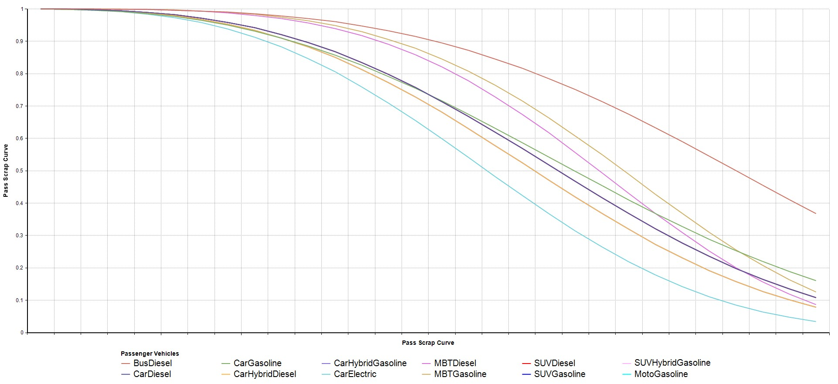

Figure 16: Base year scrapping curves for passenger vehicle technology types inthe vehicle parc model

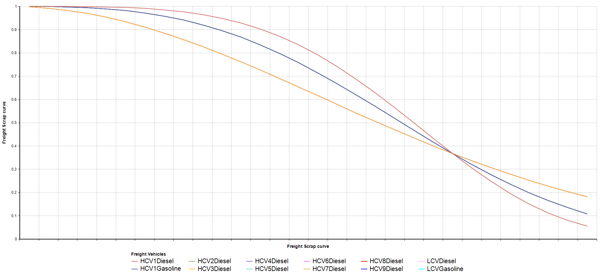

Figure 17: Base year scrapping curves for freight vehicle technology types in the vehicle parc model

#### Vehicle mileage

The process of developing mileage assumptions for the model, that would be both plausible and allow for the calibration of model fuel demand with fuel sales, requires an assumption around the initial annual mileage of ‘new vehicle’ annual mileage. The assumed ‘new vehicle’ mileage was based on national and international literature. The annual mileage of vehicles has been observed to, on average, decay steadily from this initial value for each year of operation. The US EPA’s MOBILE 6 model assumes a constant rate of decay compounding annually that is specific to vehicle type (Jackson, 2001) as shown in Figure 18. In general (buses being the exception), the rate of decay assigned is higher for vehicles with a higher initial mileage, heavy truck mileage for example decays at 10.9% per annum while for light-duty vehicles the default rate in Mobile 6 is 4.9% annual decay in annual mileage per annum. Although the latter rate has been observed to be both higher and lower for specific areas within the United States (Yu, Qiao, Li, & Oey, 2002), good agreement was shown with a parked car study covering a number of sites in Nairobi (University of California at Riverside, Global Sustainable Systems Research, 2002) where initial mileage was lower but the rate of decay very similar.



Figure 18: EPA Mobile 6 annual mileage decay assumptions compared to results of vehicle activity study for Nairobi Kenya

Lacking even rudimentary mileage accumulation data for South Africa, the value of 4.9% was used as the rate of mileage decay for the South African vehicle parc model across all vehicles classes. The rate of decay combined with the assumption of an initial ‘new vehicle’ mileage and the age profile of the model parc resulting from the scrapping assumptions discussed above results in an estimate of average annual mileage for each vehicle class. Clearly, if recent vehicle sales have been low then this will reduce the average mileage of that class because older vehicles which cover less mileage contribute disproportionately. After model calibration, these assumptions resulted in average mileages for the model vehicle classes that are reasonably consistent with previous studies and local and foreign data as shown below in Table 28.

Table 28: Assumed average passenger vehicle mileage (km/annum)

|  |  |  |  |  |  |  |  |  |  |  |
| --- | --- | --- | --- | --- | --- | --- | --- | --- | --- | --- |
| **Region** | **South Africa** | | | | | | | **North America** | **OECD –**  **Europe & Pacific** | **non- OECD** |
| **Source** | **This model**  **– new vehicle mileage** | **This model**  **– average mileage of stock** | **Phase 11** | **SAPIA PDSA2** | **RTMC3** | **LTMS4** | **Stone - Coastal KZN6** | **IEA/SMP Model (2010)7** | | |
| **Year** | **2013** | **2013** | **2006** | **2008** | **2007** | **2003** | **2002** | **2010** | **2010** | **2010** |
| CarDiesel | 21 000 | 16 934 | 21 254 | 19 000 | 14 644 | 15 000 | 18 873 | 17 600 | 11 250 | 10 875 |
| CarGasoline | 21 000 | 14 461 | 16 169 | 19 000 | 14 575 | 14 016 | 17 600 | 11 250 | 10 875 |
| CarHybridDiesel | 21 000 |  |  |  |  |  |  |  |  |  |
| CarHybridGasoline | 21 000 | 18 950 | 23 678 |  |  |  |  |  |  |  |
| CarElectic | 21 000 |  |  |  |  |  |  |  |  |  |
| BusDiesel | 40 000 | 26 083 | 22 072 |  | 35 227 | 28 912 | 61 985 | 60 000 | 60 000 | 40 000 |
| *MBTDiesel | 40 000 | 34 942 | 43 474 |  | 27 480 | 70 000 |  | 35 000 | 35 000 | 40 000 |
| *MBTGasoline | 40 000 | 24 647 | 30 927 | 30 000 | 70 000 | 70 332 | 35 000 | 35 000 | 40 000 |
| SUVDiesel | 24 000 | 20 734 | 20 314 |  |  |  |  |  |  |  |
| SUVGasoline | 24 000 | 20 245 | 19 128 |  |  |  |  |  |  |  |
| SUVHybridGasoline | 24 000 | 21 854 | 24 000 |  |  |  |  |  |  |  |
| MotoGasoline | 10 000 | 7720 | 8 340 |  | 6 124 |  |  | 5 000 | 7 500 | 7 500 |
| *1:(Merven et al, 2012)*  *2:(NAAMSA / SAPIA Working Group, 2009) 3: (Road Traffic Corporation, 2009)*  *4: (DEAT, 2007)*  *5: (Bell, Stone, & Harmse, 2003) – This model used the speed dependent COPERT equations to calculate fuel economy so the calibration with fuel sales required adjustment of annual mileage if average speed was changed.*  *6:(Stone, 2004)*  *7: (IEA, 2011)* | | | | | | | | | | |

Table 29: Assumed average freight vehicle mileage (km/annum)

|  |  |  |  |  |  |  |  |  |  |  |  |
| --- | --- | --- | --- | --- | --- | --- | --- | --- | --- | --- | --- |
| **Region** | **South Africa** | | | | | | | | **North America** | **OECD –**  **Europe & Pacific** | **non- OECD** |
| **Source** | **This model**  **– new vehicle mileage1** | **This model**  **– average mileage of stock** | **Phase 12** | **Fleet Watch Online3** | **SAPIA PDSA4** | **RTMC5** | **LTMS6** | **Stone - Coastal KZN7** | **IEA/SMP Model (2010)8** | | |
| **Year** | **2013** | **2013** | **2006** | **2006** | **2008** | **2007** | **2003** | **2002** | **2010** | **2010** | **2010** |
| LCVDiesel | 35 000 | 18 579 | 19 202 | 35 000 | 19 500 | 18 806 | 15 000 | 20 577 |  |  |  |
| LCVGasoline | 28 000 | 30 462 | 16 662 | 28 000 | 19 500 | 14 575 | 16 552 |  |  |  |
| HCV1Gasoline | 50 000 | 10 848 | 13 575 | 50 000 |  | 42 901 |  | 38 229 | 32 000 | 25 000 | 21 125 |
| HCV1Diesel | 50 000 | 37 737 | 33 417 | 50 000 |  |  | 34 221 | 32 000 | 25 000 | 21 125 |
| HCV2Diesel | 50 000 | 27 462 | 48 403 | 65 000 |  |  | 71 354 | 60 000 | 60 000 | 50 000 |
| HCV3Diesel | 85 000 | 62 745 | 85 000 |  |  |
| HCV4Diesel | 85 000 | 61 766 | 85 000 |  |  |
| HCV5Diesel | 110 000 | 67 354 | 110 000 |  |  |
| HCV6Diesel | 110 000 | 75 139 | 110 000 |  |  |
| HCV7Diesel | 150 000 | 94 547 | 160 000 |  |  |
| HCV8Diesel | 150 000 | 117 868 | 160 000 |  |  |
| HCV9Diesel | 150 000 | 98 457 | 200 000 |  |  |
| *1: (Road Frieght Association, 2009) 2: (Merven et. Al, 2012)*  *3:(Fleet Watch Online, 2006)*  *4: (NAAMSA / SAPIA Working Group, 2009)*  *5: (Road Traffic Management Corporation, 2009) 6: (DEAT, 2007)*  *7:(Stone, 2004)*  *8: (IEA, 2011)* | | | | | | | | | | | |

The large range of minibus-taxi annual mileage estimates is of interest because this vehicle class has a large effect on the model calibration due to its high modal share. The discrepancy in mileage between the various studies reflects to some degree the respective author’s struggles with calibrating their models in the absence of good activity data for these vehicles. Recent published data for African cities (International Association of Public Transport & African Association of Public Transport, 2010) presented in Table 30 suggests minibus-taxi mileages are high.

Table 30: Average annual mileage per vehicle for passenger modes in various African cities

|  |  |  |  |
| --- | --- | --- | --- |
| **City** | **Passenger car (km/annum)** | **Diesel bus (km/annum)** | **Minibus-taxi (km/annum)** |
| Abidjan | 12 000 | 60 049 | 86 400 |
| Accra | 19 200 | 29 952 | 79 872 |
| Addis Ababa | 25 357 | 53 924 | 57 350 |
| Dakar | 7 500 | 45 582 | 58 006 |
| Dar es Salaam | 25 000 |  | 70 000 |
| Douala | 15 000 | 40 000 | 50 000 |
| *Johannesburg* | *21 900* | *27 260* | *64 680* |
| Lagos | 4 260 | 73 920 | 72 000 |
| Nairobi | 8 133 | 15 000 | 18 000 |
| Windhoek | 15 863 | 15 000 |  |

The value of vehicle parc models would be greatly enhanced if reliable data for the minibus taxi industry was available, a relatively low-cost exercise given that there are relatively few vehicles of this type which operate within a commercial structure, albeit sometimes semi-formal. Good data for minibus taxis would improve the calibrated model outputs for other vehicle classes.

#### Fuel economy

Fuel economies for each vehicle class and each model year were generated by assuming a 1% annual improvement in fuel economy of the vehicle classes in the vehicle fleet relative to their 2010 fuel economy according to the aggregate manufacturer’s data available for representative car models in each vehicle class. Average vehicle fuel economy is a factor of several variables, as vehicles age the efficiency decreases, but the fuel economy of new vehicles tends to improve over time as shown in Table 31 below. This is the result not only of technology becoming more efficient but also because regulation is reducing vehicle mass and engine capacity. The South African vehicle parc is dominated by models from Europe and Japan, so given the data shown in Table 31 a higher annual improvement might be expected but given the slower rate of scrapping in South Africa and the lower value of 0.4% for the short period reviewed by the IEA, it was decided that 1% is a reasonable historical improvement in the absence of local reliable data. This assumption is also supported by a British study (Kwon, 2006), which suggests that new passenger vehicles and light commercial vehicles had an improved vehicle efficiency of 0.9% per annum between 1979 and 2000 in Britain, a much longer period than the period coved by the studies reviewed below.

Table 31: Improvements in passenger car fuel economy in world markets   
2000–2010

|  |  |  |  |  |
| --- | --- | --- | --- | --- |
|  | **(ICCT, 2011)** | | **(Cuenot & Fulton, 2011) (International Energy Agency)** | |
| **Country** | **Period** | **Annual fuel economy improvement** | **Period** | **Annual fuel economy improvement** |
| US | 2000–2010 | 1.60% | 2005–2008 | 1.90% |
| Canada | 2000–2008 | 1.28% | - | - |
| EU | 2000–2010 | 1.90% | 2005–2008 | 1.90% |
| Japan | 2000–2009 | 2.81% | 2005–2008 | 2.20% |
| South Africa | - | - | 2005–2008 | 0.40% |

Data for the fuel economy improvement of heavy-duty vehicles over the calibration period was not found and therefore an assumption of 1% was applied to these vehicle classes as well. The resulting historical fuel economy trajectory for the vehicles classes in the model is presented in Figure 19. Given the blanket 1% assumption, the fuel economy of all vehicle classes increases by just over 22% over the 20 year period shown. Clearly, in certain instances the fuel economy data for some technologies are extrapolated back to before those technologies entered the market, gasoline hybrid SUVs for instance, but this does not affect the model if no stock of these vehicles exists.

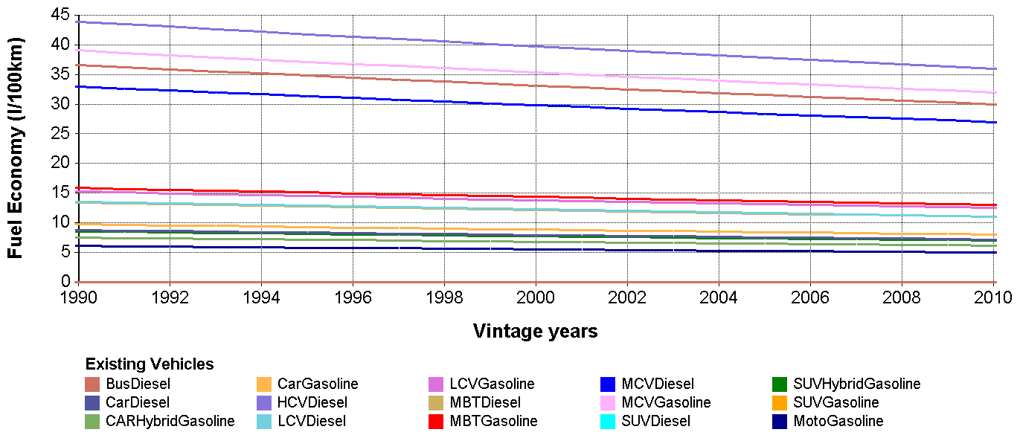

Figure 19: Assumed historical evolution of vehicle fuel economy in the model

The calibration process involved first adjusting the initial annual mileage assumed to the final values shown above in Table 28 and then adjusting the 2010 fuel economy estimates slightly until a good match was obtained between the data for historical fuel sales to the transport sector and the fuel demand of the vehicle parc model. The adjusted new vehicle 2010 fuel economy assumptions and the resulting fuel economy of stock in that year for the calibrated model are compared to other local and international studies and models in Table 32.

Table 32: Calibrated model fuel economy (l/100km) by Passenger vehicle class compared to other studies and sources – Part 1

|  |  |  |  |  |  |  |  |  |  |  |  |  |
| --- | --- | --- | --- | --- | --- | --- | --- | --- | --- | --- | --- | --- |
| **Region** | **South Africa** | | | | | | | | | **North America** | **OECD –**  **Europe & Pacific** | **non- OECD** |
| **Source** | **This model**  **– new vehicle fuel economy** | **This Model – average fuel economy of stock** | **Phase 1** | **Vander- schuren1** | **SAPIA PDSA2** | **LTMS 3** | **National Octane Study Model**  **– 45 km/h4** | **National Octane Study Model – 34**  **km/h4** | **Stone - Coastal KZN5** | **IEA/SMP Model (2010)6** | | |
| **Year** | **2010** | **2010** | **2006** | **2010** | **2008** | **2003** | **2002** | **2002** | **2002** | **2010** | **2010** | **2010** |
| CarDiesel | 6.7 | 7.0 | 7.7 | 8.2 | 6.3 | 7.7 | 5.9 | 6.7 | 6.8 | 9.5 | 7.4 | 9.1 |
| CarGasoline | 8.0 | 8.7 | 9.1 | 10.5 | 8.4 | 9.3 | 7.5 | 8.6 | 10.8 | 11.6 | 8.9 | 11.1 |
| CarHybridDiesel | 6.1 |  |  |  |  |  |  |  |  |  |  |  |
| CarHybridGasoline | 5.1 | 6.3 | 6.4 |  |  |  |  |  |  |  |  |  |
| CarElectic | 2.6 |  |  |  |  |  |  |  |  |  |  |  |
| BusDiesel | 30.0 | 32.9 | 35.5 | 36.0 |  | 36.1 |  |  | 27.9 | 33.0 | 33.0 | 28.0 |
| *MBTDiesel | 11.5 | 11.8 | 11.8 | 10.5 |  | 11.2 |  |  |  |  |  |  |
| *MBTGasoline | 13.8 | 15.3 | 15.1 | 11.4 | 14.4 | 12.7 | 15.4 | 15.4 | 16.0 | 18.0 | 18.0 | 16.0 |
| SUVDiesel | 11.5 | 11.9 | 12.0 |  |  |  |  |  |  |  |  |  |
| SUVGasoline | 13.8 | 14.4 | 13.7 |  |  |  |  |  |  |  |  |  |
| SUVHybridGasoline | 10.5 | 10.7 | 7.3 |  |  |  |  |  |  |  |  |  |
| MotoGasoline | 5.0 | 5.3 | 5.4 |  |  |  |  |  |  | 4.5 | 3.5 | 2.3 |
| 1: (Vanderschuren, 2011)  2: (NAAMSA / SAPIA Working Group, 2009) 3: (DEAT, 2007)  4: (Bell, Stone, & Harmse, 2003) – This model used the speed dependent COPERT equations to calculate fuel economy so the calibration with fuel sales required adjustment of annual mileage if average speed was changed.  5: (Stone & Bennett, 2001) 6: (Stone, 2004)  7: (IEA, 2011) | | | | | | | | | | | | |

Table 33: Calibrated model fuel economy (l/100km) by Freight vehicle class compared to other studies and sources – Part 1

|  |  |  |  |  |  |  |  |  |  |  |  |  |
| --- | --- | --- | --- | --- | --- | --- | --- | --- | --- | --- | --- | --- |
| **Region** | **South Africa** | | | | | | | | | **North America** | **OECD –**  **Europe & Pacific** | **non- OECD** |
| **Source** | **This model**  **– new vehicle fuel economy1** | **This Model – average fuel economy of stock** | **Phase 1** | **SAPIA PDSA3** | **LTMS4** | **National Octane Study Model**  **– 45 km/h5** | **National Octane Study Model – 34**  **km/h5** | **Stone & Bennett**  **6** | **Stone - Coastal KZN7** | **IEA/SMP Model (2010)8** | | |
| **Year** | **2010** | **2010** | **2006** | **2008** | **2003** | **2002** | **2002** | **1998** | **2002** | **2010** | **2010** | **2010** |
| LCVDiesel | 11.5 | 12.3 | 12.2 | 10.5 | 11.2 | 7.7 | 9.0 | 8.7 | 10.6 |  |  |  |
| LCVGasoline | 13.8 | 15.1 | 14.2 | 13.8 | 14.7 | 10.8 | 13.3 |  | 12.5 |  |  |  |
| HCV1Gasoline | 13.9 | 19.2 | 38.7 |  |  |  |  |  | 31.4 |  |  |  |
| HCV1Diesel | 16.8 | 14.8 | 30.0 |  |  |  |  | 17.4 | 17.2 | 25.6 | 23.7 | 28.0 |
| HCV2Diesel | 21.8 | 23.0 | 40.7 |  |  |  |  | 31.6 | 47.5 | 41.9 | 36.1 | 33.1 |
| HCV3Diesel | 22.2 | 23.7 |  |  |  |  |
| HCV4Diesel | 25.6 | 27.3 |  |  |  |  |
| HCV5Diesel | 32.2 | 34.1 |  |  |  |  |
| HCV6Diesel | 31.0 | 32.6 |  |  |  |  |
| HCV7Diesel | 36.7 | 38.4 |  |  |  |  |
| HCV8Diesel | 41.4 | 42.5 |  |  |  |  |
| HCV9Diesel | 50.0 | 52.0 |  |  |  |  |
| 1: (COPERT, year) - This model used the speed dependent COPERT equations to calculate fuel economy so the calibration with fuel sales required adjustment of annual mileage if average speed was changed.  2: (Vanderschuren, 2011)  3: (NAAMSA / SAPIA Working Group, 2009) 4: (DEAT, 2007)  5: (Bell, Stone, & Harmse, 2003) – This model used the speed dependent COPERT equations to calculate fuel economy so the calibration with fuel sales required adjustment of annual mileage if average speed was changed.  6: (Stone & Bennett, 2001) 7: (Stone, 2004)  8: (IEA, 2011) | | | | | | | | | | | | |

#### Occupancy and load factor

Less data was available to guide the assumptions for vehicle occupancy and load factor which are critical for calculating the demand for passenger.km and ton.km in the model. A statistical review of transport in African cities published by the International Association of Public Transport (2010) offers a regional perspective and suggests, given the figures for Johannesburg compared to other cities presented below, that occupancy in South Africa is generally lower than the rest of Africa.

Table 34: Average occupancy per vehicle for passenger modes in various African cities

|  |  |  |  |
| --- | --- | --- | --- |
| **City** | **Passenger car (pass/veh)** | **Diesel bus (pass/veh)** | **Minibus-taxi (pass/veh)** |
| Abidjan | 2.0 | 60 | 18 |
| Accra | 2.0 | 68 | 18 |
| Addis Ababa | 3.7 | 80 | 11 |
| Dakar | 2.0 | 66 | 35 |
| Dar Es Salaam | 1.9 | 45 | 29 |
| Douala | 2.3 | 45 | 17 |
| *Johannesburg* | *1.4* | *37.1* | *8.5* |
| Lagos | 1.8 | 43 | 18 |
| Nairobi | 1.7 | 70 | 18 |
| Windhoek | 1.3 |  |  |

The final occupancy and load factors selected for the model are compared to other studies and sources below.

Table 35: Model occupancy and load factor of Passenger vehicle class compared toother studies and sources

|  |  |  |  |  |  |  |  |  |
| --- | --- | --- | --- | --- | --- | --- | --- | --- |
| **Region** |  | **South Africa** | | | | **North America** | **OECD –**  **Europe & Pacific** | **non- OECD** |
| **Source** | **This Model** | **Phase 1** | **Vander- schuren1** | **LTMS2** | **IEA/SMP Model3** | | |
| **Year** | **Units** | **2013** | **2006** | **2010** | **2003** | **2010** | **2010** | **2010** |
| CarDiesel | pass/veh | 1.4 | 1.4 | 1.40 | 2.10 | 1.47* | 1.61* | 1.77* |
| CarGasoline | pass/veh | 1.4 | 1.4 | 1.40 | 2.10 | 1.47* | 1.61* | 1.77* |
| CarHybridDiesel | pass/veh | 1.4 | 1.4 |  |  |  |  |  |
| CarHybridGasoline | pass/veh | 1.4 | 1.4 |  |  |  |  |  |
| CarElectic | pass/veh | 1.4 | 1.4 |  |  |  |  |  |
| BusDiesel | pass/veh | 25 | 25 | 40 | 35 | 12.00 | 16.70 | 22.00 |
| *MBTDiesel | pass/veh | 14 | 14 | 12 | 35 | 6.00 | 8.40 | 10.70 |
| *MBTGasoline | pass/veh | 14 | 14 | 12 | 15 | 6.00 | 8.40 | 10.70 |
| SUVDiesel | pass/veh | 1.4 | 1.4 |  |  |  |  |  |
| SUVGasoline | pass/veh | 1.4 | 1.4 |  |  |  |  |  |
| SUVHybridGasoline | ton/veh | 1.4 | 1.4 |  |  |  |  |  |
| MotoGasoline | ton/veh | 1.1 | 1.1 |  |  | 1.20 | 1.20 | 1.40 |
| *Data for LDVs which include cars and light trucks/vans/suvs 1: (Vanderschuren, 2011) 2: (DEAT, 2007)  3: (IEA, 2011) | | | | | | | | |

Table 36: Model occupancy and load factor of Freight vehicle class compared toother studies and sources

|  |  |  |  |  |  |  |  |
| --- | --- | --- | --- | --- | --- | --- | --- |
| **Region** |  | **South Africa** | | | **North America** | **OECD –**  **Europe & Pacific** | **non- OECD** |
| **Source** | **This Model** | **Phase 1** | **LTMS1** | **IEA/SMP Model2** | | |
| **Year** | **Units** | **2013** | **2006** | **2003** | **2010** | **2010** | **2010** |
| LCVDiesel | ton/veh | 0.75 | 0.5 | 2.1 |  |  |  |
| LCVGasoline | ton/veh | 0.75 | 0.5 | 2.1 |  |  |  |
| HCV1Gasoline | ton/veh | 1.95 | 2.5 |  | 2.2 | 1.6 | 1.7 |
| HCV1Diesel | ton/veh | 1.95 | 2.5 |  | 2.2 | 1.6 | 1.7 |
| HCV2Diesel | ton/veh | 2.90 | 15.0 |  | 10.0 | 8.0 | 6.3 |
| HCV3Diesel | ton/veh | 5.20 |  |
| HCV4Diesel | ton/veh | 9.10 |  |
| HCV5Diesel | ton/veh | 8.30 |  |
| HCV6Diesel | ton/veh | 12.30 |  |
| HCV7Diesel | ton/veh | 18.38 |  |
| HCV8Diesel | ton/veh | 25.88 |  |
| HCV9Diesel | ton/veh | 26.63 |  |
| *Data for LDVs which include cars and light trucks/vans/suvs 1: (DEAT, 2007)  **2**: (IEA, 2011) | | | | | | | |

The model developed results for the fuel demand calibration, which validates the model but also generated interesting aggregate statistics for the South African vehicle parc by vehicle class fraction. Where disaggregate detail is presented it is for 2010 which is the current calibration year of SATIM. The aggregate calibration of the model with the registration database showed excellent agreement as shown in Figure 20 below, with the long calibration period capturing a full economic cycle but remaining within a 3% error margin.

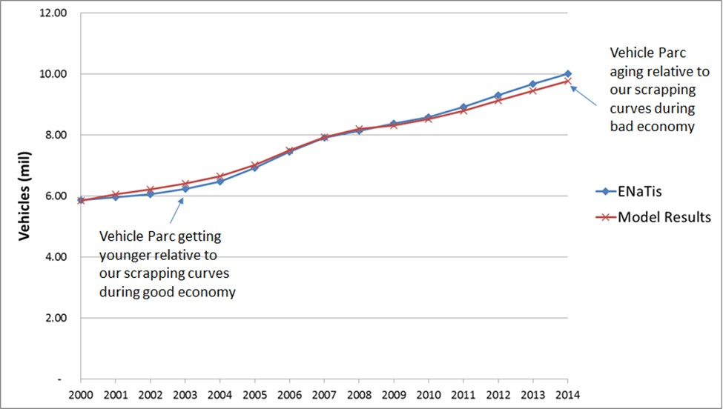

Figure 20: Calibration results of the vehicle parc model for the aggregate vehicle population compared to the registration database

Table 37: Vehicle class as a fraction of the passenger road vehicle parc for 2010

|  |  |  |
| --- | --- | --- |
| **Vehicle class** | **Count of vehicles (2010)** | **Fraction** |
| CarDiesel | 221 779 | **3.6%** |
| CarGasoline | 4 832 681 | **78.3%** |
| CarHybridDiesel | 0 | **0.0%** |
| CarHybridGasoline | 1 113 | **0.0%** |
| CarElectic | 0 | **0.0%** |
| BusDiesel | 21 686 | **0.4%** |
| *MBTDiesel | 23 911 | **0.4%** |
| *MBTGasoline | 277 064 | **4.5%** |
| SUVDiesel | 171 630 | **2.8%** |
| SUVGasoline | 252 050 | **4.1%** |
| SUVHybridGasoline | 541 | **0.0%** |
| MotoGasoline | 372 534 | **6.0%** |
| **TOTAL** | **6 174 988\*** | **100.0%** |
| *\* This total is not calibrated to include the ‘Other self-propelled vehicles’ category in the eNaTiS registrationdatabase* | | |

Table 38: Vehicle class as a fraction of the freight road vehicle parc for 2010

|  |  |  |
| --- | --- | --- |
| **Vehicle class** | **Count of vehicles (2010)** | **Fraction** |

|  |  |  |
| --- | --- | --- |
| LCVDiesel | 852 698 | **33.2%** |
| LCVGasoline | 1 394 106 | **54.2%** |
| HCV1Gasoline | 6 061 | **0.2%** |
| HCV1Diesel | 120 270 | **4.7%** |
| HCV2Diesel | 31 074 | **1.2%** |
| HCV3Diesel | 53 763 | **2.1%** |
| HCV4Diesel | 12 249 | **0.5%** |
| HCV5Diesel | 5 146 | **0.2%** |
| HCV6Diesel | 74 175 | **2.9%** |
| HCV7Diesel | 19 406 | **0.8%** |
| HCV8Diesel | 434 | **0,0%** |
| HCV9Diesel | 514 | **0.0%** |
| **TOTAL** | **2 569 897**\* | **100.0%** |
| *\* This total is not calibrated to include the ‘Other self-propelled vehicles’ category in the eNaTiS registrationdatabase* | | |

Table 39: Split of selected vehicle types by fuel(2010)

|  |  |  |
| --- | --- | --- |
| **Vehicle class** | **Diesel fraction** | **Gasoline fraction** |
| Cars & SUVS | 7% | 93% |
| MBT | 14% | 86% |
| LCV | 38% | 62% |
| HCV | 98% | 2% |

Table 40: Split of fuel consumption by selected vehicle types(2010)

|  |  |  |
| --- | --- | --- |
| **Vehicle class** | **Diesel fraction** | **Gasoline fraction** |
| Cars & SUVS | 24% | 76% |
| MBT | 3% | 4% |
| LCV | 53% | 20% |
| HCV | 20% | 0% |

In order to calculate the demand for passenger.km, the model combines generated vehicle.km with assumed occupancy, discussed previously. This allows further validation of the model by comparing the modal split for passenger transport with other studies. The model splits are presented in Table 21, which shows a good agreement with Department of Transport Data for 2005 (DoT, 2009) and the National Household Transport Survey for 2013 by Statistics SA (StatsSA, 2013).

Table 41: Model generated passenger transport data for South Africa(2010)

|  |  |  |  |  |  |  |  |  |
| --- | --- | --- | --- | --- | --- | --- | --- | --- |
|  | **Total Vehicles** | **Total veh- km** | **km per veh** | **Occup- ancy** | **Activity** | **Modal Share** | **NATMAPa (2005)** | **NHTSc (2013)** |
|  | (1000  veh.) | (billion veh-km) | (000  km) | (pers/veh,  %) | (billion p.km) | (%) of p.km | (%) of trips | (%) of trips |
| **Public** |  |  |  |  |  |  |  |  |
| Large Bus | 21.7 | 0.57 | 26.3 | 25 | 14.3 | 5% | 10% | 10% |
| MBT | 301.0 | 7.82 | 26.0 | 14 | 109.5 | 42% | 40% | 42% |
| Train* |  |  |  |  | 13.9b | 5% | 8% | 4% |
| **TOTAL** |  |  |  |  | **137.1** |  |  |  |
| **Private** |  |  |  |  |  | 48% | 40% | 25% |
| Pass. Car | 5055.6 | 78.6 | 15.5 | 1.4 | 110.0 |  |  |  |
| SUV | 424.2 | 8.6 | 20.3 | 1.4 | 12.1 |  |  |  |
| M/cycle | 372.5 | 2.9 | 7.7 | 1.1 | 3.2 |  |  |  |
| **TOTAL** |  |  |  |  | **125.3** |  |  |  |
| **Grand total** |  |  |  |  | **263.0** |  |  |  |
| *\*: Train and air transport figures are from literature not the model a: (DoT, 2009)*  *b: Intra-city data only for 2006/2007 (Metrorail, 2007) – data for inter-city is not published by the respective vendors c: (Statistics South Africa, 2013)* | | | | | | | | |

The Department of logistics, University of Stellenbosch estimates road freight activity using two models, the Freight Demand Model (FDM) for Transnet and the National Freight Flow Model (NFFM) which incorporate commodity clows and freight vehicle clows respectively (CSIR, 2012). The NFFM which is based on trafcic counts tends to overestimate ton.km and the FDM, which is based on freight clows, tends to undercount. Their annual logistics report estimate of freight demand recently switched to the FDM model output with some correction upwards (using NFFM) to account for the model’s inability to estimate local distribution trips. The resulting lower cigure made calibration possible for this study after a revision of load factors and maximum loads for heavy truck classes. A particularly important incorporation was reclecting the upward trend in load factor for very heavy articulated trucks in the dominating 57 ton GVM class operating on corridors, which has reportedly reached 85% and continues to rise (Havenga & Simpson, 2016b).

A key feature of the updated and more disaggregate HCV representations was accounting for the prevalence of truck-tractors in the vehicle sales data and translating this to load capacities for each class. The approach as shown below in Table 42, was to estimate the share of rigid and articulated trucks for each class and respective payloads for each sub-class so that a weighted average payload could be estimated. The HCV6 vehicle class dominates the HCV parc as shown in Table 43 and includes a high share of truck tractors. It was assumed that many of these are actually coupled to trailers in the dominant 57 ton GVM articulated trucks. By assuming a high share of articulated trucks for this class and a high average load factor of 73% (includes old trucks not on corridors) it was possible to calibrate freight demand to the published figure, while still leaving enough diesel in the calibration for cars, SUVs and off-road applications. This quantity of diesel implies a credible cleet energy intensity of 1.83 MJ/ton.km which compares well with international data for similar markets like Australia (Figure 21). More needs to be understood about energy use in the construction and mining sectors however is we are to be sure that the residual diesel in the calibration reclects that used by stationary and off-road activities.

Table 42; Detailed Freight utilisation assumptions for ton.km calibration (2014)

|  |  |  |  |  |  |  |  |  |  |  |
| --- | --- | --- | --- | --- | --- | --- | --- | --- | --- | --- |
| SATIM Vehicle Class | NAAMSA GVM1 | Assumed Load Factors2 | Assumed Average Payload Capacity - Rigid [tons] | Assumed Average Payload Capacity  - Artic [tons] | Assumed Share of tons moved (Rigid) | Assumed Share of tons moved (Artic) | Assumed New Vehicle Mileage (km) | Assumed Share of tkm that is Corridor | Assumed Share of tkm that is Metro | Assumed Share of tkm that is Rural |
| HCV1Diesel | 3,000 -7,500 | 45% | 3 | 0 | 100% | 0% | 50000 | 0% | 87% | 13% |
| HCV1Gasoline | 3,000 -7,500 | 45% | 3 | 0 | 100% | 0% | 50000 | 8% | 75% | 17% |
| HCV2Diesel | 7,501 – 12,000 | 50% | 5 | 0 | 100% | 0% | 50000 | 10% | 54% | 36% |
| HCV3Diesel | 12,001 –  16,000 | 55% | 7 | 14 | 70% | 30% | 85000 | 24% | 63% | 13% |
| HCV4Diesel | 16,001 –  20,000 | 60% | 10 | 18 | 60% | 40% | 85000 | 38% | 41% | 21% |
| HCV5Diesel | 20,001 –  24,000 | 65% | 12 | 22 | 50% | 50% | 110000 | 54% | 31% | 16% |
| HCV6Diesel | 24,001 –  32,000 | 73% | 14 | 28 | 10% | 90% | 150000 | 54% | 23% | 23% |
| HCV7Diesel | 32,001 –  40,000 | 73% | 19 | 30 | 50% | 50% | 150000 | 56% | 16% | 28% |
| HCV8Diesel | 40,001 –  50,000 | 73% | 24 | 32 | 85% | 15% | 150000 | 57% | 15% | 28% |
| HCV9Diesel | >50,000 | 73% | 30 | 34 | 100% | 0% | 150000 | 57% | 17% | 26% |
| LCVDiesel | <3,000 | 40% | 1 | 0 | 100% | 0% | 35000 | 0% | 85% | 15% |
| LCVGasoline | <3,000 | 40% | 1 | 0 | 100% | 0% | 28000 | 0% | 83% | 17% |

Table 43: Freight Utilisation ton.km Outputs by Vehicle Class (2014)

|  |  |  |  |  |  |  |  |  |  |
| --- | --- | --- | --- | --- | --- | --- | --- | --- | --- |
| **SATIM Vehicle Class** | **NAAMSA GVM1** | **Assumed Weighted Average Payload Capacity of Class [tons]3** | **Average Fleet Annual Mileage (km)4** | **Count of Operating Vehicles 5** | **Freight Output (tkm)** | **Share of ton-km** | **Corridor (tkm)** | **Metropolitan (tkm)** | **Rural (tkm)** |
| HCV1Diesel | 3,000 -7,500 | 3.3 | 31,568 | 139525 | 6.54E+09 | 2.8% | 2.53E+07 | 5.67E+09 | 8.44E+08 |
| HCV1Gasoline | 3,000 -7,500 | 3.0 | 9,075 | 4104 | 5.03E+07 | 0.0% | 3.88E+06 | 3.77E+07 | 8.69E+06 |
| HCV2Diesel | 7,501 – 12,000 | 5.0 | 22,973 | 35004 | 2.01E+09 | 0.9% | 2.04E+08 | 1.08E+09 | 7.28E+08 |
| HCV3Diesel | 12,001 – 16,000 | 9.1 | 51,459 | 62901 | 1.62E+10 | 7.0% | 3.86E+09 | 1.03E+10 | 2.07E+09 |
| HCV4Diesel | 16,001 – 20,000 | 13.2 | 50,656 | 13426 | 5.39E+09 | 2.3% | 2.06E+09 | 2.18E+09 | 1.14E+09 |
| HCV5Diesel | 20,001 – 24,000 | 16.8 | 62,604 | 5827 | 3.97E+09 | 1.7% | 2.13E+09 | 1.23E+09 | 6.16E+08 |
| HCV6Diesel | 24,001 – 32,000 | 26.6 | 72,593 | 98994 | 1.40E+11 | 60.7% | 7.54E+10 | 3.28E+10 | 3.21E+10 |
| HCV7Diesel | 32,001 – 40,000 | 24.5 | 73,232 | 24913 | 3.26E+10 | 14.1% | 1.84E+10 | 5.19E+09 | 9.05E+09 |
| HCV8Diesel | 40,001 – 50,000 | 25.2 | 91,296 | 816 | 1.37E+09 | 0.6% | 7.85E+08 | 2.02E+08 | 3.84E+08 |
| HCV9Diesel | >50,000 | 30.0 | 76,261 | 512 | 8.56E+08 | 0.4% | 4.90E+08 | 1.45E+08 | 2.21E+08 |
| LCVDiesel | <3,000 | 1.0 | 28,313 | 1095974 | 1.23E+10 | 5.3% | 3.67E+07 | 1.05E+10 | 1.83E+09 |
| LCVGasoline | <3,000 | 1.0 | 17,268 | 1360543 | 9.36E+09 | 4.1% | 1.73E+07 | 7.77E+09 | 1.57E+09 |

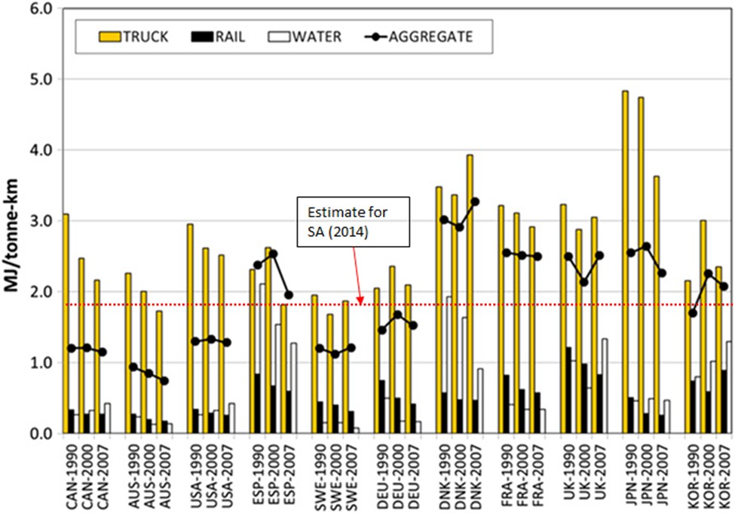

***Source:*** *Graphic by* (Eoma, Schipper, & Thompson, 2012)*; Estimate for South Africa: ton.km from Department of Logistics, University of Stellenbosch* (Havenga J. , Simpson, de Bod, & Braun, 2016a) *divided into SATIM Road Freight Energy estimate*

Figure 21: South African Road Freight (Truck) Energy Intensity in 2014 compared to selected OECD Markets 1990-2007

The model shows excellent agreement with sales for both petrol and diesel use as shown in Figure 21 below for the calibration years 2000 to 2013. This comparison between model fuel demand and actual fuel sales further validates the assumptions made in this study.

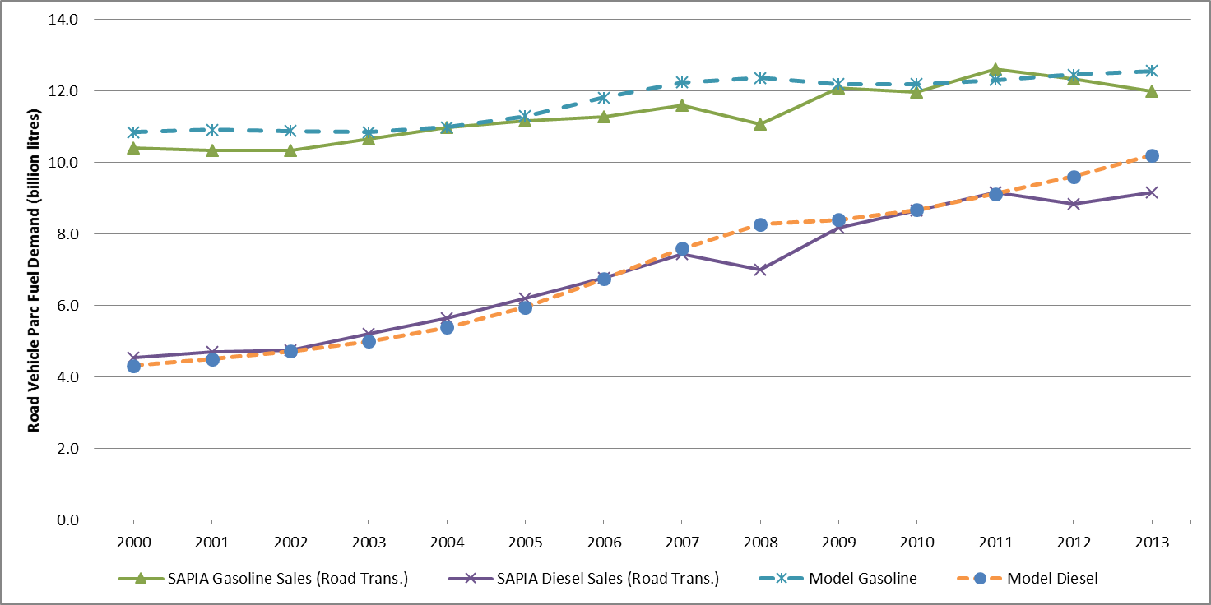

Figure 22: Model fuel demand vs actual fuel consumption for 2000 to 2013

The short-run price elasticity effects that drive the periods of error in the calibration are not important to our long-term projection model so the strategy was to get close agreement between points outside of periods of price volatility (Figure 22).

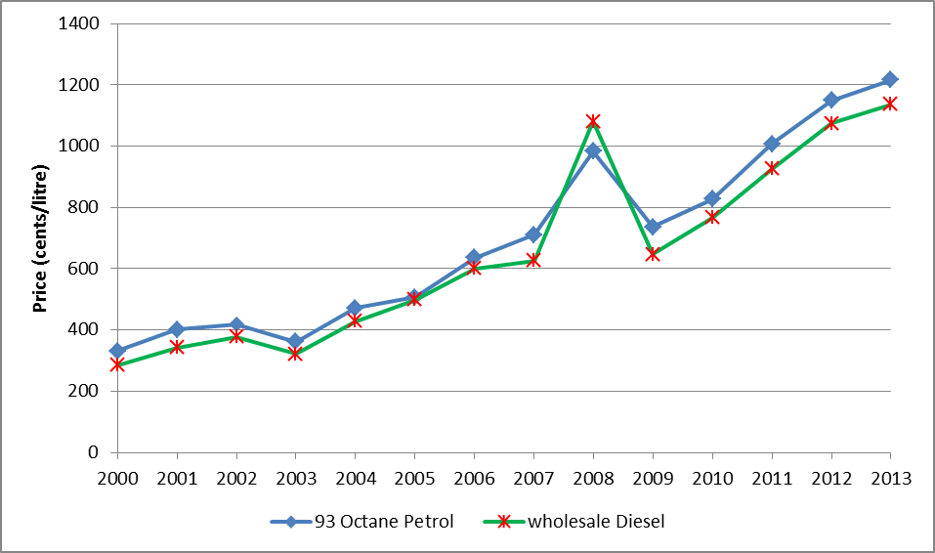

Figure 23: Change in Gasoline and Diesel Prices from 2000 - 2013

### Future improvements in vehicle fuel economy

Average vehicle fuel economy is a factor of several variables, as vehicles age the efficiency decreases, but the fuel economy of new vehicles has in recent years tended to improve over time (Table 31).

This is the result not only of technology becoming more efficient but also because regulation is reducing vehicle mass and engine capacity. The 2008 European Impro-Car project (Nemry, Leduc, Mongelli, & Uihlein, 2008) indicated that fuel economy improvements of 7% (they quote CO2 emission reductions) could be attained by a 12% vehicle mass reduction and improvements of 18% for a 30% vehicle mass reduction. Aggressive reduction of engine capacity by 30% but maintaining power by turbocharging was expected to reduce fuel economy by 7% for diesel cars and 12% for gasoline passenger cars. These two measures combined could therefore account for a 1% annualized improvement for about 20 years for gasoline cars. Giving way on engine capacity and power together, conceding performance will offer even greater potential benefits if this were to be driven by legislation.

A Joint Transport Research Centre study (JTRC, 2008) that modelled CO2 emissions from the world transport fleet using the IEA’s MoMo model adopted a 29% fuel economy improvement between 2005 and 2050 as the most likely scenario which equates to a 0.75% annualized improvement. Their model however indicated that for world vehicle fleet CO2 emissions to stabalise a 56% improvement between 2005 and 2050 would be necessary, which is equivalent to a 1.8% annualized improvement.

For the purposes of a general perspective, a series of hypothetical fuel economy improvements between 2012 and 2050 are tabulated below, showing net and annualised quantities and the end-point in 2050 given a representative fleet fuel economy for gasoline passenger cars in 2012 of 8.6 l/100 km. These are compared to the combined cycle fuel economy for two of the current most efficient small car models, scaled up by 10% to account for the reported difference of the European test cycle with real world fuel economy (Pelkmans & Debal, 2006) (Kwon, 2006).

Table 44: Hypothetical fuel economy improvement scenarios for gasoline passenger cars compared to the current efficient non-hybrid gasoline passenger cars

|  |  |  |  |
| --- | --- | --- | --- |
| **Annualised fuel economy improvement** | **Total improvement 2012 – 2050** | **2012 (l/100km)** | **2050 (l/100km)** |
| -0.5% | -17% | 8.6 | 7.0 |
| -1.0% | -32% | 8.6 | 5.8 |
| -1.5% | -44% | 8.6 | 4.7 |
| -2.0% | -54% | 8.6 | 3.8 |
| -2.5% | -62% | 8.6 | 3.1 |
|  | | | |
| Fiat 500 (1.2 l) + 10%a | | 5.6 | ? |
| Kia Rio (1.2 l) + 10%b | | 5.9 | ? |
| *a: (Fiat, 2012)*  *b:* (Kia, 2012) | | | |

The South African vehicle parc is dominated by models from Europe and Japan, so given the data for those markets shown in Table 31 above we might expect a higher annual improvement than the low value of 0.4% for the short period reviewed by the IEA. This may reflect a slower rate of scrapping and a preference for larger vehicles in South Africa. It was decided that 1% was a reasonable historical improvement for the calibration of the vehicle parc model in the absence of local reliable data. This assumption is also supported by a British study (Kwon, 2006), which suggests that new passenger vehicles and light commercial vehicles had an improved vehicle efficiency of 0.9% per annum between 1979 and 2000 in Britain, a much longer period than the period coved by the studies reviewed above.

It was similarly decided that a future sustained annualised improvement of 1% in fuel economy for existing technology types was a reasonable assumption for the reference case. As shown by Table 31 this is feasible with current technology for gasoline non-hybrids given a complete shift in consumer preference to small cars. A 1.5% annualised improvement seems far more challenging but plausible and so this was deemed an appropriate rate for a high efficiency improvement scenario.

Table 45: Assumed efficiency gains for road vehicles. Real world (Net MJ/km) (AEA, 2012)

|  |  |  |  |  |  |  |  |
| --- | --- | --- | --- | --- | --- | --- | --- |
| SATIM descriptor | AEA descriptor | Technology | 2010 | 2020 | 2030 | 2040 | 2050 |
| Gasoline Car | Passenger Car | Petrol ICE | 2.77 | 2.07 | 1.69 | 1.51 | 1.38 |
| Diesel Car | Passenger Car | Diesel ICE | 2.23 | 1.75 | 1.46 | 1.30 | 1.20 |
| Gasoline Hybrid Car | Passenger Car | Petrol HEV | 2.12 | 1.69 | 1.45 | 1.32 | 1.21 |
| Diesel Hybrid Car | Passenger Car | Diesel HEV | 1.77 | 1.49 | 1.30 | 1.20 | 1.09 |
| Electric Car | Passenger Car | BEV | 0.69 | 0.63 | 0.58 | 0.55 | 0.52 |
| Hydrogen Car | Passenger Car | H2FC | 1.08 | 0.94 | 0.84 | 0.77 | 0.71 |
| Gas Car | Passenger Car | NG ICE | 2.77 | 2.07 | 1.69 | 1.51 | 1.38 |
|  |  |  |  |  |  |  |  |
| SUV | Van / LCV | Petrol ICE | 2.85 | 2.33 | 2.06 | 1.83 | 1.67 |
| SUV | Van / LCV | Diesel ICE | 2.90 | 2.49 | 2.20 | 1.96 | 1.80 |
| SUV | Van / LCV | BEV | 0.71 | 0.66 | 0.62 | 0.59 | 0.56 |
| SUV | Van / LCV | H2FC | 1.40 | 1.25 | 1.14 | 1.05 | 0.97 |
| SUV | Van / LCV | NG ICE | 3.34 | 2.73 | 2.42 | 2.15 | 1.96 |
| BUS | Bus | Diesel ICE | 13.99 | 13.19 | 11.73 | 11.22 | 10.79 |
| BUS | Bus | BEV | 4.30 | 4.15 | 3.94 | 3.76 | 3.57 |
| BUS | Bus | H2FC | 6.63 | 6.20 | 5.69 | 5.27 | 4.87 |
| BUS | Bus | NG ICE | 16.09 | 15.17 | 13.50 | 12.90 | 12.41 |
| LCV | Van / LCV | Petrol ICE | 2.85 | 2.33 | 2.06 | 1.83 | 1.67 |
| LCV | Van / LCV | Diesel ICE | 2.90 | 2.49 | 2.20 | 1.96 | 1.80 |
| LCV | Van / LCV | BEV | 0.71 | 0.66 | 0.62 | 0.59 | 0.56 |
| LCV | Van / LCV | H2FC | 1.40 | 1.25 | 1.14 | 1.05 | 0.97 |
| LCV | Van / LCV | NG ICE | 3.34 | 2.73 | 2.42 | 2.15 | 1.96 |
| HCV1,2,3 | Small Rigid Truck | Diesel ICE | 9.381 | 8.862 | 8.167 | 7.661 | 7.366 |
| HCV1,2,3 | Small Rigid Truck | BEV | 2.865 | 2.776 | 2.623 | 2.475 | 2.343 |
| HCV1,2,3 | Small Rigid Truck | H2FC | 4.423 | 4.144 | 3.792 | 3.472 | 3.195 |
| HCV1,2,3 | Small Rigid Truck | NG ICE | 10.788 | 10.192 | 9.391 | 8.810 | 8.471 |
| HCV5,6 | Large Rigid Truck | Diesel ICE | 12.41 | 11.08 | 9.27 | 8.55 | 8.04 |
| HCV5,6 | Large Rigid Truck | H2FC | 5.88 | 5.14 | 4.39 | 3.86 | 3.51 |
| HCV5,6 | Large Rigid Truck | NG ICE | 14.27 | 12.74 | 10.66 | 9.83 | 9.24 |
| HCV4 | Construction | Diesel ICE | 13.16 | 12.08 | 11.08 | 10.40 | 9.89 |
| HCV4 | Construction | H2FC | 6.24 | 5.46 | 4.97 | 4.43 | 3.97 |
| HCV4 | Construction | NG ICE | 15.13 | 13.90 | 12.75 | 11.95 | 11.38 |
| HCV7,8,9 | Articulated Truck | Diesel ICE | 13.99 | 11.82 | 9.41 | 8.51 | 7.91 |
| HCV7,8,9 | Articulated Truck | H2FC | 6.64 | 5.62 | 4.70 | 4.18 | 3.77 |
| HCV7,8,9 | Articulated Truck | NG ICE | 16.08 | 13.60 | 10.82 | 9.79 | 9.10 |

ICE: Internal Combustion Engine,

### Investment costs for New Transport Technologies and Constraints on Market Penetration

The investment cost assumptions for new transport technologies are all derived from the LTMS project with the exception of the costs for electric passenger cars which have been updated to reflect development of this technology.

There has not been a heavy investment in time in refining cost estimates because this sector of the SATIM model is not solved as a pure least cost optimisation with technologies being fairly tightly constrained by bounds on penetration. In practice then this part of the model is used as a scenario model with alternative penetration rates being tested against one another. The rail freight and ‘other’ technologies have abstract numbers, usually 1, for costs and efficiencies and have therefore not been included. The split between road and rail is exogenously pre-processed in the demand calculation discussed below. Thus the total energy demand for the sector is split by energy service exogenously and this share is input to TIMES. In SATIM currently all freight modes output a different energy service for instance Heavy Commercial Road Freight, Medium Commercial Road Freight, Rail corridor Freight and so on. Therefore the road and rail freight modes will supply energy to meet the pre-processed energy service share without the influence of the optimiser.

While the optimisation capability of the model is not really being used the system wide impacts are still seen. This approach is a useful compromise in transport where mode shift and technology selection are notoriously irrational in practice.

## Sub-Model for Projecting Passenger Car Motorisation and the Demand for Passenger Travel – The Time Budget Model

The relationship between motorisation (vehicles per 1000 population), particularly passenger car motorisation, and GDP/capita is well documented. In general motorisation increases more or less linearly with GDP/capita until saturating and is thus usually modelled with the s-shaped Gompertz curve, an example of which is shown below fitted to the historical motorization and per-capita income data for some developed economies (Dargay, Gately, & Sommer, 2007).

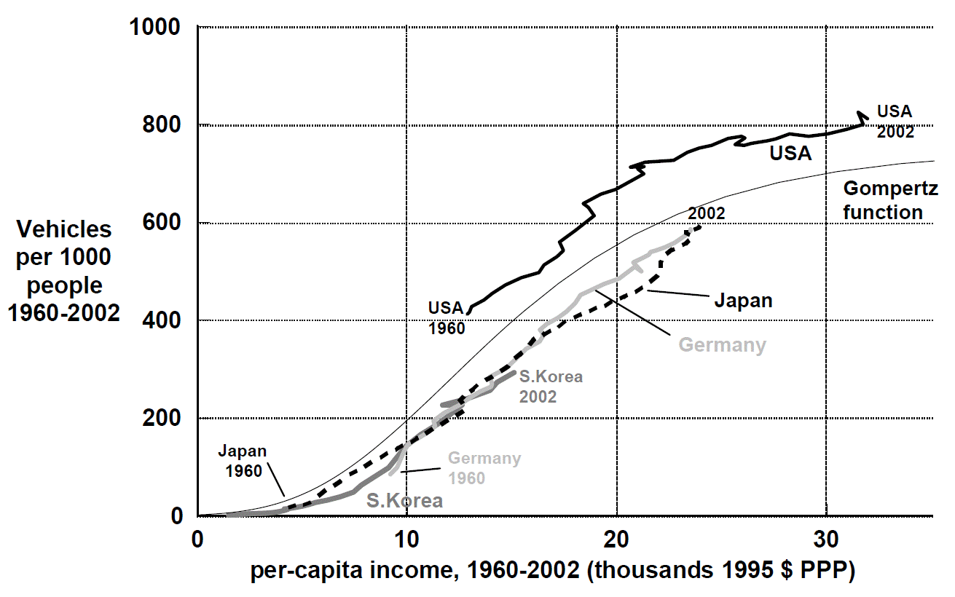

Figure 24: Gompertz Curve model of the correlation of motorisation with income per capita *Dargay et al. (2007)*

Thus far, it seems that increasing income per capita has inexorably led to a growth in private as opposed to public mode travel. This has only been tempered in extremely dense cities like Hong Kong where a private vehicle offers no particular time saving or convenience advantage. Understanding the likely evolution of private vehicle motorisation with changing per capita income and the impact of travel time is therefore critical to projecting the demand for passenger travel. South African cities are not notably dense and high speed public transport is only beginning to emerge so it seems likely that for the foreseeable future, people ascending the ladder of per capita income are likely to assume the established appetite for private travel of their new income group. In SATIM, this principle, along with assumptions around average traffic speeds and the prevailing travel time budget have been leveraged in a sub-model to project the demand for passenger travel which is described in more detail below.

### Background - The daily travel time budget

Time-use and travel surveys from numerous cities and countries throughout the world suggest that the travel time budget is on average approximately 1.1 h per person per day across the spectrum of per capita income (Schafer & Victor, 2000).

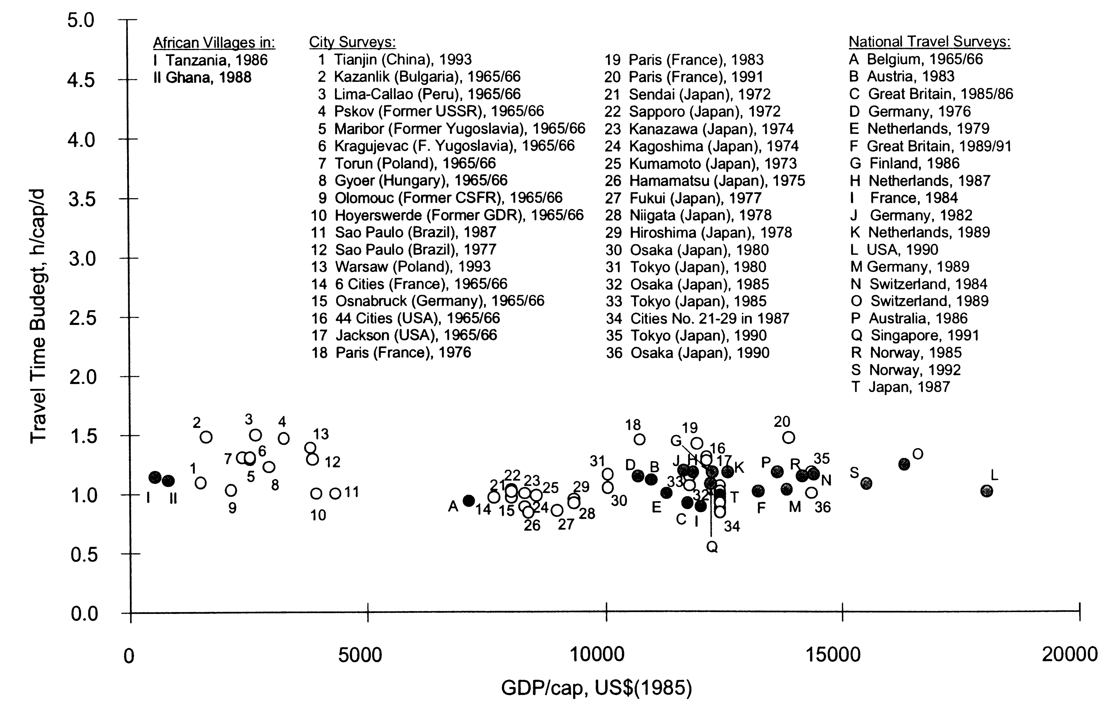

Figure 25: Average per-capita travel budget for various localities and regions across the GDP spectrum   
*Schafer & Victor (2000)*

South African cities are not notably dense, and the poor tend to live in satellite ‘townships’ far from employment nodes, which suggests that the travel time budget in South Africa may be different. Victor and Schafer however argue that the share of travellers to total population tends to be lower in low-income groups and therefore the time budget when converted to an average per person in the population is similar to high-income groups. This has been eloquently expressed by Schafer as follows (Schafer, 2006):

*“Although the amount of time spent traveling is highly variable on an individual level, large groups of people spend about 5 percent of their daily time traveling….. On average, residents in African villages, the Palestinian Territories, and the suburbs of Lima spend between 60 and 90 minutes per day traveling, the same as for people living in the automobile dependent societies of Japan, Western Europe, and the United States.”*

Schafer and Victor raise the caveat that the stability of average travel time budget holds only for travel by all modes and that time spent in motorised modes rises with income and mobility as people shift from slow non-motorised modes to motorised travel. As this shift tends to completion, however, total motorised travel approaches 1.1 hours. Thus an analysis across income groups must consider that at the lower income end the time budget will include some non-motorized transport, walking for instance which would be less, at the upper income end of the scale but for a large population the average time budget for all income groups will be around 1.1 hours.

### Using the Time Budget Model to Project Demand for Passenger Travel on Land

The projection of energy demand for land transport required an exogenous input of future passenger travel, in passenger.km, into the time budget model. The method used to calculate the demand for passenger travel can be summed up as follows:

* Passenger demand for road and rail was modelled for three income groups representing low-, medium- and high-income households. This was done because growth of private transport over low speed public modes is strongly related to household income. The low-income group includes households with income of up to R19 000 per annum (in 2007 rands), the middle-income group includes households with an income between R19000 and R76 800 and the high-income group the remainder.
* Motorisation (car ownership) per capita for each of the income groups was estimated for the base year using survey data (DoT, 2005).
* Assumptions around ratios of public and private transport, average speed and travel time budget were made for each of the income groups and used to calculate their net demand for passenger travel. Due to the sparseness of activity data the model was calibrated to match the vehicle parc model for only two modes, private and public, for the base year of 2006.
* Mobility not met by private transport was assumed to be met by public transport (for example minibus, bus, metrorail, BRT or rapid train) and distributed between modes according to anticipated investment in infrastructure supporting each of the modes.

Population projections under each income group were used to project the travel time budget of each income group in the future. The calculation of travel demand was made as follows where i is one of 3 income groups and j is one of two modes, public or private:

${PKM}_{ }=\sum_{i=1}^{i=3}{\sum_{j=1}^{j=2}{ {(F}_{ij} × S_{j} × T_{i} ×N_{ij})}}$***Equation 8***

PKM = Total passenger.km per year

Fij = Fraction of annual time budget spent travelling in motion on mode j by income group i. This excludes time spent walking and waiting to make use of mode j.

Sj = Average speed of mode j

Ti = Travel time budget per person per year for income group i

Nij = Number of people in income group i using mode j

The variable Fij is the fraction of time spent actually travelling and must therefore be adjusted to exclude time spent walking and waiting to make use of the mode as follows:

$F_{ij}=\left(1-F_{w_ij}\right)×F_{T_ij}$***Equation 9***

Fij = Fraction of annual time budget spent travelling in motion on mode j by income group i. This excludes time spent walking and waiting to make use of mode j.

Fw_ij = Fraction of time spent walking and waiting when using mode j

FT_ij = Total Fraction of annual time budget spent travelling in on mode j by income group i.

The number of people with access to a private vehicles in each income group which is the variable Nij,for the private travel mode, was estimated based on the National Household Travel Survey undertaken in 2003 (DoT, 2005). The survey found that 75% of households in the high-income group had access to a car but that only 26% of households across all income groups had access to a car. The critical assumptions in Table 38 below are:

* Car ownership/access – the % of people in an income group with access to a car.
* Cars per person with access to a car – the number of cars per person having access to a car.

If we assume these remain constant over the projection period we can estimate the number of cars for each future year as the population in each income group changes over time.

Table 46: Assumptions and checks used to estimate access to private vehicles by income groups – base year (2006)

|  |  |  |  |  |  |  |  |
| --- | --- | --- | --- | --- | --- | --- | --- |
|  |  | **Traveller group** | | | |  |  |
| **Model variable** | **Unit** | **Low- income** | ***Middle- income*** | **High-income** | **Comp./ gov/car rental** | **Total/avg** | **Calib. check** |
| Annual income (percentile) | (%) | 50% | 30% | 20% |  |  |  |
| Population | million | 23.44 | 14.06 | 9.37 |  | 46.88 |  |
| *Car ownership/access* | ***% of pers*** | ***7%*** | ***23%*** | ***78%a*** |  | ***26%*** | ***26%b*** |
| *Cars per person with access to car* | ***cars/pers*** | ***0.25*** | ***0.30*** | ***0.40*** |  |  |  |
| Calculated total cars | m veh | 0.41 | 0.96 | 2.94 | 0.68 | 4.987 | 4.987c |
| M/cycle ownership | % of pers | 0.1% | 0.4% | 1.4% |  |  |  |
| Total m/cycles | m veh | 0.03 | 0.06 | 0.13 | 0.05 | 0.27 | 0.27c |
| Persons with access to a private vehicle |  | 7% | 23% | 79% |  |  |  |
| Private vehicles/person with access to vehicle | veh/pers | 0.25 | 0.31 | 0.41 |  |  |  |
| Persons with access to a private vehicle | million pers. | **1.67** | **3.24** | **7.44** |  |  |  |
| Persons without access to a private vehicle | million pers. | **21.77** | **10.82** | **1.94** |  |  |  |
| *a: The NHTS* (DoT, 2005)*had 5 income categories rather than the 3 of this study. The 2 highest together accounted for just over the 20th percentile of the population of households and had an average access rate to a car of 75% which has been increased slightly to take account of the lapse of 3 years since the study.*  *b: NHTS* (DoT, 2005)  *c: Fleet size of the Vehicle Parc Model.* | | | | | | | |

There is a sparsity of data which shows representative average speeds of traffic on South African roads. Clearly local circumstances as regards congestion and road type are enormously variable, and establiishing average speeds on all roads would be an immense undertaking. In a study which developed a speed based emission inventory model for the City of Johannesburg Goyns (2008) sampled the speed of thirty vehicles for a total of 716 hours covering 29 587 km in 2006/2007. The results indicated an average trip duration of 17 minutes, an average trip distance of 11.5 km and an average speed of 41 km/h (Goyns, 2008). The time budget model was, however, as one would expect, very sensitive to average speed and the speeds measured by Goyns did not allow for a time budget as high as 1.1 hours. A compromise was made by assuming the average speed Sprivate of private transport to be 34 km/h, the average speed of the NEDC emissions test cycle (Dieselnet, 2000) used in Europe which is meant to be representative of urban driving including a portion of highway driving.

Table 47: Total distance, time and speed for the new European drive cycle

|  |  |  |  |
| --- | --- | --- | --- |
| **Phase** | **Distance** | **Time** | **Average Speed (km/h)** |
| (km) | [sec] |
| 1 (ECE 15) | 4.052 | 780 | 18.7 |
| 2 (EUDC) | 6.955 | 400 | 62.6 |
| NEDC: ECE15 + EUDC | 11.007 | 1180 | **33.6** |

The speed of public transport Spublic was assumed to be significantly lower at 20 km/h. Thus to calibrate the time budget model, Fij the fraction of the annual time budget spent on mode j by income group i was varied until the passenger travel demand and total vehicle km for each mode matched that of the vehicle parc model. Table 40 presents the estimates of the variables for Equation 4 and Equation 5. A good calibration was attained for reasonable values of F given our assumptions for time budget T and average speed S. It may well be that average speeds in South Africa are higher and that for the time being the time budget of private travelers in particular is moderately less than 1.1 hours per day but it is proposed that a calibrated time budget model with at least plausible estimates for the variables will give a better estimate of future passenger.km than simple extrapolation of demand into the future.

Table 48: Time budget model assumptions for calculating passenger travel demand for public and private modes

| **Variable** | **Traveller group** | | | | **Total** | **Calib. check** |
| --- | --- | --- | --- | --- | --- | --- |
| **Low- income** | **Middle- income** | **High-income** | **Comp./ gov/car rental** |
| **1. All modes** | | | | | | |
| Ti (hours/day/person)b | 1.1 | 1.1 | 1.1 |  |  |  |
| Annual travel daysc | 300 | 300 | 300 |  |  |  |
| Ti (hours/year/person) | 330.00 | 330.00 | 330.00 |  |  |  |
| **2. Public – no access to car** | | | | | | |
| Fw_ij d | 42% | 42% | 42% |  |  |  |
| FT_ij | 100% | 100% | 100% |  |  |  |
| Fij | 58% | 58% | 58% |  |  |  |
| Sj (km/h) | 20 | 20 | 20 |  |  |  |
| Ni (106 persons)e | 21.77 | 10.82 | 1.94 |  |  |  |
| PKMij (109 p.km) | 83.34 | 41.42 | 7.41 |  | 132.17 |  |
| **3. Public – access to car** | | | | | | |
| Fw_ij d | 42% | 42% | 42% |  |  |  |
| FT_ij | 75% | 48% | 11% |  |  |  |
| Fij | 44% | 28% | 6% |  |  |  |
| Sj (km/h) | 20 | 20 | 20 |  |  |  |
| Ni (106 persons)e | 1.67 | 3.24 | 7.44 |  |  |  |
| PKMij (109 p.km) | 4.79 | 5.96 | 3.13 |  | 13.9 |  |
| **Total public PKM (109 p.km)** | **88.13** | **47.38** | **10.54** |  | **146.1** | **147.0a** |
| **4. Private** | | | | | | |
| Fw_ij | 0.00 | 0.00 | 0.00 |  |  |  |
| FT_ij d | 25% | 52% | 89% |  |  |  |
| Fij | 25% | 52% | 89% |  |  |  |
| Sj (km/h) | 34 | 34 | 34 |  |  |  |
| Ni (106 persons)e | 1.67 | 3.24 | 7.44 |  |  |  |
| PKMij (109 p.km) | 4.6830 | 18.92 | 74.26 | 18.87f | 116.7 | 118.6a |
| **Total PKM (109 p.km)** | **92.81** | **66.30** | **84.80** | **18.87** | **262.8** | **265.5a** |
| *a: p.km output of the Vehicle Parc Model for 2006.*  *b: See* (Schafer & Victor, The Future Mobility of the World Population, 2000)  *c: Author’s assumption*  *d: Author’s assumption adjusted so that time budget model calibrates to vehicle parc model for 2006*  *e: See Table 38 above for the estimate of these numbers*  *f: Estimated from the number of these vehicles in the vehicle parc model and fixed assumptions of 18,000 km annual mileage and occupancy of 1.4 persons/vehicle* | | | | | | |

To summarise: the time budget model allowed us to generate passenger travel demand for each year of the projection from exogenous values of future population and income. Essentially the premise of the model is that private vehicle passenger demand will increase not only with population growth but also as the proportion of the population in the middle and higher income groups increases. The rate of increase will saturate if the high income group becomes dominant. The time budget model also affords the flexibility to investigate scenarios such as:

* a scenario of reduced average speeds due to congestion;
* a scenario of higher public transport speed due to implementation of brt and high speed rail;
* time budgets specific to income groups; and
* a scenario of public mode walking and waiting time.

While this sub-model could arguably be more disaggregated it is appropriate to local data availability and is a great improvement on the assumption of simple linear growth of passenger travel demand with population growth that underpins many projections of transport energy demand.

The mobility of the future population between the income groups defined above is clearly critical to the projection of demand for passenger travel. As shown in Figure 13 above this input was derived from an analysis of the results of a Computable General Equilibrium (CGE) model made available by a collaborating research group. This CGE model for South Africa was developed to study the economic implications of introducing carbon taxes in South Africa for the purpose of greenhouse gas emissions mitigation (Alton, et al., 2012). Our study used this CGE model to estimate the probable future evolution of household income in South Africa, for the 3 income groups used by the travel time budget model, given a moderate and stable GDP growth of 3.9% between 2010 and 2030. The same method was used to project future appliance ownership for the Residential sector and is discussed in more detail with regard to that in Section 0 below.

## Projecting Demand for Freight on Land

The sector GDP projections of the CGE model also formed the basis for the freight model. Clearly as GDP grows the quantity of goods that must be transported grows proportionally and we can model this simplistically as follows:

TKMi = ei X (1 + GRGDP)i X TKMi-1 ***Equation 10***

Where:

TKM = demand for freight transport in units of ton.km

ei = the elasticity of freight demand with respect to transport GDP

= (1 + % change in freight demand)/(1 + % change in GDP)

GRGDP = transport GDP growth rate

The sectors relevant to freight demand (transport, mining and iron and steel) were projected to grow as shown in Figure 23 by the CGE model base case until 2030, the CGE projections are extrapolated from 2030 to 2050.

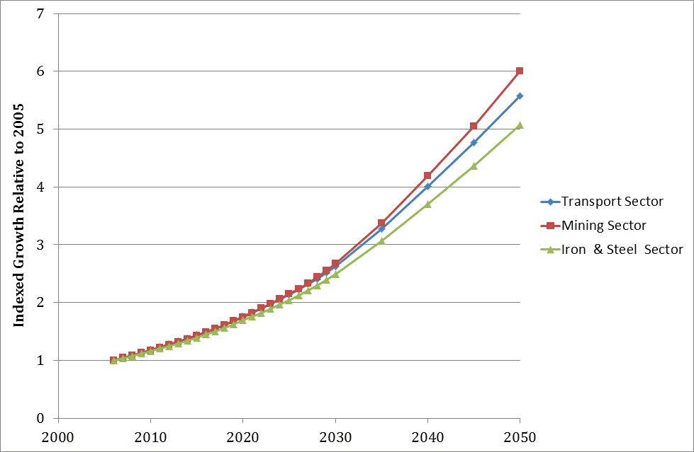

Figure 26: CGE model output for annual household consumption 2005-2030 by deciles of households  
*Author’s calculations using data from Alton et al. (2012)*

Their difference in growth is small in the projection window, only diverging after 2030. Therefore transport sector GDP growth was taken as GRGDP for the land freight modes, road and rail.

Data was not available for the elasticity of demand for freight ei and this was taken as 0.8. This results in a threefold increase in the demand for freight transport between 2005 and 2050. This is an area where future research can contribute to better estimates of growth in freight demand. A particular concern is that a transition to a less energy intensive service economy could translate to a long-run elasticity significantly less than 0.8.

The freight demand for rail in the base year of 2006 was assumed to be that published in the CSIR’s State of Logistics Report (Ittmann, King, & Havenga, 2009) disaggregated into corridor, rural, urban and bulk mining freight. This was combined with the road freight demand estimated by the vehicle parc model and the road/rail splits for corridor and for rural/urban freight estimated as shown below. The base case assumed that these remain the same till 2050 and an energy efficient scenario that included a shift back from road to rail could be modeled.

Table 49: Organisation of road and rail freight demand such that the road/rail split can be kept constant for the base case

|  |  |  |  |
| --- | --- | --- | --- |
| **Mode** | **Freight 2006 (t.km)** | **Road / rail split 2006 (%)** | **Assumed base case road / rail split 2050 (%)** |
| Transport freight by road – LCV | 14 |  |  |
| **Road vs rail – rural/urban freight#** | | | |
| Transport freight by road – MCV | 9 | 26% | 26% |
| Transport freight by rail – other | 26 | 74% | 74% |
| **Road vs rail – corridor freight#** | | | |
| Transport freight by road HCV* | 120 | 81% | 81% |
| Transport freight by rail corridor | 28 | 19% | 19% |
| Transport freight – rail export (bulk mining) | 67 |  |  |
| **Total** | **265** |  |  |
| *\* In practice a portion of this NAAMSA category are rigid trucks active in urban/rural freight.*  *# The total of road and rail freight is grown with exogenous GDP estimate and then disaggregated by the road/rail split* | | | |

## Calculation of Future Energy Demand from Road Vehicles

First a projection for vehicle-km is calculated for each demand using an occupancy (passenger/veh for passenger vehicles) or load factor (tons/veh for freight):

${ Passenger VKM}_{ti}=\frac{{PKM}_{ti}}{O_{ti}}$***Equation 11***

${ Freight VKM}_{ti}=\frac{{TKM}_{ti}}{L_{ti}},$***Equation 12***

Where:

*VKMti* = vehicle-km projection for demand *i* in year *t*,

PKMti = passenger-km projection for passenger demand *i* in year *t*,

TKMti = ton-km projection for freight demand *i* in year *t*,

Oti = vehicle occupancy for passenger demand *i* in year *t*,

Lti = loading for freight demand *i* in year *t*.

Then, each year, the shortfall in vehicle-km capacity for each demand *i* (e.g. private cars) is calculated by taking the difference between the capacity of the vehicle parc for demand *i* in that year and the vehicle-km demand projection for that year, and used to calculate the total vehicle sales for vehicles that year. Since vehicle vintages are tracked, the ‘sales’ calculation is for the vintage for that year.

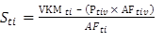 ***Equation 13***

Where:

Sti = Sales in year t for vehicles vintage t that can meet demand i,

Ptiv = Population of vehicles vintage v in year t that can meet demand i (this changes

each year as vehicles from the vintage are scrapped),

AFtiv = Average km/year that vehicles vintage v is expected to drive (this decreases as the vehicles get older).

Then shares of the sales for technologies competing for a particular demand are imposed (different ones for different ones for different scenarios) exogenously. Assuming that all technologies for a particular vintage have the same capacity (drive the same number of km per year) and that their capacity will be fully utilized allows us to calculate the fuel used by each technology as follows:

 ***Equation 14***

Where:

Ftijv = Fuel used in year t to meet demand i by technology j, vintage v,

Etijv = Fuel economy (l/100km) for technology j, vintage v, in year t to meet demand i.

# Residential Sector

The modelling process in the Residential sector is faced with both energy consumption data challenges and structural challenges due to the great diversity in energy consumption patterns of households, the basic building blocks of the sector (Senatla, 2012). Households vary widely in their energy profile and the sector is made up of many of these small diverse users. The challenge is therefore to trade-off model detail, computational effort and data availability. Typically national surveys are the primary source of data on households and in general these characterise households by their income, dwelling type, demographic profile and other households characteristics. Income appears to be the best determinant of both the type and quantitiy of energy used by households in South Africa and household income therefore forms the first level aggregation of end users. The compromise that was reached with SATIM was to group household income groups that have similar energy consumption characteristics. The purpose of household groupings is to be able to build a model which can incorporate and react to the following:

* Energy use profiles and consumption levels across income groups
* The movement of households between income groups
* Policy interventions which target certain households (i.e. an increase in residential electricity tariff for high energy consumers)
* Mitigation actions relevant to a specific household group (i.e. a solar hot water heating programme on low income households)

## Model Structure

### Household classification process

Determining the household groupings involves balancing model simplicity against model versatility allowing policy options and future scenarios to be captured (Senatla, 2012). Each iteration of SATIM provides a possibility for sectoral improvement although problems with data have in certain cases required devolution. The LTMS’s disaggregation of households by income, electrification status and rural/urban divide has, for instance, generally been considered the most comprehensive grouping as it was informed by a stakeholder engagement process. The current model however groups households by income and electrification status only since Statistics South Africa[1] no longer provides households data by urban or rural classification and there is no intention of so doing in the future as this classification is argued to be unhelpful for development purposes.

Therefore, based on data from the Statistics South Africa’s 2007 Community Survey, National Income Dynamics Study (NIDS) and All Media and Products Survey (AMPS), households were classified into the 5 groupings shown below in Table 42.

Table 50: Households grouping in current South African TIMEs Model (SATIM)

|  |  |  |
| --- | --- | --- |
| Household grouping | Number of households | Percentage share (%) |
| Low Income electrified | 4,089,009 | 33% |
| Low income non electrified | 1,654,030 | 13% |
| Middle income electrified | 3,553,678 | 28% |
| Middle income non electrified | 747,667 | 6% |
| High income | 2,367,588 | 20% |
| Total | 12,500,610 | 100% |

Low‐income households have a household income of under R19 000 in 2007, middle‐income households had an income between R19 000 and R76 800 in 2007 and high-income households had income above R76 800. The choice of three income bands and the income split was influenced to a large extent by electrical appliance ownership. Electricity is the dominant fuel in the residential sector and consumption of electricity by households in the income bands is driven by appliance ownership (Beute, 2010), (Dekenah, 2010) (Gertler, Shelef, Wolfram, & Fuchs, 2012). High income households tend to own more appliances and as a result they consume more electricity. Using appliance ownership to disaggregate households by income seems reasonable as appliance ownership is itself strongly related to household disposable income. Electricity usage data and electrical appliance data came from differing sources with differing income band classifications; therefore the approximate income bands from the appliance ownership analysis were used.

The energy intensive appliances shown in Table 43 were used for the analysis of categorising households. These appliances were used because they contribute significantly to the electrical load profile while less intensive appliances such as television sets and radios do not contribute significantly. The analysis started with analysing saturation levels in thresholds of 10% - 90% in different income bands. For example if analysis is at 10th percentile, households in any particular income band which showed 10% ownership of the appliances shown in Table 43, that income band will have a tally of 1, else 0. Figure 24 shows the results of 10% - 90% saturation thresholds. The 70th percentile was found to be similar to the indexed average ownership trend shown in Figure 25, and it was chosen as the appropriate percentile for categorising households.

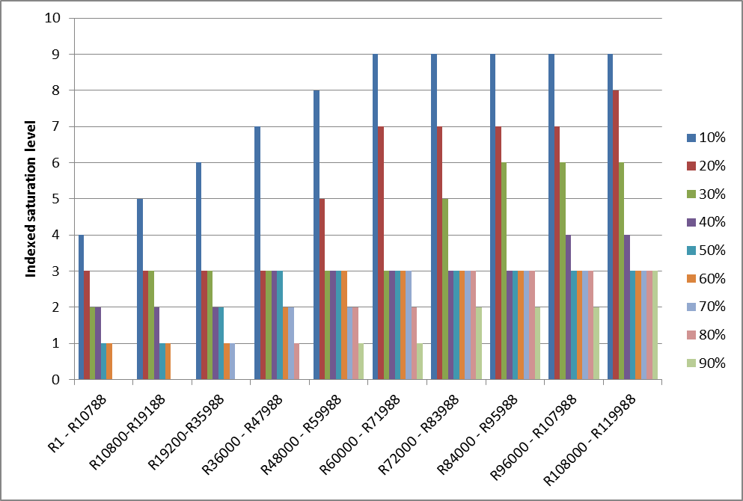

Figure 27: Appliance saturation levels

By using the 70th percentile, it was found that low income households earned an income that is less than R19 188 (which is very close to R19 200 for low income households of this study from Statistics South Africa), middle income households earned an income between R19 200 and R71 988 (which is close to the middle income households cut-off point of R76 000 from Statistics South Africa) and high income households earned above R72 000[2]. Figure 25 shows the indexed average ownership of all thresholds of appliances shown in Table 43.

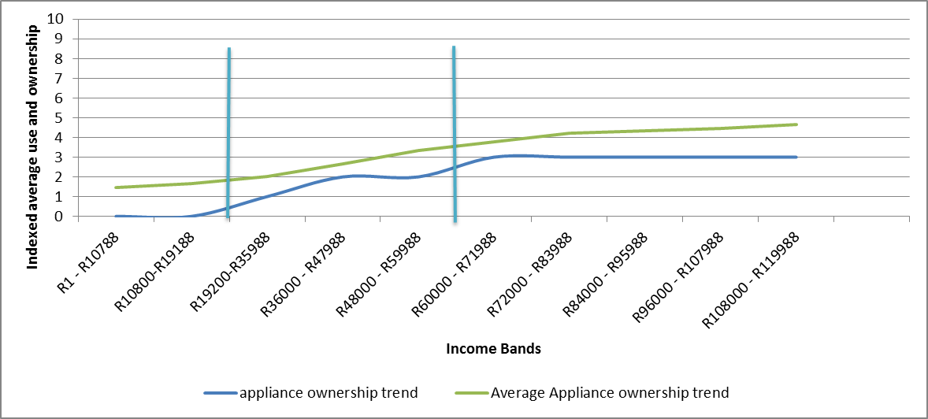

**Low Income**

**Middle Income**

**High Income**

Figure 28: Indexed households appliance ownership

Source: Derived from All Media Products Survey, 2007 and Statistics South Africa 2007

Table 51: Energy Intensive Appliances

|  |
| --- |
| Electric Stove |
| Other Gas Or Coal Stove |
| Microwave Oven |
| Refrigerator |
| Free Standing Deep Freezer |
| Vacuum Cleaner |
| Dishwasher |
| Auto Front Loading Washer |
| Auto Top Loading Washer |
| Semi-Auto Twin Tub |
| Tumble Dryer |

Source: chosen from AMPS (2007)

Having decided on the households’ groupings, it is essential to delve into end use fuel consumption and technologies used for the base year calibration. The residential sector is modelled with demands (end uses) for:

* Lighting,
* Cooking,
* Space heating,
* Water heating,
* Refrigeration
* “other” end uses

Some of these end uses are met with different fuels. For base year calibration, the model needs:

* Energy intensities of energy services
* Technologies and associated fuels used for the end uses
* Technology shares in low, middle and high income households
* The different household groupings (low, middle and high income households)
* Technology investment and operating costs
* Technology efficiencies and lifetimes

The national income dynamic study (NIDS), AMPS datasets and other small studied were collated to estimate the technology ownership shares of all appliances in the residential sector.

Information on the main fuel used for heating, lighting and cooking across different income groups is collected routinely by Statistics South Africa in the census, community surveys, and the general household survey. These surveys do not however provide a quantitative overview of energy consumption patterns and energy end-use characteristics of different households. Therefore, quantitative data on energy consumption in South African households is limited. This is partly due to historically poor energy data collection systems which have worsened over the past decade, the inaccessibility of household specific electricity consumption data, as well as challenges related to the recording and quantifying of multiple fuel use by households. This lack of quantitative energy consumption data required some consolidation of end use energy data from a range of studies, including micro-level studies (communities, villages etc) from various sources. The data collated from micro-level studies on household energy use was cross checked with energy consumption data from energy balances from the Department of Energy, Load Research data by Enerweb, the LTMS study, ESKOM, National Energy Regulator of South Africa (NERSA) and the South African Petroleum Industry Association (SAPIA).

## Compiling the Base Year Consumption Data - Assumptions and Issues

The main sources for residential data related to energy consumption and output are:

* 2007 Community Survey data,
* National Income Dynamics Study (NIDS),
* All Media and Products Survey (AMPS)
* Department of Energy
* from the previous LTMS,
* ESKOM, in particular the Domestic Load Research Database (NRS 034).
* National Energy Regulator South Africa (NERSA),
* South African Petroleum Industry Association (SAPIA).

The residential sector base year data in SATIM has a greater number of discrepancies with the national energy balance than the other sectors and estimates of all the energy carriers except paraffin differ markedly as shown below.

Table 52: Comparison of Estimates of the Aggregate Consumption of Fuels (PJ) by the Commercial Sector for the SATIM Model and the DOE Energy Balance for South Africa - 2006

|  |  |  |  |  |  |
| --- | --- | --- | --- | --- | --- |
| Fuel | Electricity | Oil Paraffin | Coal | Biomass Wood | Oil LPG |
| SATIM | 158.9 | 22.6 | 26.8 | 125.8 | 1.9 |
| DOE EB | 142.8 | 22.9 | 152.6 | 190.4 | 13.4 |

These differences are accounted for as follows:

* As is the case with the Industry and Commerce sectors, a portion of the 35PJ or 5% attributed to the ‘General/Unspecified’ Category of sales in 2006 by the National Regulator’s statistics (NERSA, 2006) has been apportioned to the Residential Sector.
* As described in the review of the Industry Sector, a bottom-up calculation of household coal use in the Residential Sector yielded a much lower number than the national energy balance and the excess coal has been attributed to the Industry Sector.
* Similarly, a bottom-up calculation of biomass use in the Residential Sector, including extensive surveys undertaken by the ERC itself, yielded a much lower number than the national energy balance. A portion of the difference is accounted for by the Pulp and Paper and Food and Beverage sub-Sectors of the Industry Sector as described previously.
* No data for LPG usage has been found in the public domain for South Africa and at this time only nominal amounts have been attributed to LPG consumption by all the sectors in SATIM. LPG technologies can be selected in the future by the model but the base year situation has yet to be resolved.

## Assumptions and constraints for reference scenario in the residential sector

Scenario based energy modelling requires a development of differing scenarios which are underpinned by assumptions in the form of “What If?” analysis. In such a modelling exercise, there is always a reference scenario (also termed business-as-usual scenario) which will be changed or modified to construct other scenarios. A scenario is made up of assumptions on future fuel use, fuel prices, and technology costs in different sectors, technology efficiencies and changes on technology market shares. This section explains the critical assumptions and constraints that were used to construct the reference scenario and how those assumptions were made for each of the sectors that were modelled.

To consume energy, a wide range of technologies is used and it is vital to predict how the technology availabilities and use thereof will evolve throughout the modelling period. In disaggregated sectors such as the residential sector and transport sectors, mobility of households from any of the three household categories (as defined above) has to be predicted throughout the modelling period. In the residential sector, the key energy demand driver is population growth but since energy is consumed in households and the model is configured around households, the key assumptions to be defined is splitting the growing population population growth into the three household categories over the modelling period.

### Projecting the Evolution of Household Income

To translate population into households, population conversion fraction to household fraction is required. This proposed conversion fractions have to take into account the household sizes of different household categories. Using demographic data from Statistics South Africa’s censuses (1996 and 2001) and Community Survey 2007, it was observed that high income households had a household size of 2.41 people per household, middle income 2.97 people per household and low income household an average household size of 4.34 people per household in 2007. For simplicity, household sizes were assumed to be constant throughout the modelling period, but the movement of households from one income band was assumed to change relative to assumed changes in GDP growth, labour market growth.

There are two significant assumptions that underpin mobility of households, and these assumptions are centred on the variables that are used to categorise households. These variables are the rate of electrification in non-electrified households and mobility of households from one income band to another income band. For household income mobility, the computable general equilibrium (CGE) model ESAGE (which is a detailed economic model) is used to estimate the probable future evolution of household income in South Africa, for the 3 income groups used. The CGE model deals with actual expenditure within households and households are divided into deciles with the highest income decile split into quintiles as shown in Table 45.

Table 53: Mapping of Stats SA Income and Expenditure Survey Categories and CGE Modelling Results to Three Income Categories

|  |  |  |  |  |  |  |
| --- | --- | --- | --- | --- | --- | --- |
| SATIM | Stats SA Income & Expenditure Surveys | | | CGE model | | |
| Income Band | Fraction of households | Aggregation | Average household consumption | Fraction of households | Household categories (Share) |
| Low Income | No income | 9.10% | 46% | R 13 662.00 | 10% | 50% |
| R1 - R4800 | 5.50% | R 23 492.00 | 10% |
| R4 801 - R9 600 | 9.90% | R 28 384.00 | 10% |
| R9 601 - R19 200 | 21.10% | R 32 426.00 | 10% |
| Middle Income | R19201 - R38 400 | 21.40% | 34% | R 38 645.00 | 10% |
| R 44 464.00 | 10% | 30% |
| R38 401 - R76 800 | 13.00% | R 53 566.00 | 10% |
| R 74 354.00 | 10% |
| High Income | R76 801 - R153 600 | 8.70% | 20% | R 141 306.00 | 10% | 20% |
| R153 601 - R307 200 | 6.10% | R 208 067.00 | 2% |
| R307 201 - R614 400 | 3.30% | R 244 258.00 | 2% |
| R614 401 - R1 228 800 | 1.10% | R 292 088.00 | 2% |
| R1 228 801 - R2 457 600 | 0.40% | R 364 406.00 | 2% |
| R2 457 601 or more | 0.30% | R 596 546.00 | 2% |

To match the actual expenditure results from the CGE model with the TIMES energy model, it was necessary to map the CGE results for 14 income groups to the three household categories required for residential modelling. Thus in the first year of the CGE model our 3 income groups contain 50%, 30% and 20% of all households but as the consumption of deciles rises in future years and they exceed the fixed threshold of the income group, more households will migrate from the lower to the middle group and from the middle income to the higher income group.

### Assumptions on future technology share

As SATIM is an optimisation model, which aims to meet energy services at a least cost, the analyst has to define constraints and bounds on technology uptake in the future, because if no bounds are made, the cheapest technology will always be chosen by the model. Upper and lower limit bounds are ascribed to technologies in the residential sector, these are defined for each technology individually, a generic example of the way technology shares are assigned is shown in Table 46. The upper and lower limit can be defined as the maximum and minimum technology share that a particular technology can take.

Table 54: Generic Example of Assumed technology limit shares

|  |  |  |  |
| --- | --- | --- | --- |
| Years | 2010 | 2030 | 2050 |
| Default Upper Limit Share (%) | 5% | 25% | 50% |
| Default Lower Limit Share (%) | 50% | 25% | 5% |

## Future Demand for Energy from the Residential Sector

Projections of future demand are done in terms of the demand for energy services or “Useful energy” (e.g. cooking, lighting, etc.) rather than in terms of “final energy” (e.g. paraffin, LPG, etc.) to allow for a better study of the substitution between alternative fuels, as well as an appraisal of the effect that evolution of the technological improvements has on projections of fuel requirements.

In SATIM the drivers of demand for energy by the Residential Sector are population and household income growth. The critical assumptions are the future population in each of our three income groups, the future income of those groups and the elasticity of energy consumption with respect to income for a given energy service.

Elasticities are assumed to decrease with increasing income which is intuitive because at a certain income level a household will become saturated with energy intensive appliances. The following table illustrates the structure of the elasticity assumptions:

Table 55: Illustrative Example of Assumptions of the Elasticity of Useful Energy Use by Household with respect to Household Income for increasing household income

|  |  |  |  |  |  |
| --- | --- | --- | --- | --- | --- |
| **Energy Service** | **Household Income Threshold (000 Rands)** | | | | |
| **15** | **40** | **100** | **400** | **>400** |
| Lighting | 0.7 | 0.6 | 0.3 | 0.2 | 0.1 |
| Cooking | 0.5 | 0.4 | 0.1 | 0.05 | 0 |
| Space Heating | 0.7 | 0.6 | 0.4 | 0.2 | 0.1 |
| Water Heating | 0.7 | 0.6 | 0.3 | 0.1 | 0 |
| Refrigeration | 0.8 | 0.7 | 0.4 | 0.1 | 0.05 |
| Other | 0.7 | 0.6 | 0.4 | 0.2 | 0.1 |
| Non Energy Uses* | 0.7 | 0.6 | 0 | 0 | 0 |

*\*: Mostly use of paraffin to polish cement floors*

Thus given that we can estimate an energy intensity (per capita energy usage) for our income groups and energy services from our base year data, we can project future energy intensities by iterating from estimated base year energy intensities as follows:

EIijn = Energy Intensity for income group i using energy service j in year n (GJ/per person/year)

εij = Elasticity of Useful Household Energy Consumption with respect to Household Income of Income

Group i for energy service j

ΔIin = Growth in income of income group i in year n (%)

EIijn = EIij(n-1) X (1 + εij X ΔIin) Equation 15

The demand for residential energy, as represented by this model, is therefore strongly dependent on two assumptions, the future transition of people to an income group with a higher energy intensity and the growth of average real income within the high income group which will increase the energy intensity of the people that remain in that group. The Low and Middle Income groups are assumed to have a constant average income.

For the purposes of estimating residential energy demand the electrification rate has a large impact for the Low and Middle Income groups, where not all households are electrified. Thus an exogenous projection of the electrification rate is required to derive a population split between the five income groups. This is based on historical trends and future government/Eskom targets which yields the following assumption:

Table 56: Assumed Future South African Electrification Rates by Income Group

|  |  |  |  |  |  |  |
| --- | --- | --- | --- | --- | --- | --- |
| **Income Group** | **2006** | **2010** | **2020** | **2030** | **2040** | **2050** |
| Low Income | 71% | 71% | 80% | 85% | 90% | 95% |
| Middle Income | 83% | 83% | 90% | 95% | 95% | 100% |
| Overall Electrification | 80% | 81% | 90% | 95% | 97% | 100% |

These shares can be applied to the 3 group income split shown in **Error! Reference source not found.** to estimate a projected future population share for the 5 income/electrification groups as used in Table 42. The resulting population split across 5 income categories can be calculated by multiplying the this population share with the projected population and this can be combined with the other assumptions described to calculate future useful energy demand as follows:

Uijn = Useful energy demand for income group i using energy service j in year n (GJ)

EIijn = Energy Intensity for income group i using energy service j in year n (GJ/per person/year)

Pin = Population of income group i in year n (persons)

Uijn = EIijn X Pin Equation 16

# Supply of Energy from the Electricity Supply Sector

Electricity production in South Africa was estimated to account for 50% of total greenhouse gas emissions in 2000, by far the largest sectoral source (Mwakasonda, 2009). This stems from a reliance on coal-fired power plants and has resulted in South Africa being one of the world’s most carbon intensive economies. Unsurprisingly, given this profile, the sector’s critical economic importance and high costs in public funds, the electricity supply system has been modelled (with various limitations and constraints) more than any other part of the energy system in South Africa, and data is relatively good on the activity, stock and costs of the system and its existing technologies as well as technology options for the future.

## Model Structure

The power sector is split into Generation, Transmission and Distribution. In SATIM, the Generation component is modelled in the most detail. Since the country is modelled as a single node, transmission is modelled as a single technology linking centralised/high voltage electricity (ELCC) to medium voltage levels (ELC). The medium voltage electricity is distributed to each sector using a different technology to capture the different losses incurred in the different sectors. This is depicted in the figure below. Note that for purposes of simplicity, the supply technologies and sector distribution legs have been shown in aggregate form

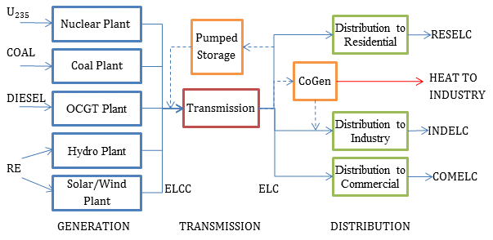

Figure 29: Simplified Schematic of SATIM Model of the South African Power Sector

Technologies such as pumped storage are modeled as consuming power from the transmission system and feeding output back into the system; cogeneration options are modeled after transmission and feed power back onto the grid at that point (industrial electricity demand), and also generate heat which contributes to the industrial heat demand. Aggregate losses are modeled for transmission and distribution. The model is a one-region model and so there is no impact on results from shifting generation from current locations to more dispersed locations (for instance as a result of developing a significant amount of renewable energy capacity). The structure and assumptions underlying the transmission, distribution and generation components of SATIM are briefly discussed below.

## Transmission

In brief, the transmission system is modelled as follows:

* The Transmission technology captures the national average transmission losses, in converting ELCC to ELC. Currently this is estimated at 3.8%
* An existing stock/capacity for the transmission technology is estimated based on the peak demand in the base year plus a reserve margin. For the base year of 2006, this is currently estimated as 31.8 GW.
* At the time of writing the following additions are being made to the model:
  + The operating cost of is set to reflect the estimated running cost of this infrastructure.
  + The investment cost of new transmission capacity is set to reflect estimated average cost of investment.
  + A reserve constraint is imposed on ELC to ensure the reserve is maintained.

## Distribution

The legs of the distribution system supplying each sector are modelled as technologies as follows:

Table 57: Distribution Technologies in SATIM

|  |  |
| --- | --- |
| **Distribution Leg** | **Technology Code in SATIM** |
| Electricity to Agriculture | AGRELC |
| Electricity to Commerce | COMELC |
| Electricity to Industry | INDELC |
| Electricity to Residential | RESELC |
| Electricity to Transport | TRNELC |
| Electricity to Upstream (Refineries) | UPSELC |

In brief, these distribution legs are modelled as follows:

* The distribution technologies capture the average losses incurred by each sector. The capacity is set according to the peak demand in each sector plus the reserve margin
* A reserve constraint is imposed on each distribution technology to ensure the reserve is maintained.
* At the time of writing the following additions are being made to the model:
  + The operating cost of the distribution technology is being set to reflect the average tariff seen by each sector
  + The investment cost of new distribution capacity is set to reflect average cost of investment
  + Currently all sectors are modelled to experience electricity supply at national average distribution losses (10%). Large industries may however have their own proximate substation supplied at the very highest distribution voltage so losses would be lower than is currently modelled in SATIM. This is in the process of being amended.

## Generation

The structure and assumptions used to model existing and future generation technologies are dealt with in greater detail below. There are two main groups of power plants in the model:

* Existing/old Power Plants (before 2010)
* New/Future Power Plant Technologies (from 2010 onwards) available to the model optimiser.

As noted above the South African power sector has been extensively modelled and the data exists to model the system in some detail. Furthermore TIMES offers the potential for a high degree of parameterization, particularly of technologies. The current level of parameterization in SATIM, used to model the existing power plants and new technologies available to the model optimiser are discussed below.

### Existing Power Plants

Existing power plants are aggregated into 14 representative technologies as shown below in Table 50.

Table 58: SATIM Aggregation of Existing Power Plants (before 2010) into Technologies

|  |  |  |
| --- | --- | --- |
| **Technology Group** | **Examples** | **Installed Capacity 2006 (GW)** |
| Coal-fired Eskom Large (> 500 MW) Wet-cooled | Arnot, Duvha, Kriel, Lethabo, Majuba Wet, Matla, Tutuka | 21.09 |
| Coal-fired Eskom Large Dry-cooled | Kendal, Majuba Dry, Matimba | 9.38 |
| Coal-fired Eskom Small | Camden, Grootvlei, Komati, Hendrina | 2.78 |
| Coal-fired Municipal | Kelvin A&B, Pretoria West, Rooiwal | 0.44 |
| Coal-fired Sasol SSF |  | 0.52 |
| Coal-fired Sasol Infrachem |  | 0.13 |
| Diesel-fied OCGT* | Acacia, Atlantis/Ankerlig, Mossel Bay/Gourikwa, Port Rex | 2.40 |
| Hydro South Africa | Gariep, Vanderkloof, and mini hydros | 0.67 |
| Hydro Regional | Cahora Bassa | 1.50 |
| PWR nuclear | Koeberg | 1.80 |
| Pumped Storage turbine | Drakensberg, Palmiet and Steenbrass | 1.58 |
| Biomass/Coal CHPs - Pulp and Paper Industry | Mbashe, Sappi Stanger, Mondi Merebank, Mondi Felixton, Mondi Umlhlathuze | 0.23 |
| Biomass Bagasse | Sugar mills | 0.10 |
| Gas CHPs | Mossgas | 0.10 |
| **TOTAL** |  | **42.71** |

*\*OCGT: Open-cycle Gas Turbine*

### Parameterization of Existing Power Plants

The technologies in the demand-side sectors of SATIM are quite uniform in an abstract sense, being defined by a limited number of parameters such as efficiency, demand share and cost. The supply-side technologies are necessarily more complex and a great many parameters exist in TIMES that can be used to profile them and introduce constraints into the model. Thus it makes sense to explore the methodology for this sector by detailing the parameterization of the technologies. Existing power plant technologies are modelled in a similar way and all have the following basic parameterization. CHP plants and Pumped Storage plants have additional parameters in SATIM which are discussed separately below. The basic parameters input to the model are listed below.

Table 59: SATIM Parameterization of Power Plant Technologies

|  |
| --- |
| **Parameter** |
| Energy Input Commodity or Fuel |
| Water Consumption* |
| Efficiency |
| Output commodity |
| Energy availability |
| Capacity availability |
| Capacity credit |
| Fixed operating and maintenance cost |
| Variable operating and maintenance cost |
| Refurbishment/retirement profile |
| “SEASON” & “DAYNITE” operating categories |

*\*Water is tracked as an emission rather than an input commodity*

The above parameters have the following attributes:

* **The Energy Input Commodity or Fuel** is coal, diesel and other fuels
* **Water consumption [FLO_EMIS]** is tracked in the model as an emission rather than an input commodity. This is because if the latter were implemented, all technologies would have at least 2 input commodities and the model would apply the plant efficiency to both, complicating implementation. By tracking water consumption as an emission, a consumption rate of litres/MWh can be loaded like an emission factor, a cost can be allocated and constraints placed on consumption without the complications arising from modelling water as an input commodity.
* **Efficiency**, relates the energy input commodities to the sum of energy output commodities.
* The **Output Commodity**  is “centralized electricity” (ELCC).
* **Energy availability** relates the total annual output to the installed capacity. The availability is less than one to account for maintenance and unplanned down-time. Availability is calculated as follows:

[NCAP_AFA] = (1-POR) X (1-FOR) Equation 17

Where:

[NCAP_AFA] = Availability Factor

POR = Planned Outage Rate and

FOR = Forced Outage Rate. [NCAP_AFA]

* **Capacity availability**: Since all existing plants are dispatchable, this parameter simply de-rates the power of a plant by (1-FOR). For example, a 100 MW plant with a 5% FOR, will have a capacity availability of 95%, which means that at any given point in time, the modelled system can only rely on up to 95MW for that plant.
* **Capacity Credit** gets used in the Reserve Margin Constraint calculation which is similar to the Reserve Margin calculation. Reserve Margin (RM) is the capacity in percent above peak demand required to compensate for the outage rates discussed above and is conventionally calculated for systems dominated by base load as follows:

RM = (Installed Capacity)/(Peak demand) - 1. Equation 18

Where RM = Reserve Margin

The growth in intermittent generation capacity has resulted in a modified form of this equation, the Reserve Constraint coming into common use.

$\sum_{1 to n}^{i}{\left({CC}_{i} × {Installed Capacity}_{i}\right)} ≥ \left(RM+1\right) ×Peak Demand$ Equation 19

Where CCi = Capacity Credit of technology i

Capacity credit is set to 1 for dispatchable plants such that for n dispatchable plants the equations above are equivalent. For an intermittent technology like wind however capacity credit will be less than 1 and depend on the local resource, spatial distribution of sites and installed capacity. The figures in SATIM

* **Fixed and Variable operating and maintenance cost** excludes fuel costs except in the case of Koeberg nuclear plant.
* **A refurbishment/retirement profile** specifies the capacity that is initially available and how that increases in the case of refurbishments and decreases as plants or parts of plants retire in the future. The assumed profiles for Eskom plant are shown below in Figure 27.



Figure 30: Assumed Refurbishment/retirement Profiles for Existing ESKOM Plant

* Base-load plants: Koeberg nuclear and the existing coal plants, are put in the **“SEASON”** category, and all the other existing plants in the **“DAYNITE”** category. A power plant in the “DAYNITE” category can respond to load changes within the “representative day(s)” of each season, whereas one in the “SEASON” category is constrained to maintain a constant level of output throughout the “representative day(s)” of each season.

### Additional Parameterization for Combined Heat & Power (CHP) Plants

Combined Heat & Power Plants (CHP) have additional parameters as follows:

Table 60: Additional Parameterization in SATIM for CHP Power Plants

|  |
| --- |
| **Parameter** |
| Industrial Process Heat |
| Operation in Back Pressure |
| Additional input fuel |

* In addition to Industrial Sector Electricity (INDELEC), CHP’s are modelled as producing a second output commodity, **Industrial Process Heat [IPPS]** pertaining to the sub-sector (eg. Iron & Steel) in which the CHP is found.
* CHP’s are modelled as **operating in back-pressure**, with a constant Electricity to Heat output ratio [NCAP_CHPR]. In back pressure mode you cannot bypass the heat load so the electricity to heat ratio is constant. Alternatively in ‘Condensing’ mode, the electricity to heat ratio is determined endogenously which requires a number of additional parameters and is appropriate when CHP has a large share of the system which is not the case in SATIM.
* Some CHP’s are given the option to use an alternate fuel (e.g. biomass and coal). The share of biomass/coal is fixed based on estimates of historical consumption.

### Additional Parameterization for Existing Pump Storage Systems

Existing pump storage systems are modelled using three different technologies in TIMES, a pump, a storage dam and a turbine, as shown in Figure 28 below. In addition pumped storage systems in SATIM have their own additional parameterization as follows:

Table 61: Additional Parameterization in SATIM for Pumped Storage Power Plants

|  |
| --- |
| **Parameter** |
| Night Storage Technology |
| Input Commodity – Downstream Electricity |
| Output Commodity– Upstream Electricity |

\**Technically the pump storage dam technology is a member of the night storage technology (NST) set*

The above parameters have the following attributes:

* In TIMES you need to declare storage technologies as such and the **storage dam technology** is allocated as a member of the set **[NST]** which signifies it as a **night storage technology**.
* The cycle efficiency of the system is attributed the pump technology. The capacity and cost parameters are attributed to the turbine.
* The **input commodity** is electricity downstream of transmission **(ELC)**, and the output commodity is electricity upstream of transmission **(ELCC)**.

ELCDummy

ELCDummy

Pump

Turbine

Storage (DAM)

ELCC

ELC

Figure 31: Schematic of Pumped Storage sub-Model in SATIM

### Basic Structure & Assumptions for New/Future Power Plants

As with the transport sector, a great many technologies are possible candidates for future supply of electricity in the power sector. The level of detail selected here is a trade-off between capturing as many of these possibilities and not wasting effort on very marginal future prospects or on disaggregation that is still not useful because the power sector in only slowly diversifying now and trends are unclear. New power production technologies need not only to reflect the many emerging renewable and clean coal technologies but also all possible options for import from neighbouring regions. South Africa has, for instance, a rich solar resource and therefore there is reasonable disaggregation of these technologies. The following new electricity production technologies are currently modelled in SATIM to be available to the model’s optimser from 2010 onwards:

Figure 32: New Electricity Production Technologies Available in SATIM

|  |  |  |  |  |
| --- | --- | --- | --- | --- |
| **Technology** | **Efficiency (%)** | **Availabil-ity factor (%)** | **Water use (litres/ MWh)** | **Upper Capacity (GW)\*** |
| ***Indigenous Coal, Gas, Nuclear & Hydro*** | | | | |
| Supercritical Dry-Cooled Coal | 37% | 92% | 229.10 |  |
| Fluidised Bed Combustion Coal | 36% | 90% | 33.3 |  |
| Integrated Gasification Combined Cycle Coal | 37% | 86% | 256.8 |  |
| Combined Cycle Gas Turbine | 48% | 89% | 12.8 |  |
| Open-Cycle Gas Turbine diesel | 30% | 89% | 19.8 |  |
| Open-Cycle Gas Turbine gas | 30% | 89% | 19.8 |  |
| Nuclear PWR higher cost | 33% | 92% | 0 | 10 |
| Landfill gas | 100% | 50% | 0 | 0.5 |
| Micro hydro | 100% | 50% | 0 | 0.5 |
| ***Imports*** | | | | |
| HCB North hydro import | 100% | 38% | 0 | 0.85 |
| Boroma - Quedas Ocua hydro import | 100% | 42% | 0 | 0.16 |
| Ithezi Tezhi hydro import | 100% | 64% | 0 | 0.12 |
| Kafue hydro import | 100% | 46% | 0 | 0.75 |
| Kariba North Bank extension hydro import | 100% | 38% | 0 | 0.36 |
| Mphanda Nkuwa hydro import | 100% | 67% | 0 | 1.125 |
| Kudu gas import | 48% | 89% | 12.8 | 0.711 |
| Mmamabula coal import | 37% | 85% | 100 | 1.2 |
| Moatize - Benga coal import | 35% | 85% | 100 | 1 |
| ***Solar & Wind*** | | | | |
| Solar Central Receiver 12 hrs storage | 100% | 47% | 245 |  |
| Solar Central Receiver 14 hrs storage | 100% | 48% | 245 |  |
| Solar Central Receiver 3 hrs storage | 100% | 29% | 245 |  |
| Solar Central Receiver 6 hrs storage | 100% | 37% | 245 |  |
| Solar Central Receiver 9 hrs storage | 100% | 41% | 245 |  |
| Solar Parabolic Trough 0 storage | 100% | 25% | 245 |  |
| Solar Parabolic Trough 3 hrs storage | 100% | 31% | 245 |  |
| Solar Parabolic Trough 6 hrs storage | 100% | 36% | 245 |  |
| Solar Parabolic Trough 9 hrs storage | 100% | 44% | 245 |  |
| Solar PV centralised concentrated | 100% | 27% | 0 |  |
| Solar PV centralised non-concentrated | 100% | 19% | 0 |  |
| Solar PV rooftop commercial | 100% | 18% | 0 |  |
| Solar PV rooftop residential | 100% | 18% | 0 |  |
| Wind high resource | 100% | 29% | 0 | 10 |
| Wind medium resource | 100% | 25% | 0 | 15 |
| ***Pumped Storage*** | | | | |
| Pumped Storage New | 73% | 94% | 0 |  |
| Pumped Storage New pump | 73% | 94% | 0 |  |
| Pumped Storage New dam | 73% | 94% | 0 |  |
| Pumped Storage New turbine | 73% | 94% | 0 |  |
| ***Biomass & Combined Heat and Power*** | | | | |
| Biomass municipal waste | 19% | 85% | 200 | 0.1 |
| Biomass forestry waste (CHP) | 51% | 90% | 210 |  |
| Biomass bagasse (CHP) | 37% |  | 200 |  |
| Cogen-coal (CHP) | 56% |  | 229.1 |  |

***\*Upper Limit on Total Installed Capacity in 2010 (GW)***

Briefly, the following important assumptions underpin this model of available new electricity technologies:

* All new coal technologies available to the model are dry-cooled because of increasing water scarcity in South Africa, particularly at potential new build sites. Current committed coal-fired build is supercritical dry-cooled and thus consistent with this. As is evident from the above, water consumption is not zero but of the order of solar thermal technologies and low compared to the SATIM assumption of 1873 litres/MWh for existing large wet-cooled stations.
* There are a large number of regional options available for hydropower import but the net capacity, while significant, is relatively small as shown by the capacity constraints above which sum to 3.4 GW, just less than 8% of existing installed capacity. Grand Inga in the Congo, the largest hydropower resource in the region remains excluded from the SATIM model because of concerns around political instability and economic capacity issues limiting the probability of reliable plant expansion on that site.
* Two wind classes representing the quality of available sites are modelled, one with a capacity factor of 29% and one with 25% based on a wind map for South Africa (Hageman, 2008). Based on this research, the best class of (29%) is limited to 10 GW and any if wind is economical beyond that capacity, the additional capacity will have a capacity factor of 25% which in turn is limited to 15 GW.
* 4 different PV classes are modelled:
  + Centralized PV without storage which outputs electricity to the transmission system (ELCC) with and without tracking
  + Rooftop PV for commercial/residential buildings **without** battery which outputs electricity to the residential (RESELC) and commercial (COMELC) distribution legs.
  + Rooftop PV for commercial/residential buildings **with** battery which outputs electricity to the residential (RESELC) and commercial (COMELC) distribution legs.
* Different Solar thermal options are considered, each with different storage options and associated costs and diurnal availabilities. The following new solar thermal technologies are currently modelled in SATIM:
  + Solar Central Receiver (Tower) 3 hrs storage
  + Solar Central Receiver (Tower) 6 hrs storage
  + Solar Central Receiver (Tower) 9 hrs storage
  + Solar Central Receiver (Tower) 12 hrs storage
  + Solar Central Receiver (Tower) 14 hrs storage
  + Solar Parabolic Trough 0 storage
  + Solar Parabolic Trough 3 hrs storage
  + Solar Parabolic Trough 6 hrs storage
  + Solar Parabolic Trough 9 hrs storage

### Parameterization of New Technology Power Plants

TIMES offers a powerful level of parameterisation for new technologies allowing the modeller to not just characterise the technical specifications and costs but how these may change in the future. The learning rate of renewable technology costs is, for instance, a crucial assumption affecting the cost optimum future technology mix.

Table 62: SATIM Parameterization of New Power Plant Technologies

|  |
| --- |
| **Parameter** |
| Limits on capacity |
| Investment cost |
| Technology life |
| Technology lead-time |
| Lower bound on new capacity |
| Lower bound on capacity factor |
| Bounds on Wind Classes |
| Wind Intermittency |
| Capacity Credit of Wind |
| Diurnal Production of Solar with and without storage by timeslice |

New power plants are modelled in a similar way to existing ones with the following differences:

* There is no initial capacity or retirement profile for new technologies but **future capacity** is bounded by a capacity limit parameter.
* An investment cost is specified. Renewable technologies have **investment costs** that decrease over time to capture the effect of learning from global installed capacity (note that in this model this parameter is set exogenously).
* A technology life in years is specified.
* A **technology lead-time** is specified to capture the construction duration.
* In the case of committed build, a **lower bound is imposed on the new capacity** as per the build plan, taking into account the construction duration.
* Some technologies have a **lower bound on the load factor** (also called capacity factor) to characterize fuel contracts. This is defined by setting up an inequality relationship between special algebraic parameters rather than the parameter-value/s pair method of most other parameterisation in TIMES. This means that the plants must generate a minimum of electricity to attain this capacity factor. Currently in SATIM this only applies to gas-fuelled gas turbine plant which must maintain a load factor in excess of 20% in terms of fuel supply contracts.
* As discussed above, SATIM has **two wind classes**, with capacity factors of 29% and 25%, to reflect the varying quality of sites. Each wind class is bounded by the potential for deployment in each class, that is, the minimum or maximum limit on capacity built specifically in that year. Currently in SATIM this is only used to reflect historical build of the high resource wind class as follows:
  + 2009 - 0.2 GW
  + 2010 - 0.3 GW
  + 2011 - 0.3 GW
* The **intermittency of wind** is captured by setting the capacity availability equal to the energy availability. For instance a 100 MW wind farm at 29% estimated capacity factor will be modelled as only be able to produce 29MW of output in any time-slice.
* The **capacity credit** of wind is fixed at a conservative value below the capacity factor. Currently in SATIM the capacity credit for both wind classes is set to 0.23.
* In SATIM, **solar PV without battery storage can only output power during daytime hours**. This is accomplished by setting the capacity factor per time slice. Timeslices not in daylight are set to zero.
* **Solar PV with battery storage** can also provide some power for the winter evening peak as shown by Figure 30 below:

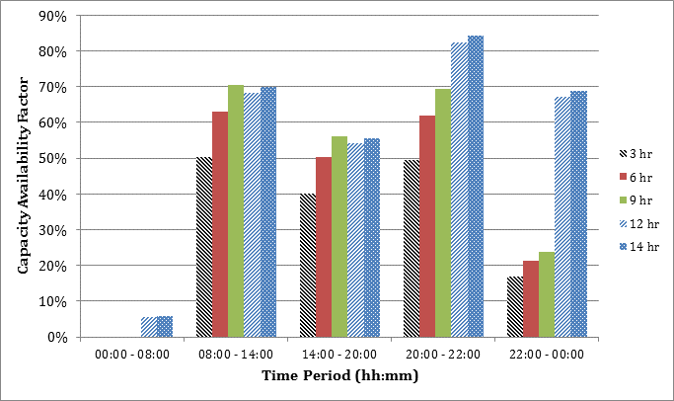

Figure 33: Illustrative Comparison of SATIM Capacity Availability Factors by Model Timeslice for New Solar Central Receiver Technologies Having 3 - 14 Hours of Storage – Winter Season

### Parameterisation of New Power Plant Technologies in the Process of Being Implemented

In some scenarios it is useful for new Nuclear reactors to be modelled with the “lumpy investment” feature. Typically, this feature would be implemented when the power sector is modelled alone because it’s very computationally intensive. For full sector model runs the demand typically increases in the region of 1GW per annum which accommodates the minimum build size of most technologies and the ‘lumpy investment’ feature is not necessary.

# Supply of Energy from the Liquid Fuels & Gas Supply Sector

This sector includes the supply of liquid fuels like diesel and gasoline as well as gas to the South African economy. Conventionally these products would be derived from crude oil but South Africa has a large so-called synthetic fuel industry that produces liquid fuels from gas and coal feedstocks. This industry, which includes a coal to liquid refinery at Secunda, operated by Sasol and a gas to liquid refinery at Mossel Bay operated by PetroSA, complicates the modelling of this sector somewhat because these plants add a number of input commodities to the energy chain. The supply of gas by pipeline from rich deposits in neighbouring countries, by the import of LNG or locally mined from recently discovered shale gas deposits are competing options for industrial and even residential energy supply. Including these primary energy supplies and the technologies like pipelines and terminals that will supply them is part of the current research project on this sector.

## Model Structure

Petroleum refining (refining crude oil, natural gas and coal[3]) is an extremely complex process which has numerous discrete processing units operating in close interaction. The numerous processing units produce a range of energy and non-energy products and they also have unique energy requirements (in the form of ancillary energy services) and as a result caution has to be taken when modelling the operation of refineries. In SATIM, there are three distinct modelling processes associated with refinery modelling, namely energy modelling (which considers input commodities and the associated output products), steam supply modelling and modelling of non-energy output products. Before delving into the three distinct modelling processes, it is worth highlighting the types of refineries that are modelled. Modelling liquid fuels supply involves accounting for existing and possible future refineries. The Existing Refineries are regrouped into 4 technologies as follows:

* Refinery Crude Oil Coastal Existing (Sapref, Enref, Chevref)
* Refinery Crude Oil Inland Existing (Natref)
* Refinery Gas-to-Liquid (GTL) Existing (PetroSA)
* Refinery Coal-to-Liquid (CTL) Existing (Secunda)

The model also accounts for two future refineries, namely New CTL and New Crude Oil Refinery which will both come online in 2018, with a life span of 50 years. These future refineries are generic refineries included in the model to account for the shortfall of future liquid fuel supply. The New Crude oil Refinery has emulated the capacity data for the planned Mthombo refinery that is planned to be built in the Eastern Cape in the near future while the New CTL refinery has emulated the capacity data from the discontinued Mafutha CTL refinery project.

## Base Year Data

The refinery slate data for existing refineries is clearly critical in constructing a model that realistically reflects the fuels actually produced by the liquid fuels sector which can balance the demands of the consuming sectors. For SATIM this data rests on what is now quite an old study (Lloyd, 2001) but the only large scale changes to South Africa’s refineries since then has been the increase in capacity of Enref in 2003 from 100,000 barrels/day to 125,000 barrels/day. The finding of this study, with coastal crude refineries aggregated, is presented in Table H.2 in Appendix H in the spreadhsheet appended to this document. The level of product disaggregation is somewhat lower in SATIM which models the following output commodities from refineries:

Table 63: SATIM Refinery Outputs

|  |
| --- |
| **Commodity** |
| Aviation Gasoline |
| Diesel Oil |
| Gasoline |
| Methane Rich Gas |
| Kerosene |
| Liquified Petroleum Gas |
| Other Oil-derived Products |

## Assumptions Characterising Refineries and Refining Processes

Public data for detailing the existing fleet of liquid fuel refineries is scarce and industry reports to which the Energy Research Centre have access (eg Lloyd, 2001) are now quite old. The planning of future infrastructure has also been a less public process in the semi-regulated privately owned liquid fuels sector than in the electricity supply sector which is dominated by a public company. Therefore there is not the same wealth of data for characterising future technologies in SATIM. Nevertheless due to its importance the sector is modelled in some detail as described below.

### Parameterization of Refinery Technologies

The fundamental parameters required for an energy model of the liquid fuel supply sector can be summarised as follows:

* input and output commodities,
* investment costs (new refineries only) and running costs
* refinery availabilities and efficiencies.

A more detailed parameterisation of refinery technologies in SATIM is presented below in Table 56.

Table 64: SATIM Parameterisation of Refinery Technologies

|  |  |  |
| --- | --- | --- |
| Parameter Type | Parameters | Description |
| Energy Input Commodities (feedstock and ancillary services) for crude oil refineries | Crude oil | These are the feedstocks for the refineries. The natural gas that is imported from Mozambique undergoes conversion process to make it a material gas which can serve as input into the CTL refineries. The methane rich gas is produced by SASOL in its CTL refineries. |
| Methane Rich Gas |
| Electricity |
| Energy Input Commodities (feedstock and ancillary services) for Gas to Liquid refineries | Natural Gas |
| Steam |
| Energy Input Commodities (feedstock and ancillary services) for Coal to Liquid refineries | Coal |
| Natural Gas |
| Electricity |
| Steam |
| Set of Energy Output Commodities: products (including commodities for non-energy applications e.g. bitumen) | Aviation Gasoline | These are the fuels that are produced by the refineries. |
| Diesel oil |
| Gasoline |
| Heavy Fuel Oil |
| Kerosene |
| Liquefied Petroleum Gas (LPG) |
| Other Oil (non-energy) |
| Methane Rich Gas |
| Set of Non-energy output commodities: process emissions | CH4, CO2, N2O, PM10s etc. | Greenhouse gas and toxic regulated emissions from the refinery |
| Efficiency | Efficiency | Relates the sum of energy input commodities (including both feed-stock and ancillary services) to the sum of energy output commodities |
| Availability | Availability | This constrains the total annual output to the capacity. The availability is less than one to account for maintenance and unplanned down-time |
| Input share constraint | Constraint (%) | A constraint fixing the share of the different energy input commodities based on historical observations |
| Upper and lower constraints on the share of the different energy output commodities. | Constraint (%) | The lower and upper shares are set to 5% on either side of the product slate observed in (Lloyd 2001) to give the existing refineries some range of manoeuvre allowed by the equipment in place without requiring further investment. |
| Operating cost based on reported costs. | Costs (Rands) |  |
| Process emission factor | CO2 (kton/TJ) | Relating the CO2 emission to the total energy output of the refinery. Energy emissions (e.g. arising from the production of steam) are accounted for at the level of the supply of the fuels as done in all the other sectors. |
| Retirement profile | Time (years) | Specifies how much capacity is initially available and how that decays as plants or parts of plants retire in the future. |

Currently the production of existing refineries in SATIM is set to the product slate determined by Lloyd (2001) with product shares as an upper bound only. Currently in SATIM commodity output shares are fixed for all technologies except new technology crude oil refineries where there is some flexibility in the slate as shown below:

Table 65: Assumed Upper Bounds on Output Commodity Shares for Refinery Technologies

|  |  |  |  |  |  |  |
| --- | --- | --- | --- | --- | --- | --- |
| **Output Product** | **Crude Coastal Existing** | **Crude Inland Existing** | **GTL Existing** | **CTL Existing** | **CTL New** | **Crude New** |
| Av Gasoline | 0% | 0% | 0% | 0% | 0% | 0% |
| Diesel | 33% | 39% | 29% | 24% | 73% | 50% |
| Gasoline | 29% | 32% | 50% | 54% | 24% | 50% |
| HFO | 23% | 4% | 0% | 0% | 0% | 0% |
| Kerosene | 11% | 21% | 12% | 4% | 0% | 20% |
| LPG | 2% | 0% | 4% | 1% | 4% | 3% |
| Other | 2% | 4% | 5% | 7% | 0% | 5% |
| Methane Rich Gas | 0% | 0% | 0% | 8% | 0% | 0% |
| **TOTAL** | **100%** | **100%** | **100%** | **100%** | **100%** | **128%** |

*Note: If the sum of upper bounds sum to 100% the shares are effectively fixed*

Future work needs to extend these refinery slate assumptions from just an upper bound to an upper and lower bound and use this to define a realistic band, consultation with refinery experts, of output commodity shares for existing refineries and new CTL refineries rather than the current fixed slate. Although non-energy products (commodity “Other’ above) do not contribute to the refinery energy outputs, they are included because this allows the model to account for energy used to produce these products.

Table 58 below presents a summary of the assumptions regarding refinery technology characteristics and costs as used in SATIM currrently.

Table 66: Summary of Existing and New Refinery Technology Characteristics

|  |  |  |  |  |  |  |  |
| --- | --- | --- | --- | --- | --- | --- | --- |
|  | | **Existing Technologies** | | | | **New Technologies** | |
|  | **Units** | **Sasol CTL** | **Inland Crude Existing** | **Coastal Crude Existing** | **PetroSA GTL** | **New CTL1** | **New Crude2** |
| Capacity | bbl/day | 150 000 | 108 000 | 405 000 | 45 000 |  |  |
| Capacity in terms of outputs | PJ/annum | 246 | 212 | 874 | 59 |  |  |
| Overall Efficiency | % | 44% | 93% | 95% | 78% | 49% | 97% |
| Availability | % | 96% | 96% | 96% | 96% | 96% | 96% |
| Plant Life | Yrs |  |  |  |  | 50 | 50 |
| Running Costs per unit of output3 | mR/PJ | 30 | 11 | 11 | 25 | 30 | 11 |
| Investment Cost3 | mR/[PJ/ annum] | 0 | 0 | 0 | 0 | 305 | 66 |
| Lev. Cost of Production (in 2006) | R/GJ | 41 | 88 | 87 | 46 | 66 | 91 |
| Lev. Cost of production (with IRP/100$/bbl) | R/GJ | 57 | 128 | 121 | 95 | 80 | 129 |
| CO2 emissions | (kt/PJ) | 118.88 | 6.87 | 2.90 | 0.004 | 118.88 | 6.18 |
| CH4 emissions | (kt/PJ) | 1.49 | 0.00 | 0.00 | 0.004 | 1.49 | 0.00 |

*1: Based on data for proposed Mthombo project*

*2: Based on data for proposed Mafutha project*

*3: mR: currency unit - million South African Rands*

*4: These are unknown but thought to be low*

As can be seen above, the CTL refinery technology has very high greenhouse gas emissions and low energy conversion efficiency but operates at a low cost of production because coal is locally cheap. This along with the dominance of coal in the electricity supply sector is one of the determining factors in South Africa’s carbon intensive economy and presents both a challenge and an opportunity to mitigation initiatives. The model outputs for this sector will therefore be very sensitive to an emissions constraint.

Another future improvement envisioned is to specify a minimum unit size for new technologies. Currently, so-called ‘lumpy’ investments are not implemented in SATIM for the liquid fuels sector. A caveat is that this feature can extend the time to find a solution significantly.

### Characterization of CTL Technology

Modelling CTL refineries requires some additional data to determine the shares of inputs and outputs to that required for crude oil refineries. Fortunately much of this data is available in documents published by Sasol themselves, the company operating South Africa’s CTL refinery located at Secunda. In brief this technology is characterised as follows:

1. Required for constraints on output shares:

* The product slate is derived from (Lloyd, 2001)
* The Methane Rich Gas output is determined from Sasol’s financial statements as published in the “Analyst Book Dec 2006” (SASOL, 2007)

1. Required for constraints on input shares:

* The Total Coal use by Sasol is determined from Sasol’s financial statements as published in the “Analyst Book Dec 2006” (SASOL, 2007).
* The Coal for material use for the base year (feedstock excl. steam generation) is published in the Sasol Sustainability report 2009 (SASOL, 2009) expressed in kton dry ash free (DAF)
* The dry ash free (DAF) coal to run of mine coal (ROM) ratio used to convert this number is 0.65 as per personal communication with Sasol.
* The total coal for energy use (in TJ) is published in the Sasol Sustainability report 2009 (SASOL, 2009).
* The Energy content of steam used in the Sasol process of 2,627 MJ/ton comes from a personal communication with Sasol.

### Modelling the Supply of Ancillary Steam Input Services to Refineries

Refineries have various commodity inputs which can include crude oil, coal, gas, methane rich refinery gas and steam, all of which complicates costing the energy chain. Steam is modelled as an ancillary input service to the refinery by creating boiler technologies that output steam with an energy commodity as an input.

The modelling of steam as an ancillary input service allows the model to potentially optimise the most cost effective fuel (coal vs gas) and technology (e.g. existing vs new and more efficient boiler vs CHP) to provide the steam needed for process heat, as well as for feedstock in CTL plants. This latter use is much greater per unit of refinery output than process heat requirements. Steam is also consumed by crude refineries and GTL plants but further data is required for the characterization and therefore this consumption is not currently reflected in SATIM. The steam consumption of crude and GTL refineries is however significantly lower and so the absence of this detail is assumed to not have a very significant impact on the overall results. While the framework for optimising refinery steam production is in place, the current version of SATIM therefore only has the following 2 technologies implemented:

Table 67: Current Refinery Steam Boiler Technologies Implemented in SATIM

|  |  |  |  |
| --- | --- | --- | --- |
| **Boiler Technology** | **Input Commodity** | **Output Commodity** | **Efficiency** |
| Refinery CTL Boiler Existing | Coal Existing | Steam Existing | 72% |
| Refinery CTL Boiler New | Coal New | Steam New | 77% |

Competing technologies have thus not yet been defined and costs not yet researched. This forms part of the work on the on-going SATIM project and will allow for more rigorous treatment of the liquid fuels supply sector.

# Supply of Primary Energy

The ANSWER interface and TIMES model are designed around the principle of a reference energy system that depicts the whole energy chain, so it is important to account for all the energy used in the model from extraction to final consumption. Primary energy resources such as coal are used to produce final energy and each step along the different transformation stages undergo losses. These losses (in the form of efficiencies) have to be accounted for in the model.

Since the resources are finite in nature, the model has to meet the demand for energy within that constraint. To cater for limitations on resources, the analyst has to use constraints to limit an ever mounting usage of the resource. In the SATIM model, resource constraints have been implemented for fossil fuels and for renewable energy. It is assumed that there is no resource limit on nuclear fuel during the modelling period. The key resource constraints on fossil fuels are the supply of natural gas from regional sources (the southern and west coast gas-fields in South African waters, and the Namibian and Mozambican gas-fields) and the supply of coal from within South Africa. South African oilfields are very insignificant and are assumed to deplete very rapidly. It is assumed that there is no limit to imported oil and liquified natural gas, and global scarcity is expressed through scenarios of higher prices. Coal bed methane is assumed to have no energy potential for South Africa, and the same assumption is made about shale gas in the Karoo basin for the reference case although the latter is the subject of alternative scenarios for current SATIM projects.

The prices of product typically refined from crude oil such as gasoline, diesel and kerosene are assumed to be linearly linked to the crude price by a fixed constant. This allows local and import prices for all oil derived fuels to be automatically generated for one oil price projection without the necessity of separate projections. The price of oil products projections are based on the IEA World Energy Outlook projections for the oil price in the “current policies” scenario, which are updated annually.

## Supply of Natural Gas

Table 68: Cumulative Gas Reserves

|  |  |  |
| --- | --- | --- |
| Gas Resource | Bound(PJ) | Bounds (bcm) |
| Coal bed methane gas | 6100 | 157 |
| Ibhubezi gas fields | 200 | 5 |
| Oribi gas fields | 700 | 18 |
| Shale gas | 40000 | 1032 |
| Gas from Northern fields in Mozambique | 170000 | 4388 |
| Gas from Southern fields in Mozambique | 4500 | 116 |

Table 69: Available gas reserve on an annual basis

|  |  |  |  |  |  |
| --- | --- | --- | --- | --- | --- |
|  | **2010** | **2020** | **2030** | **2040** | **2050** |
| Coal bed methane gas |  |  |  |  |  |
| Ibhubezi gas fields |  |  |  |  |  |
| Oribi gas fields |  |  |  |  |  |
| Shale |  | 20 | 800 | 2.89 | 100000 |
| Northern Mozambique | 0 | 0 | 0 | 0 | 0 |
| Southern Mozambique | 116 | 156 |  |  |  |
| LNG Import | unlimited | unlimited | unlimited | unlimited | unlimited |

### Overview

We conducted elicitation interviews with two experts on the subject of gas prices. Prices depend primarily on the type and origin of the gas. An initial discussion constructed 8 reference categories: conventional gas deposits, unconventional deposits (shale, coal-bed methane), gas imported from SADC countries (by pipeline, by LNG terminal or LNGT, by floating storage regasification unit or FSRU), and gas imported from outside the SADC region (by LNGT or FSRU). The final model included only shale gas, conventional deposits, and LNG imports, so that we focus on these categories here. The elicited probability distributions cover possible prices of these different gas types in the reference years 2020, 2035, and 2050.

### Summary of qualitative discussions

#### Influential factors

The main factors influencing production costs, and hence gas prices, are the “raw” costs of extracting the gas at the wellhead, transportation costs, and the costs of building the related infrastructure. Each of these major costs is influenced by a number of factors. In addition, when referring to the price of gas for electricity production, the price of gas for alternate uses (e.g. heating) is perhaps *the* key determinant.

Wellhead costs depend primarily on the size, location and geology of deposits, in particular whether the deposit is inland or offshore. Transportation costs depend on whether the gas is transported by pipeline, LNG terminal, or FSRU. Infrastructure for gas potentially demands massive capital investment, so that the determinants of these costs must include the complexities of capital arrangements. Pipeline costs depend on the installed capacity (e.g. 24- or 36-inch pipelines), which is itself a function of expected demand. The cost of this capital investment is typically recovered over the lifetime of the pipelines via tariff structures, which are a function of whether pipes are running at or near full capacity. When pipelines are underutilised per-unit transport costs rise to defray capital costs.

Other price determinants are essentially a consequence of the flexibility of gas in its final uses, and the fact that it is a commodity traded for profit. Gas is priced using netback pricing – pricing based on subtracting the costs of bringing a resource to the marketplace from all the revenues generated by that resource – and hence sales of gas in one market (e.g. electricity generation) depend on the value that that gas can fetch in alternate markets (e.g. industrial processes, heating). Moreover gas companies must compete with other investment possibilities for available capital. Over the longer term, this means that prices are (somewhat) self-regulating. If prices drop dramatically, there is an effective oversupply of capital, some of which will be withdrawn and invested elsewhere. Demands for return on capital are in turn influenced by perceived risk and hence by government policy and political instability.

#### Trends and scenarios

Current strategic planning around gas in South Africa centers on the development of large shale deposits in South Africa and even larger deposits of conventional gas in Mozambique. Opinions are that, given the size of the available deposits and the current political climate, shale deposits are highly likely to be developed; though uncertainty exists as to what extent.

Southern Mozambican gas is currently transported via pipeline but this is almost at capacity and expansions are planned. Two LNG trains are planned for 2020, with more LNG trains expected by 2035. Much larger deposits exist in Northern Mozambique but these are unlikely to be transported by pipeline as distances are too great. This possibility becomes even more remote if shale gas is developed in South Africa. Transportation via LNG train to Richard’s Bay is more likely. Significant infrastructure and hence capital expenditure would be needed for either option. Development of this option would require substantial regional co-operation, but the possibility of this seems, currently, limited. The Mozambican government has a share of ownership of the NM deposits, but this is shared with gas companies who are driven primarily by profits. More likely, South Africa will have to compete with other customers for Mozambican gas on the open market.

Conventional gas deposits in South Africa has thus far been limited in their scale and impact, and this is expected to continue. Coal-bed methane is an expensive, location-dependent source with high environmental and water treatment costs. Although potentially quicker to develop than shale, it will probably not be an important prospect for South Africa.

Uncertainty ranges on gas price forecasts are relatively constant through time, in contrast to other commodities like oil and coal. This is because the gas price is effectively set at the marginal producer's cost of production (including capital). This is very likely to be a conventional off-shore gas well with a LNG liquefaction plant attached. Crucially, this step in the supply curve is very large in terms of global volumes, both now and in the long term, and the costs of production for these units are more or less homogeneous. Short-term fluctuations can of course occur because of imbalances between supply and demand, but in general these trends will be relatively short-lived (i.e. a few years).

### Quantitative forecasts

Figure 31 shows the probability distributions elicited from the two experts. We have quantified this assessment using an average of the expert’s assessment of the different gas types at [3.9,17.5] for shale and [6.8, 13.7] for imported LNG.

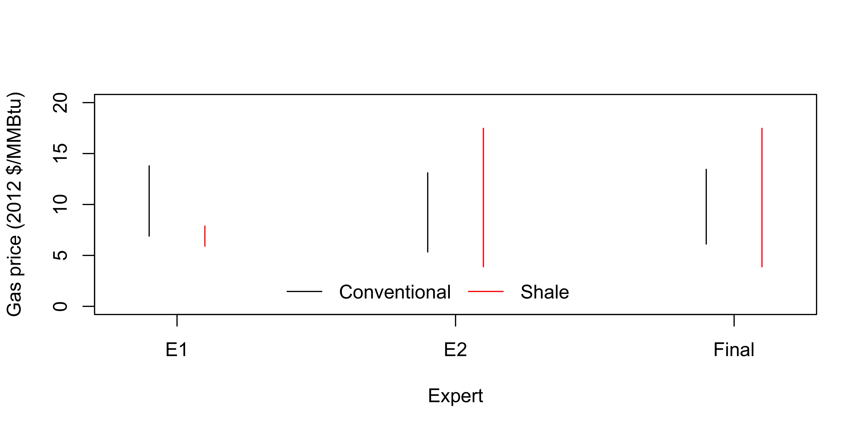

Figure 34: Elicited distributions for domestic conventional gas and domestic shale gas (2 experts)

### Post-processing

Between-expert agreement is particularly low for shale gas prices. We suspect that Expert 1’s assessed price range for shale takes into account factors endogenous to the SATIM model. In particular the upper bound of $8/MMBtu appears to assume that at higher prices shale gas would be superseded by other gas types and thus not available locally. These are plausible causal explanations, but they can also be accounted for within SATIM. We therefore preferred to use the broader uncertainty bounds provided by Expert 2 in the case of shale gas.

The aggregated distribution was converted into annual time series using Algorithm 1 and 3. When generating values for the three time points 2020, 2035, and 2050, we impose a moderate positive autocorrelation between the values obtained in consecutive periods, by setting off-diagonal correlations to 0.3 i.e. $Σ_{ij}=0.3, ∀i≠j$. Sample trajectories generated by Monte Carlo simulation are shown in Figure 32.

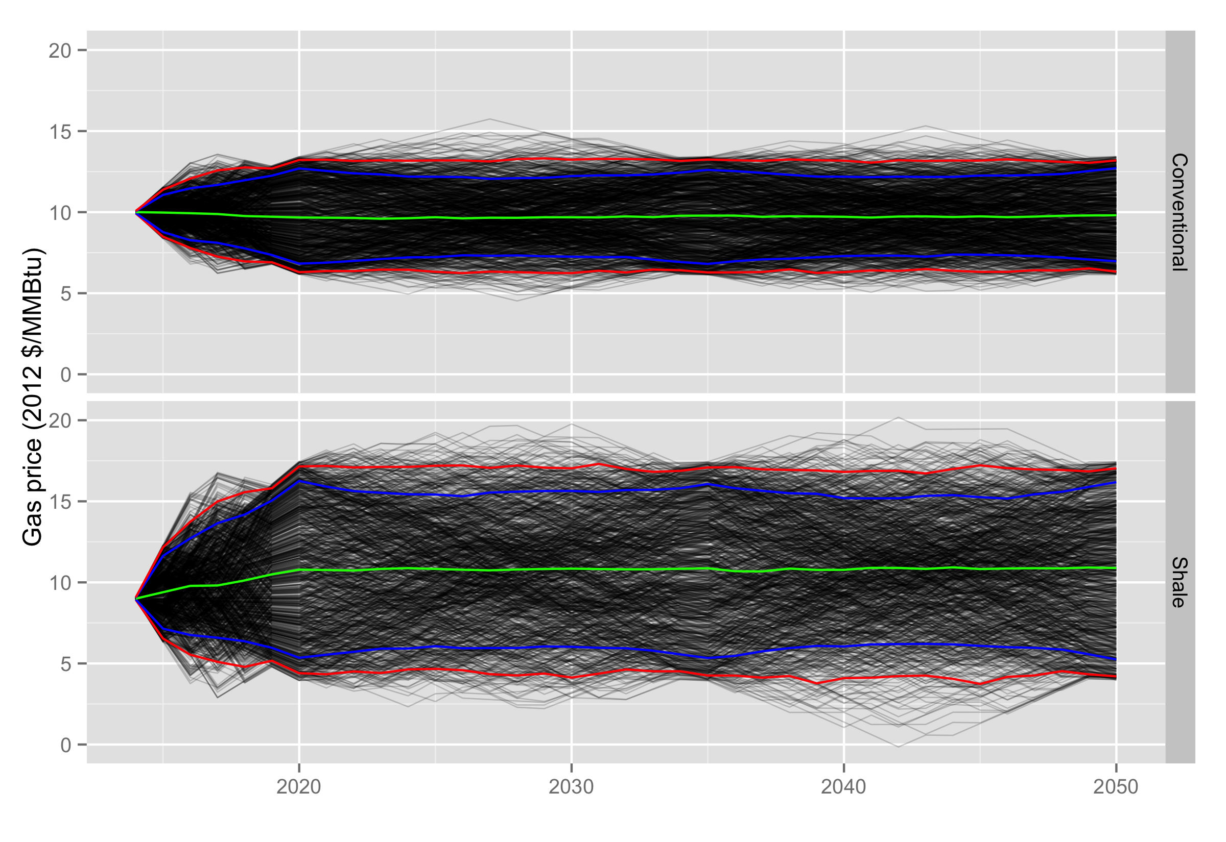

Figure 35: Probabilistic projections of conventional and shale gas prices over the period 2014 – 2050.

## Supply of Coal

We conducted elicitation interviews with four experts on the subject of future local coal prices. The elicited probability distributions thus covered possible values in the mean growth rate over these three.

### Summary of qualitative discussions

#### Historical background and current context

Originally coalmines were tied geographically and economically to power stations. Transportation costs were small, and power stations were purpose-built to use the coal quality provided by the satellite mine (most of the coal in the Central Basin is of relatively low quality). Traditionally Eskom effectively assumed the risk of coal mining by issuing long-term contracts at a fixed rate. These were issued at cost of production plus a relatively small return on capital (historically around 9%). Later, the growth of an export market for high-grade (HG) coal led to the development of stand-alone export-focussed mines.

These two ostensibly independent systems – electricity generation using low-grade coal, and exports of high-grade coal – are in fact linked through the possibility of “washing” coal – a process that shifts the distribution of coal quality, with some proportion of coal becoming higher quality and some proportion becoming lower quality. The precise proportions and quality shifts are complex and mine-specific, but the net effect is that sometimes coal below export-grade is washed to export-grade, with the remaining lower-quality “middlings” still suitable for power generation.

already paired (i.e. with power stations) coalmines and export-based coalmines were strategically grouped, usually by rough geographical proximity, in a bid to optimise operations. The optimisation focussed on matching lower-grade middlings with power stations quality requirements and minimizing the associated transportation costs. The process included the renegotiation of long-term contracts with Eskom – again the agreed-upon price being the cost-of-production plus a relatively small mark-up.

Almost all of Eskom’s long-term contracts end within the next 5-15 years. Traditionally, these contracts have made coal a relatively low-risk, low-return investment, at least in the local market. Now, with increased competition for investment from other industries and countries, global mining companies are demanding higher rates of return in order to make big capital investments – of the order of around 12%. India and China also use low-grade coal in their power stations, creating an export market (and hence competition) for coal traditionally destined for use by Eskom. Eskom’s strategic dilemma is how to balance short-term contracts, which must pay a premium in order to compete with the low-grade export price and are thus both more expensive in the long run and subject to fluctuations in that market, and long-term contracts, which require huge amounts of capital to be committed.

Complicating Eskom’s contractual choices further, there is substantial political pressure to expand mine ownership beyond the big traditional mining companies to “juniors” with strong black empowerment initiatives – the mining charter requires 26% black ownership, while Eskom policy targets 51%. Smaller “juniors”, however, pay more than the established large companies to borrow capital. This increased cost is passed to Eskom and, ultimately, results in higher electricity prices.

#### Influential factors

As will be clear from the previous background, the main uncertainty is how and over what time period Eskom attempts to resolve the strategic difficulties it now faces, in the form of sourcing and contracting coal, and how mining houses respond to these initiatives. Vast amounts of coal exist in South Africa, but what remains tends to be of low quality and expensive to mine. Mining companies will only mine coal if it is profitable to do so; these expenses will have to be borne by Eskom if the coal is to be mined at all. The Waterberg area of South Africa contains a vast amount of coal but mining operations here could be more difficult and expensive than they have been in the Central Basin (suggested costs run as high as R600/t for 22-23 MJ coal without capital and transport costs, and R850/t with these costs)

The main factors influencing the future price of coal are the costs of mining it, and the necessary return on capital: logistics (mainly transportation costs by road or rail); labour costs; energy inputs (in the form of diesel and electricity); capital expenditures and the associated required rates of return on capital; environmental and social costs (acid mine draining, royalties/licensing, carbon tax); the growth of the low-grade export market; and assorted “other” costs (water costs, engineering costs, replacement capital costs, employee housing costs, and equipment costs).

Each of these factors is a complex subsystem subject ~~itself~~ to major uncertainties regarding their futures. Transportation costs are a function of the geographic proximity of mines and power stations, the efficiency to which they are paired (the mines and the power plants), and the relative importance of the export market. Expansions to the rail network require large capital expenditure, so that these tend to occur in a small number of large increments. The timing of these is extremely difficult to predict. Currently labour costs are rising faster than inflation, which is unsustainable in the long run. In the Central Basin there is little opportunity for technological improvements to reduce labour costs, but some benefits may accrue if open cast mining in the Waterberg area occurs.

In the future Eskom is expected to need to offer in the region of 10-15% return on long term contracts to compete not only with the low-grade export market but also with copper mines and other investment opportunities. This number, however, is subject to the rate offered by other investments, and also to changes in risk introduced by, for example, political events. Environmental and social costs are expected to increase but the exact magnitude of this depends on unknown changes in legislature (for example, including a cash provision for certain types of mine rehabilitation not currently required, or increases in royalty fees, which are relatively low). Water costs are generally viewed as unimportant relative to other costs, although this position is not universally held.

#### Trends and scenarios

In the near-term (to 2020), any major changes in the domestic coal price are likely to be caused by (a) increases in the cost of capital on renegotiated contracts, once the current ones begin to expire; (b) legislation forcing mines to set aside cash provisions for environmental costs; (c) legislation increasing government royalties; (d) changes in the export price of low-grade coal; (e) transportation costs, expected to remain high but potentially increasing even further as a relatively larger proportion of coal is transported by road (any significant rail infrastructure would take longer to build). Labour costs are expected to stay relatively constant, increasing at 1-2% faster than inflation.

To 2035, substantial uncertainties exist around what will occur when the current long-term contracts expire, but the expectation is that producers will force Eskom into agreeing to a substantially higher return on capital than it has historically paid. Large infrastructure construction will be necessary to maintain supplies of coal to Central Basin stations, increasing transportation costs. Labour costs are uncertain but are expected to fall back to the inflation rate at some point, higher wages being unsustainable. By this time, it is likely that stronger environmental legislation will be in place, increasing these costs; and also that greater royalties will be extracted.

In the period 2035-2050, the effects of coal mining in the Waterberg, if it occurs, will be most keenly felt, and transportation costs increase further, unless power stations are built there. Labour costs, if they have not already come down, are expected to do so. Open cast mining in the Waterberg is likely to increase diesel costs (at least, with currently known technology). Mines that negotiated their contacts around 2030 will again be coming to the end of their contracts, and hence will be in the “low return on capital” part of their lifespan, although this will of course depend on the length of the signed contracts and will differ from mine to mine. Legislation on royalties and/or environmental and social costs is even more likely to have been implemented by this point in time.

### Quantitative forecasts

Figure 33 shows the probability distributions elicited from the four experts:

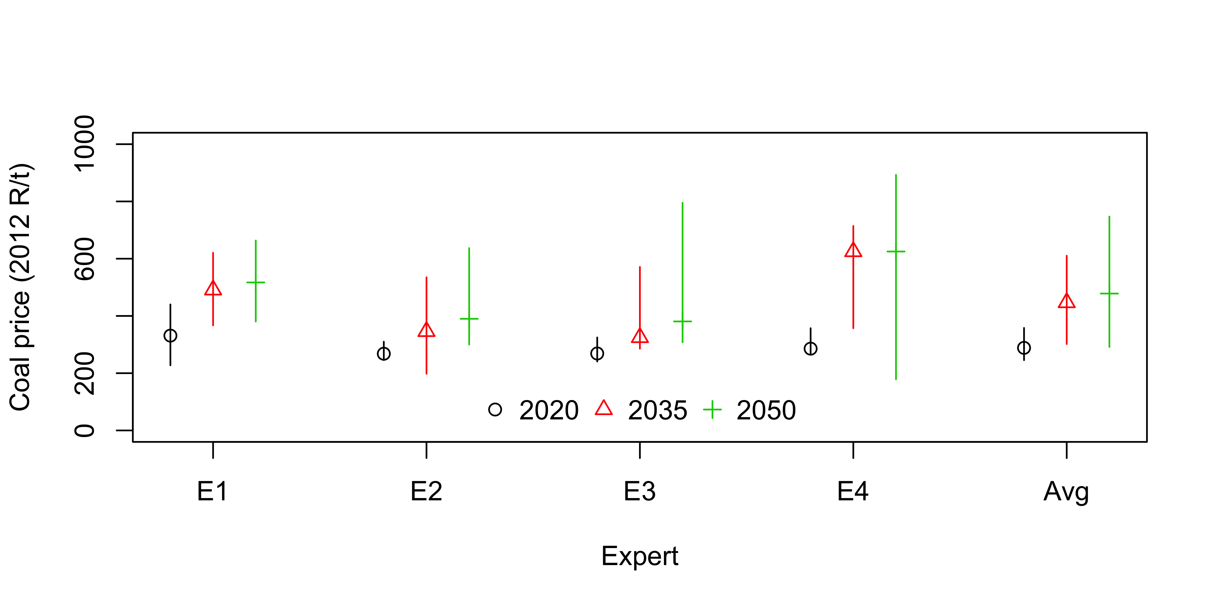

Figure 36: Elicited distributions for domestic coal prices (4 experts)

### Post-processing

After reviewing the information gathered from the elicitation and literature, it was felt that simply having a single price for all the coal going to power plants in the model would be over simplistic and would miss some important factors such as:

* Some of existing power plants have ongoing fixed price contracts with mines that are close to the power plants (mine-mouth existing)
* There could potentially be cheaper coal in the Waterberg, which may or may not be worth transporting to the Central Basin, depending on the relative mining costs and the rail transport infrastructure
* The demand for coal from coal power plants depends on how competitive coal electricity is with other options for generating electricity
* The coal power plants relying on uncontracted coal would be competing with other domestic users of coal as well as global markets

The different supply options and their costs can be combined to form a crude supply cost curve for coal. The combined demand by coal power plants and other users when applied to the cost curve would determine the coal price. The supply cost curve was implemented in SATIM as shown in the diagram below.



Figure 37 Implementation of Coal supply Curve in SATIM

The diagram shows 2 existing supply and one new supply route for power plants in the Central Basin:

* MINCLE1: Existing mine-mouth (conveyor link)
* MINCLE2: Existing (trucked/railed)
* MINCLN: New (trucked/railed)

The Waterberg has 2 supply routes:

* MINCLE-A: Existing mine-mouth (conveyor link)
* MINCLN-A: New (truck/rail/conveyor)

The supply to coal to liquids plants is modelled with two routes:

* MINCLS: Existing coal mines supplying Sasol’s existing CTL plant in the Central Basin
* MINCLS-A: New coal mine to supply future CTL plants in the Waterberg

We also model one existing export grade producing route (MINCLE3) in the central basin. Discard coal, is modelled but is not shown in the diagram.

Over time the existing mines run out and the demand has to be met with production from new mines. The export grade and domestic high grade are then produced by washing coal produced by MINCLN. The existing rail lines from the Waterberg to the Central Basin and the export line to Richard’s Bay as well as options to expand those lines are included.

The uncertainty range that was explored mainly concerns the new Central Basin and Waterberg low grade producing mines. The table and chart below show the cost breakdown per ton of 21MJ/kg for the aggregate of the existing mines in both regions as well as the extreme and median cases for both regions.

Table 70 Breakdown of parameters for the coal supply curve and associated uncertainty

|  |  |  |  |  |  |  |  |  |  |  |  |  |
| --- | --- | --- | --- | --- | --- | --- | --- | --- | --- | --- | --- | --- |
|  | **Central Basin** | | | | | **Waterberg** | | | | | | |
| **Con-veyor** | **Existing truck & rail** | **New truck & rail** | | | **Existing** | **New Surface** | | | **New Underground** | | |
| **L** | **M** | **H** | **L** | **M** | **H** | **L** | **M** | **H** |
| **Saleable Production Cost** | 188 | 200 | 200 | 200 | 232 | 106 | 132 | 281 | 595 | 298 | 364 | 592 |
| **Transport** | 1 | 100 | 84 | 100 | 100 | 1 | 10 | 17 | 23 | 10 | 17 | 23 |
| **Capital** | 46 | 46 | 59 | 59 | 59 | 23 | 27 | 27 | 27 | 68 | 68 | 68 |
| **Return on Capital** | 24 | 24 | 129 | 161 | 211 | 33 | 59 | 77 | 96 | 148 | 194 | 241 |
| **Acid mine drainage** | 0 | 0 | 10 | 30 | 50 | 0 | 10 | 30 | 50 | 10 | 30 | 50 |
| **Total** | **259** | **370** | **482** | **550** | **652** | **163** | **238** | **432** | **790** | **534** | **672** | **975** |

The acid mine drainage rehabilitation costs range from 10 to 50 R/ton based on literature (Golder Associates,2010) and the expert interviews. The return on capital ranges between 10% and 15% also based on literature (Macquarie) and interviews. The capital costs for the central basin are based on a capital intensity assumption of around 1800 R/ton of washed product (including cost of washing plant), and a life of 30 years for the mine. The capital intensity for a new surface mine in the Waterberg is assumed to be around 800 R/ton is based on the Resgen Boikarabelo project.

The saleable production cost is a function of labour, energy inputs and other running costs per ton mined, and the stripping ratios and washing plant yields. The large uncertainties in the Waterberg region is due to the uncertainty around the stripping ratios and washing yields.

The transport cost is a function of the how the coal is transported from the mine to the power plant (conveyor/rail/road) and unit cost of transport of each mode. We assume a higher share of non-conveyor transport in the Central Basin assuming that the new mines will not be located near power plants. The price of diesel is an important factor for road and this is endogenous to the model. The assumed ranges for mining and transport are shown in the table below.

Table 71 Detailed assumptions on uncertainty on the stripping, washing and transport parameters

|  |  |  |  |  |  |  |  |  |  |  |  |  |
| --- | --- | --- | --- | --- | --- | --- | --- | --- | --- | --- | --- | --- |
| **Coal mining assumptions** | **Central Basin** | | | | | **Waterberg** | | | | | | |
| **Conveyor** | **Existing truck & rail** | **Conveyor** | | | **Existing truck & rail** | **Surface** | | | **Underground** | | |
| **L** | **M** | **H** | **L** | **M** | **H** | **L** | **M** | **H** |
| **Stripping Ratio** | 2 | 1.8 | 1.8 | 1.8 | 1.8 | 0.6 | 0.6 | 1.6 | 2.5 | 4.5 | 4.8 | 5 |
| **Washing Yield** | 80% | 70% | 70% | 70% | 70% | 50% | 40% | 33% | 25% | 70% | 60% | 50% |
| **Transport assumptions (Share of total coal transported from mine to power plant)** | | | | | | | | | | | | |
| **Conveyor** | 100% | 0% | 0% | 0% | 0% | 100% | 75% | 58% | 40% | 75% | 58% | 40% |
| **Rail** | 0% | 21% | 40% | 21% | 21% | 0% | 13% | 21% | 30% | 13% | 21% | 30% |
| **Road** | 0% | 79% | 60% | 79% | 79% | 0% | 13% | 21% | 30% | 13% | 21% | 30% |

The resulting average prices for the Central Basin, Waterberg and combined is shown below. Figure 36 below shows the result of averaging the costs sampled from the ranges described above weighted by the production (shown in Figure 36) of each supply route for each corresponding cost scenario. The weighted average matches the combined elicited values shown in Figure 33 quite well.

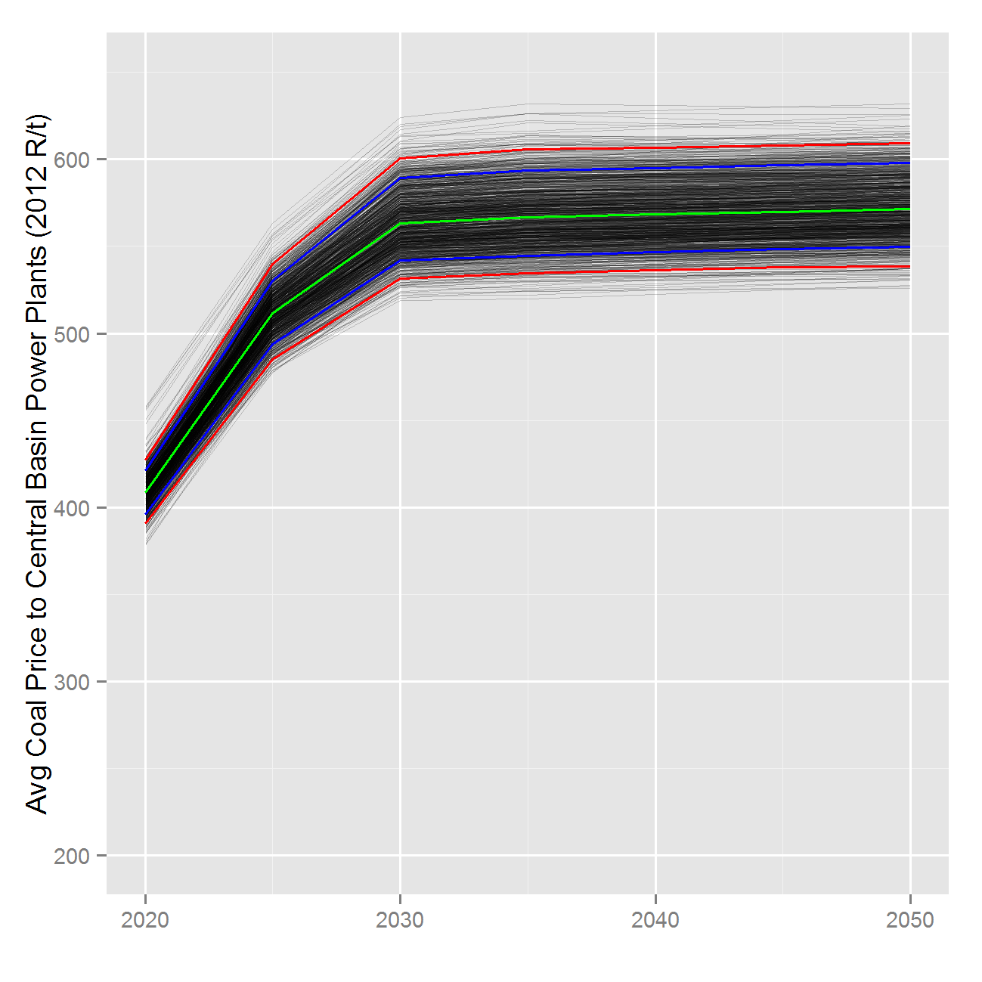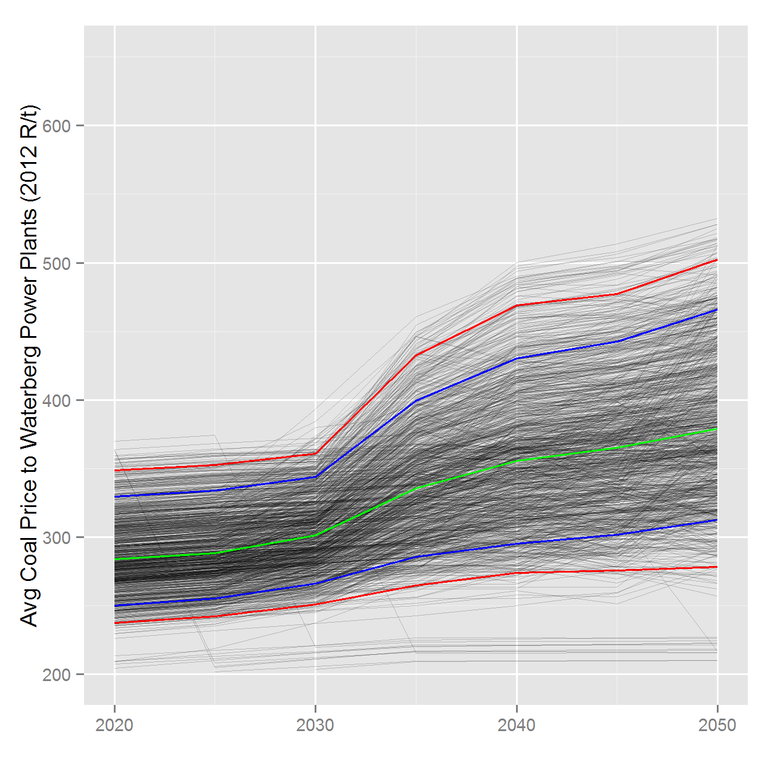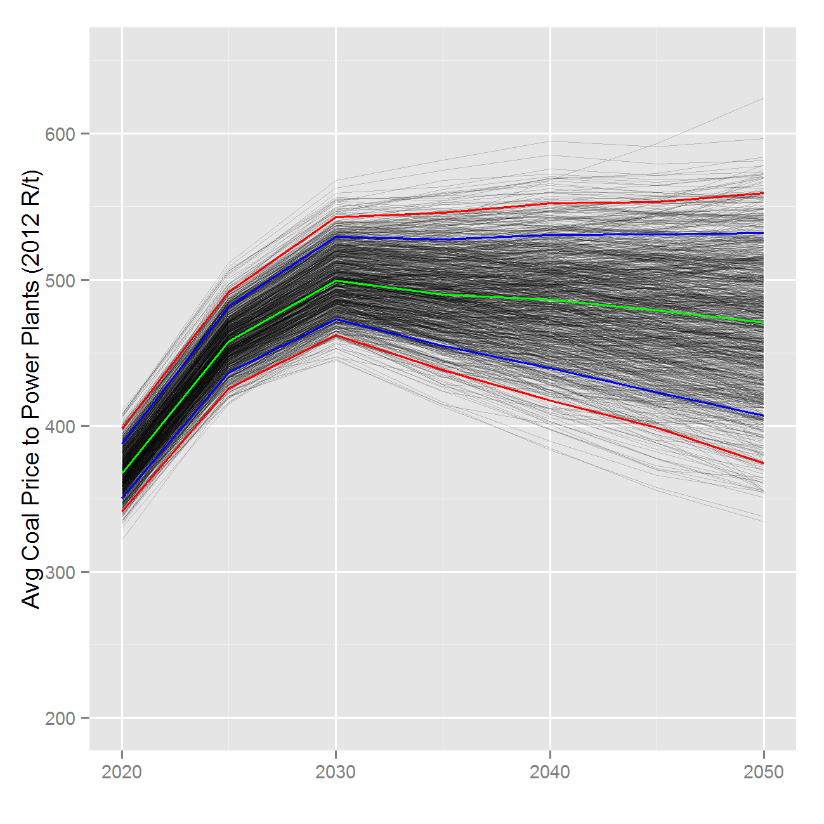

Figure 38 Average coal price seen by coal power plants



Figure 39 Production Range for different supply routes

# Representation of transmission and distribution infrastructure in SATIM

Fuel transportation systems included in SATIM are electricity transmission lines and distribution lines. For liquid fuels, we only included the distribution network (this includes the trucks and the service stations used). The liquid fuels pipelines are modelled as a separate entity in freight sub-sector. For the gas network, we included the transmission and distribution pipelines. The main parameters used to represent the transportation system are efficiency, lifetime and the investment and operating costs. All gas transmission pipelines are assumed to have 22 cubic feet in diameter, which can deliver 53 PJ/annum. Their lifetimes is assumed to be similar to UK’s pipelines which were approximated to have 80 years (Dodds & Mcdowall, 2012) and they each take 4 years to be build.

Table 72: Gas transmission Pipelines

|  |  |  |  |
| --- | --- | --- | --- |
| Pipeline name | Efficiency[4] | Investment Cost (mR/PJ) | Starting year |
| Coastal gas Pipeline | 96% | 127.7 | 2017 |
| Indigenous Ibhubezi Pipeline | 96% | 127.7 | 2017 |
| Northern Mozambique Pipeline | 96% | 512.9 | 2019 |
| Southern Mozambique Pipeline | 96% | 0[5] | 2006 |
| Pipeline Gas Indigenous Shale | 96% | 127.7 | 2022 |

The investment costs shown in Table 6 were arrived at using Equation [1] and they are just indicative as the accurate way of costing the pipelines is to use Equation [2] because pipelines costs are usually given in R/metre or $/mile (Zwaan, Schoots, Rivera-tinoco, & Verbong, 2011). This approach of using indicative costs (mR/PJ) leads to (Dodds & McDowall 2012) conclusion that representation of pipelines is complicated in energy models.

$Investment Cost=Capital Investment (EPC+ODC)/Capacity$***[PJ]***  [20]

Total costs = Capital costs/metre X total km (of pipelines) [21]

The distribution pipelines are divided into two types: service and mains distribution pipelines. The mains distribution pipelines are those that run from city gates to regional pipelines. The service distribution pipelines are those that connect households’ meters to the regional mains distribution pipelines. The cost of distribution pipelines is higher than the cost pf transmission pipelines. In 2013, Egoli gas mentioned that the cost of adding a customer to the existing network is in the range of R2500/metre - R6500/metre for pipelines with diameters ranging from 10 cm – 18 cm. The fact that South Africa cities are not as dense as the United Kingdom and the USA, ultimately, the costs of service distribution network maybe higher here in South Africa because more material has to be installed to service an area with natural gas. Table 7 and Table 8 show the distribution parameters that were included in the model for all sectors and industry respectively. Most of these parameters are form literature, which is mainly from UK and USA and may differ significantly when applied here but in the absence of better local data they are used to give an indication. The efficiency of the entire distribution network is assumed to be 1 for gas pipelines and liquid fuels distribution. Electrical distribution is assumed to have an operating efficiency of 0.972. The lifetimes for liquid fuels and electricity distribution networks are assumed to be 60 years while gas distribution pipelines are assumed to be 80 years just like the transmission pipelines.

Table 73: Transmission and distribution infrastructure costs

|  |  |  |  |  |
| --- | --- | --- | --- | --- |
| **Type** | **Gas** | **Diesel** | **Petrol** | **Electricity** |
| Commercial distribution | 202 | - | - | 9002 |
| residential distribution | 404 | - | - | 18004 |
| Transport distribution | 202 | 25.83 | 25.46 | 9002 |
| Agricultural distribution | - | - | - | 18004 |
| Power Distribution | 21.26 | - | - | - |
| Refineries distribution | 21.26 | - | - | 4501 |

**Table 74: Industry electricity and gas distribution costs**

|  |  |  |
| --- | --- | --- |
| **Industrial Distribution costs** | **Gas** | **Electricity** |
| Mining, SIC-2 (IMI) | 125.73 | 5603.10 |
| Iron & Steel, SIC-351 (IIS) | 125.73 | 5603.10 |
| Chemicals, SIC-33 (ICP) | 125.73 | 5603.10 |
| Precious & Non-Ferrous metals, SIC-352 (INF | 125.73 | 9002.10 |
| N.M.M Products, SIC-34 (INM) | 125.73 | 5603 |
| Food, Beverage & Tobacco, SIC-30 (IFB) | 202.00 | 9002.10 |
| Pulp & Paper Products, SIC-323 (IPP) | 202.00 | 9002.10 |
| Other (IOT) | 202.00 | 9002.10 |

# References

Alton, T., Arndt, C., Davies, R., Hartley, F., Makrelov, K., Thurlow, J., et al. (2012). The Economic Implications of Introducing Carbon Taxes in South Africa. *Working Paper 2012-46*. Helsinki, Finland: World Institute for Development Economics Research (WIDER), United Nations University.

Arndt, C., Davies, R., & Thurlow, J. (2011). *Energy Extension to the South Africa General Equilibrium (SAGE) Model.* United Nations University's World Intitute for Development Economics Research (UNU-WIDER).

Bell, A., Stone, A., & Harmse, B. (2003). *FINAL REPORT INVESTIGATION (DESK TOP STUDY) INTO THE OPTIMUM FUTURE OCTANE GRADE STRUCTURE FOR SOUTH AFRICA - Excel Spreadsheet Model accompanying main report.* Pretoria: Department of Minerals and Energy, Republic of South Africa.

Bennett, K. (1975). *Energy Utilisation in South Africa.* Energy Research Institute, University of Cape Town.

Beute, N. (2010). Electrification in South Africa over the last 20 years. *Domestic Use of Energy.* Cape Town: IEEE.

CBECS. (2003). *CBECS table E6A end use data kWhSqf.*

CCT. (2007). *Annual survey of registered industrial and commercial fuel burning appliances.* Cape Town, South Africa: City of Cape Town air quality department.

Cuenot, F., & Fulton, L. (2011). *International Comparison of Light-Duty Vehicle Fuel Economy and Related Characteristics.* Paris: IEA.

Dargay, J., Gately, D., & Sommer, M. (2007, January). Vehicle Ownership and Income Growth, Worldwide: 1960-2030. *Energy Journal, 28*(4).

de Villiers, M. (2000). *Greenhouse gas baseline and mitigation options for the commercial sector.* Energy Research Centre, University of Cape Town.

DEAT. (2007). *Long Term Mitigation Scenarios 2007.* Retrieved from Department of Environment & Tourism, Republic of South Africa: http://www.environment.gov.za/HotIssues/2009/LTMS2/LTMSTechnicalSummary.pdf

Dekenah, M. (2010). A load profileprediction model for residential consumers in South Africa. *Domestic Use of Energy Conference.* Cape Town: Energy Institute, Cape Peninsula University of Technology.

Dieselnet. (2000). *Emission Test Cycles ECE 15 + EUDC / NEDC*. Retrieved July 2012, from Dieselnet: http://www.dieselnet.com/standards/cycles/ece_eudc.php

DoE. (2009). *Digest of South African Energy Statistics 2009.* Directorate: Energy Information Management, Process Design and Publications. Pretoria: Department of Energy, Republic of South Africa.

DOE. (2009). *Energy Balances 2006 V1 - Microsoft Excel File.* Retrieved from Department of Energy: http://www.energy.gov.za/files/media/media_energy_balances.html

DOE. (2011). *Integrated Resource Plan for Electricity 2010 - 2030.* Department of Energy, Republic of South Africa.

DOE. (2014). *2014-Disaggregated Energy Balances - Microsoft Excel File.* Retrieved from Department of Energy: http://www.energy.gov.za/files/energyStats_frame.html

DoT. (2005). *KEY RESULTS OF THE NATIONAL HOUSEHOLD TRAVEL SURVEY - The First South African National Household Travel Survey 2003.* Pretoria: Department of Transport, Republic of South Africa.

DoT. (2009). *National Transport Master Plan (NATMAP) 2050 Modelling Report.* Pretoria: Department of Transport, Republic of South Africa.

Energy Research Centre. (2011). *South African Low Emissions Pathways Project, Final Technical Report.* Energy Research Centre, University of Cape Town.

FAO. (2011). *Why has Africa Become a Net Food Importer? Explaining Africa Agricultural and Food Trade Deficits.* Rome: Trade and Markets Division, Food and Agriculture Division of the United Nations.

Gbetibouo, G., & Ringler, C. (2008). Mapping South African Farming Sector Vulnerability to Climate Change and Variability - A Subnational Assessment. *IFPRI Discussion Paper 00885*. International Food Policy Research Institute (IFPRI).

Gertler, P., Shelef, O., Wolfram, C., & Fuchs, A. (2012). *Poverty, Growth and the Demand for Energy.* California: University of California at Berkeley.

Goyns, P. (2008). Modelling real-world driving, fuel consumption and emissions of passenger vehicles: a case study in Johannesburg. *Thesis submitted in fulfillment of the Requirements for the degree Doctor Philosophiæ in Energy Studies*. Department of Geography, Environmental Management and Energy Studies, Faculty of Science, University of Johannesburg.

Gutknecht, B., & Akos, I. (n.d.). *1Climate in danger: Facts and Implications of the Greenhouse Effect”.* Swiss Agency for the Environment Forests and Landscape.

Hageman, K. (2008). *Appendix 3 - New assessment of wind resources for South Africa in Marquard A, Merven B and Tyler E (2008) 'Costing a 2020 Target of 15% Renewable Electricity for South Africa'.* Cape Town: Energy Research Centre, University of Cape Town.

Havenga, J., Simpson, Z., & van Eeden, J. (2011). *The State of Logistics in South Africa - Sustainable Improvements or Continued Exposure to Risk.* Centre for Supply Chain Management, University of Stellenbosch.

Howells, M., Kenny, A., & Solomon, M. (2002). Energy Outlook 2002 - Modelling Energy in South Africa. Energy Research Centre, University of Cape Town.

Hughes, A., Haw, M., Winkler, H., Marquard, A., & Merven , B. (2007). *Energy Modeling: A modelling input into the Long Term Mitigation Scenarios process, LTMS Input Report 1.* Cape Town: Energy Research Centre, UCT.

ICCT. (2011). *Global Comparison of Light-Duty Vehicle Fuel Economy/GHG Emissions Standards August 2011 Update.* International Council on Clean Transportation.

IEA. (2009). Energy Balances of non-OECD Countries. Paris: International Energy Agency.

IEA. (2011). *Energy Statistics for non-OECD Countries.* Paris: International Energy Agency.

IEA. (2011). Sustainable Mobility Project (SMP) Model - Excel spreadsheet forwarded by email.

International Association of Public Transport & African Association of Public Transport. (2010). *Report on Statistical Indicators of Public Transport Performance In Africa.*

IPCC a. (2006). *2006 IPCC Guidelines for National Greenhouse Gas Inventories.* Intergovernmental Panel on Climate Change.

IPCC b. (2007). *Climate Change 2007: Working Group I: The Physical Science Basis - Direct Global Warming Potentials.* Intergovernmental Panel on Climate Change.

IPCC c. (2007). *IPCC Fourth Assessment Report: Climate Change 2007 - Synthesis Report".* Intergovernmental Panel on Climate Change.

Ittmann, H., King, D., & Havenga, J. (2009). The State Of Logistics - A Five-Year Review. *SAPICS 31ST ANNUAL CONFERENCE AND EXHIBITION.* Sun City, South Africa: SAPICS.

Jackson, T. (2001). *Fleet Characterization Data for MOBILE6: Development and Use of Age Distributions, Average Annual Mileage Accumulation Rates, and Projected Vehicle Counts for Use in MOBILE6.* Assessment and Modeling Division Office of Transportation and Air Quality. U.S. Environmental Protection Agency.

JTRC. (2008). *Transport Outlook 2008 Focusing on CO2 Emissions froom Road Vehicles Discussion Paper No. 2008-13.* Paris: Joint Transport Research Council of the OECD and the International Transport Forum.

Kia. (2012). *Brochure - Introducing the New Rio*. Retrieved from Kia South Africa: http://www.kia.co.za/Content/Uploads/documents/0398GLE%20Kia%20Rio%20Brochure_small.pdf

Kwon, T.-H. (2006). The Determinants of the Changes in Car Fuel Efficiency in Great Britain (1978-2000). *Energy Policy, 34*, 2405-2415.

Lloyd, P. (2001). *The South African Petroleum Industry: A Review.* Cape Town: Report by Industrial & Petrochemical Consultants (Pty) Ltd - selected extracts forwarded in personal communication by Philip Lloyd.

Mwakasonda, S. (2009). *Greenhouse Gas Inventory South Africa 1990 to 2000.* Pretoria: Department of Environment & Tourism, Republic of South Africa.

NAAMSA / SAPIA Working Group. (2009). *Excel Spreadsheet of the NAAMSA / SAPIA Working Group Vehicle Car Parc as Used for the SAPIA Petrol and Diesel Study, forwarded by email August 2009.*

Nemry, F., Leduc, G., Mongelli, I., & Uihlein, A. (2008). *Environmental Improvement of Passenger Cars (IMPRO-car).* Seville, Spain: European Commission, Joint Research Centre, Institute for Prospective Technological Studies.

NERSA. (2006). *2006 Energy Supply Statistics for South Africa.* National Energy Regulator of South Africa (NERSA).

Pelkmans, L., & Debal, P. (2006). Comparison of on-road emissions with emissions measured on chassis dynamometer test cycles. *Transportation Research, 11*(Part D), 233–241.

Road Traffic Management Corporation. (2009). *Road Traffic Report – Year 2008.* RTMC, an Agency of the Department of Transport, Republic of South Africa.

SAIRR. (2012, February 1). *South Africa remains a net food exporter.* Retrieved from South African Institute of Race Relations: http://www.sairr.org.za/media/media-releases/SA%20remains%20a%20net%20food%20exporter.pdf

SASOL. (2007). *Analyst Book for the Half Year ended December 2006.* Sasol Limited.

SASOL. (2009). *Positive Actions - Sasol Sustainable Development Report 2009.* Sasol Oil.

Schafer, A. (2006). Long-Term Trends in Global Passenger Mobility. *The Bridge Linking Engineering and Society*, 24-32.

Schafer, A., & Victor, D. (2000). The Future Mobility of the World Population. *Transportation Research, 34*(Part A), 171-205.

Senatla, M. (2012). Periodic modelling in a highly dynamic sector: The case of updating Long Mitigation Scenarios' (LTMS) MARKAL model in the residential sector of South Africa. Cape Town, Presented at International Energy Workshop 2012.

Stats SA. (2012). *Gross domestic product Annual estimates 2002 – 2010 Regional estimates 2002 – 2010 Third quarter 2011.* Pretoria: Statistics South Africa.

StatsSA. (2010a). *Statistics South Africa - Time series data, building statistics.*

Stone, A. (2004). Creating a National Database of Traffic Based Vehicle Emissions Factors and Vehicle Parc - Excel spreadsheet model supporting this publication. *National Association of Clean Air (NACA) Western Cape Symposium.* Cape Town.

Stone, A., & Bennett, K. (2001). A BULK MODEL OF EMISSIONS FROM SOUTH AFRICAN DIESEL COMMERCIAL VEHICLES. *National Assiciation of Clean Air Conference (NACA) 2001.* Port Elizabeth.

University of California at Riverside, Global Sustainable Systems Research. (2002). *Nairobi, Kenya Vehicle Activity Study.*

Vanderschuren, M. (2011). *Personal Communication - Excel spreadsheet of vehicle model outputs.* Department of Civil Engineering, University of Cape Town.

Winkler, H (ed.). (2007, October). Long Term Mitigation Scenarios: Technical Report. *Prepared by the Energy Research Centre for Department of Environment Affairs and Tourism*. Pretoria.

Winkler, H et al. (2006). Energy Policies for sustainable Development in South Africa - Options for the Future. Energy Research Centre. University of Cape Town.

Yu, L., Qiao, F., Li, G., & Oey, H. (2002). *Forecasting Traffic Characteristics for Air Quality Analyses.* Austin: Texas Department of Transportation.

Zhou, P., Yamba, F., Lloyd, P., Nyahuma, L., Mzezewa, C., Kipondya, F., et al. (2009, November). Determination of regional emission factors for the power Sector in Southern Africa. *Journal of Energy in Southern Africa, 20*(4).

# Appendices

The detailed assumptions of the model can be accessed in the appendices which can be found in the Microsoft Excel file ‘SATIM Methodology Appendices v1.0.xlsx’ posted on the ERC website with this document.

**Appendix A.** Comparison of Aggregate Demand Sector Energy Consumption by Fuel for 2006 - Comparison between SATIM and DOE Energy Balance

**Appendix B1.** Industrial Sector - Summary of SATIM Energy Consumption Estimates by Primary Fuel or Energy Carrier, Sector & Energy Service for Base Year 2006

**Appendix B2.** Industrial Sector - Selected Reference Case Assumptions

**Appendix C1.** Agriculture Sector - Summary of SATIM Energy Consumption Estimates by Primary Fuel or Energy Carrier, Sector & Energy Service for Base Year 2006

**Appendix D1.**  Residential Sector - Summary of SATIM Energy Consumption Estimates by Primary Fuel or Energy Carrier, Sector & Energy Service for Base Year 2006

**Appendix D2.** Residential Sector - Reference Case Assumptions

**Appendix E1.** Transport Sector - Summary of SATIM Energy Consumption Estimates by Primary Fuel or Energy Carrier, Sector & Energy Service for Base Year 2006

**Appendix E2.** Transport Sector - Reference Case Assumptions

**Appendix F1.** Commercial Sector - Summary of SATIM Energy Consumption Estimates by Primary Fuel or Energy Carrier, Sector & Energy Service for Base Year 2006

**Appendix F2.** Commercial Sector - Reference Case Assumptions

**Appendix G1** Electricity Supply Sector - Reference Case Assumptions for Existing Power Plants

**Appendix G2** Electricity Supply Sector - Reference Case Assumptions for New Technology Power Plants

**Appendix H.** Liquid Fuels Supply Sector - Reference Case Assumptions

**Appendix I.** Primary Energy Supply Sector - Reference Case Assumptions

1. Organisation in South Africa that is responsible for large scale households surveys
2. All Rands are in 2007 Rands
3. South African liquid supply industry uses coal, gas and crude oil as their feedstock
4. This is the efficiency when the transmission pipelines have a leakage rate of0.7%. This is under reference case. In a situation where the leakage rate increases, the efficiency is lowered to account for those losses
5. The pipeline already exists hence it does not have investment costs